weillcornellmedicine

THE MAGAZINE OF WEILL CORNELL MEDICAL COLLEGE AND WEILL CORNELL GRADUATE SCHOOL OF MEDICAL SCIENCES
VOL. 14, NO. 1

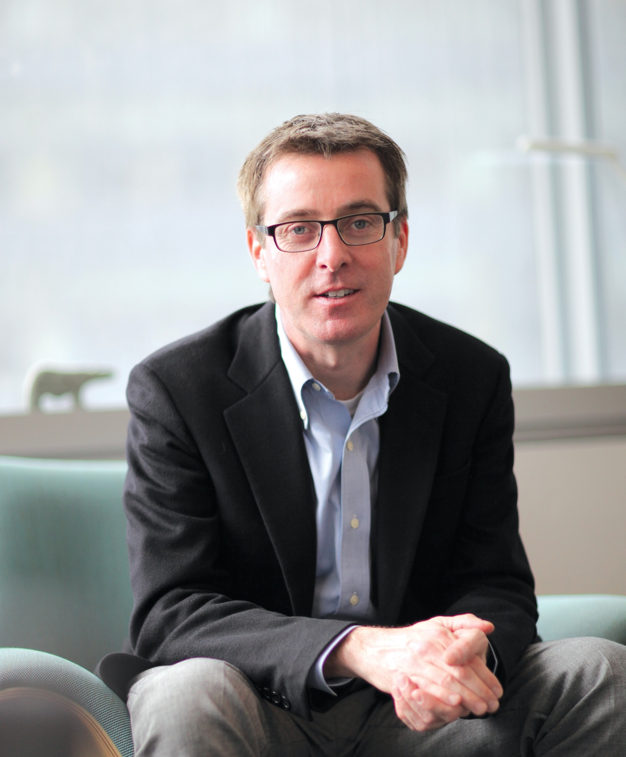
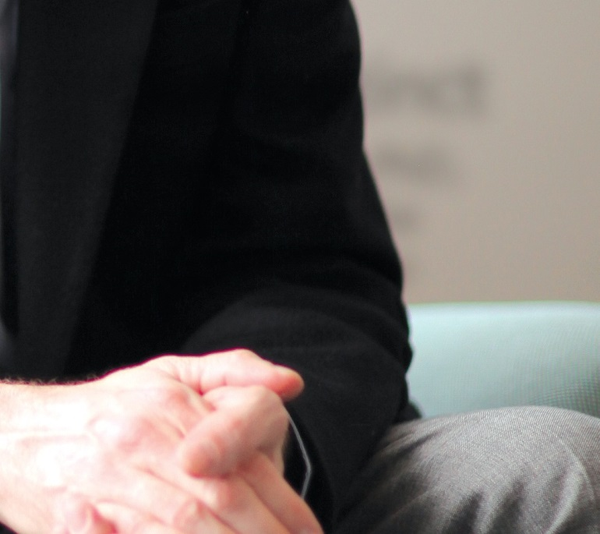

Gut Instinct

David Artis, PhD, Explores the Microbiome

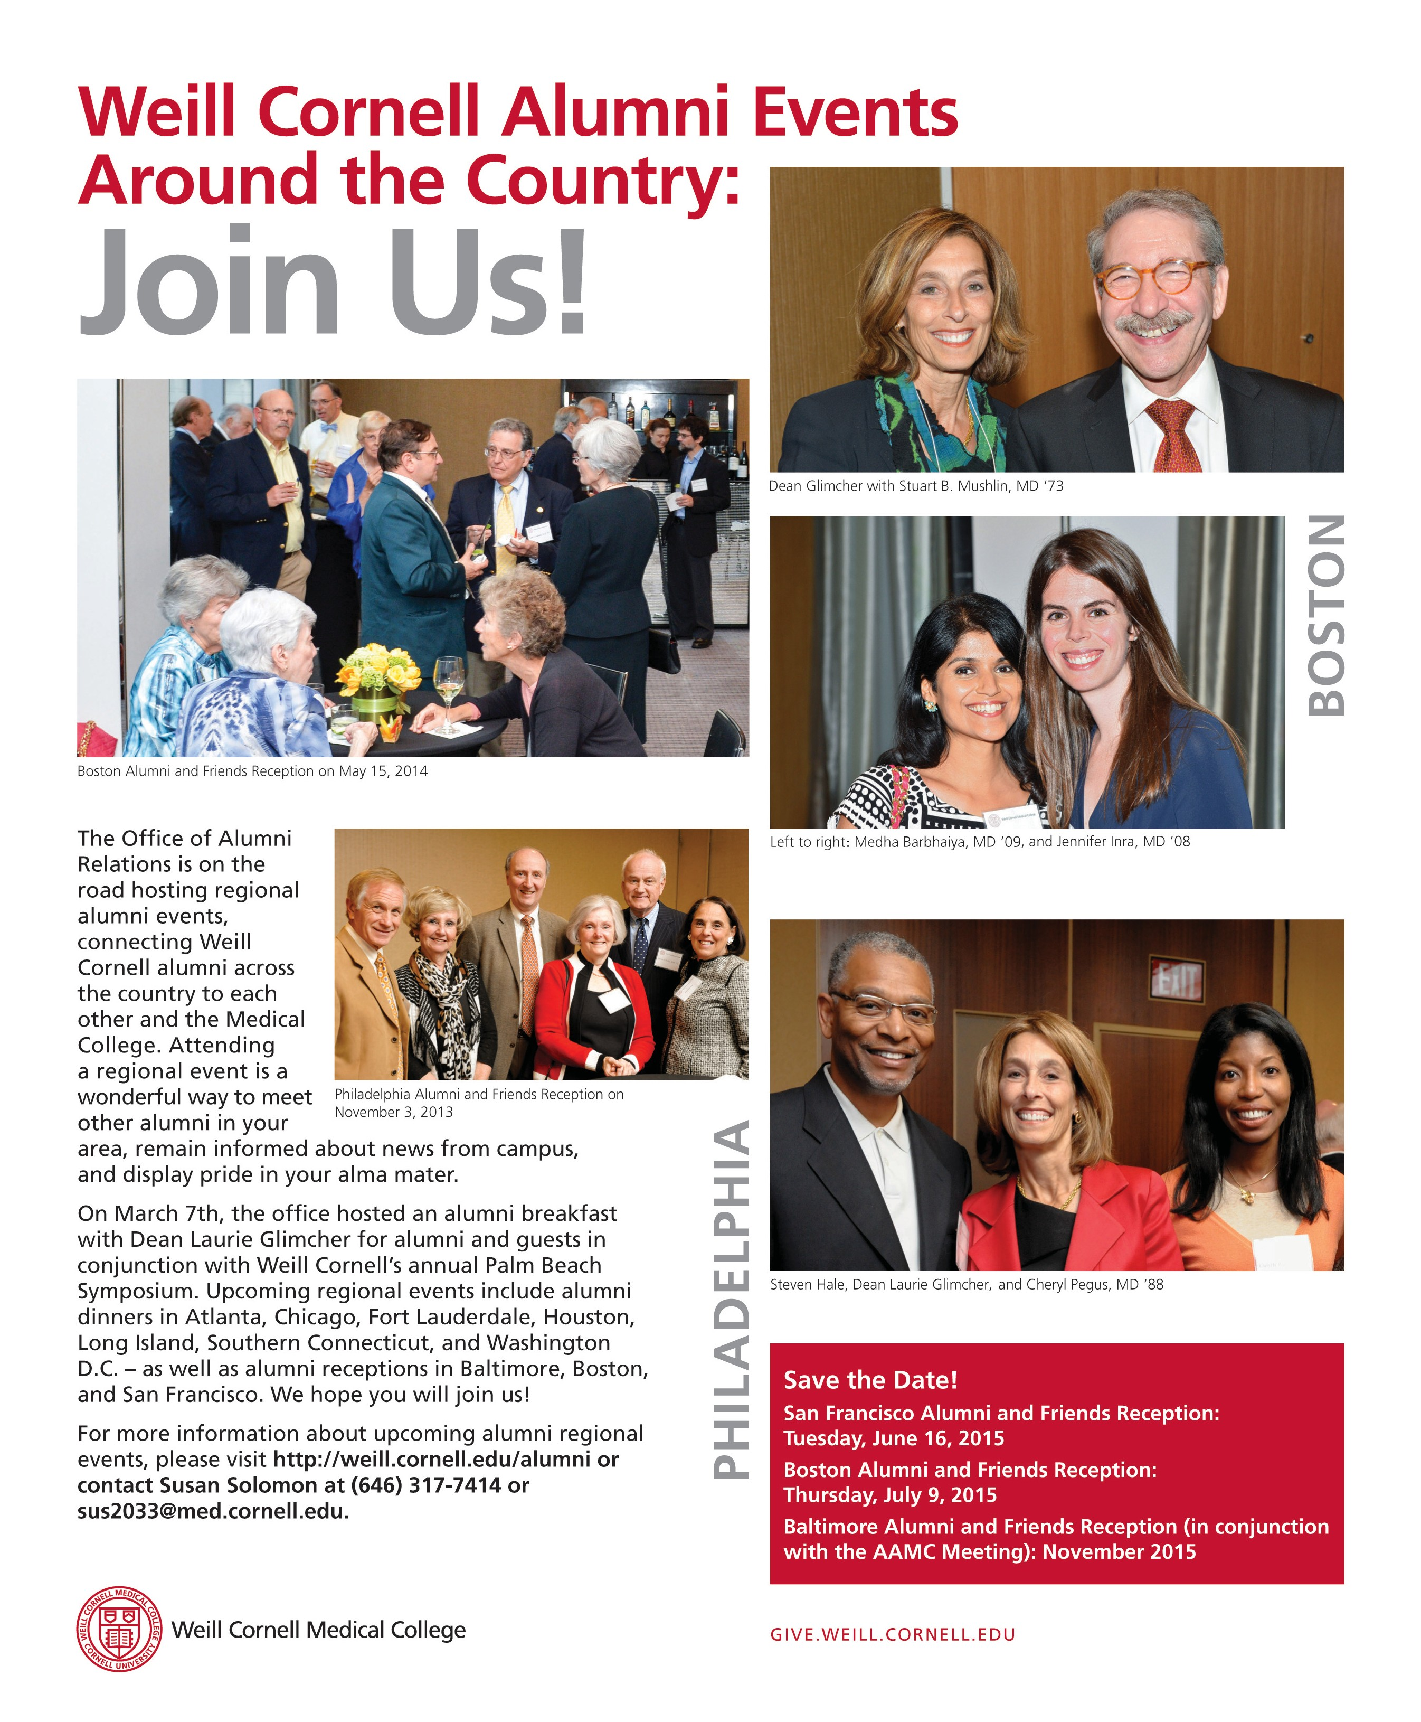

weillcornellmedicine

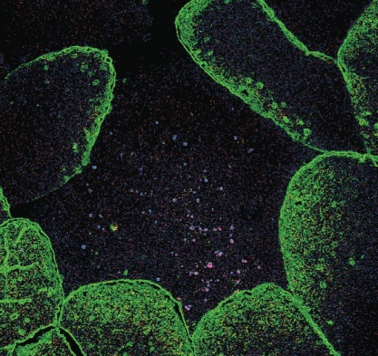
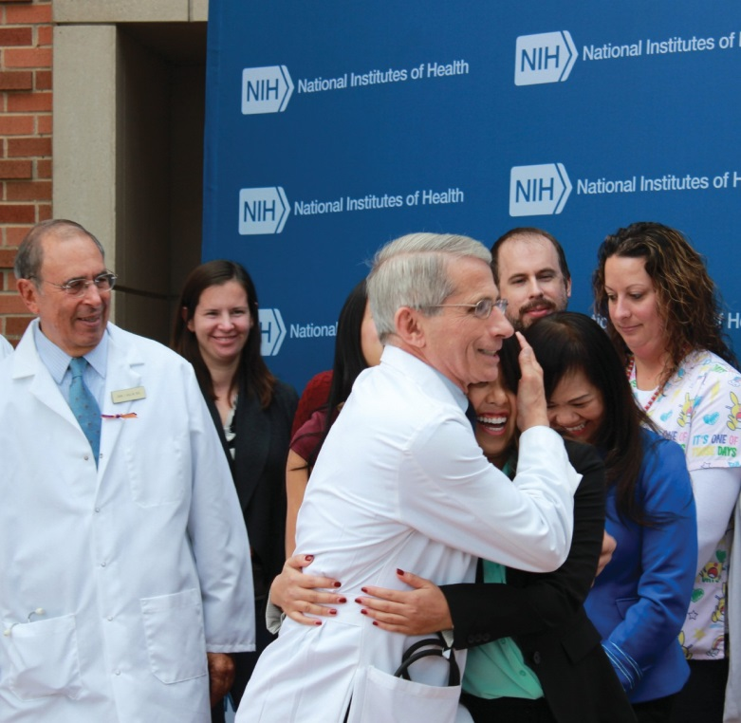
THE MAGAZINE OF

24
WEILL CORNELL MEDICAL COLLEGE AND WEILL CORNELL GRADUATE SCHOOL OF MEDICAL SCIENCES

VOL. 14, NO. 1

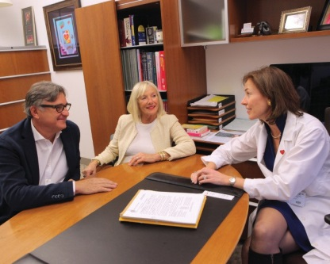
30 34

FEATURES

24 SYMBIOTIC RELATIONSHIP
AMY CRAWFORD
It’s known as the microbiome: the vast complement of bacteria that share our bodies. Thanks to striking advances in sequencing technology, researchers are learning more and more about this tiny ecosystem, which coevolved with us and on which our health depends. At Weill Cornell, those investigations are led by David Artis, PhD, director of the new Jill Roberts Institute for Research in Inflammatory Bowel Disease, who’s studying the microbiome’s far-reaching impact. In addition to affecting gastrointestinal disorders like IBD, Artis and his colleagues say, it influences our immune systems—and much more.

For address changes and other subscription inquiries, please e-mail us at wcm@med.cornell.edu

Twitter: @WeillCornell
Facebook.com/ WeillCornellMedicalCollege
YouTube.com/WCMCnews

Cover photograph by John Abbott
30 TRUE HEARTED
BETH SAULNIER
Headquartered in the Belfer Research Building, the Dalio Institute of Cardiovascular Imaging is using MRI, CT, and PET—as well as novel technologies such as 3D printing and computer modeling of blood flow dynamics—to better understand the mechanics of heart disease. This winter, it launched a clinical program, HeartHealth, designed to prevent cardiac ailments long before patients see symptoms. The Institute’s goal, says director James Min, MD, is “to imagine a world without heart disease.”

34 NATIONAL TREASURE
BETH SAULNIER
At the NIH Clinical Center in Bethesda, Maryland, every patient is part of a research protocol—and their care is provided free of charge. The facility, which has several Weill Cornell alumni at its helm, is the Institute’s crown jewel—a patient-centered, state-of-the-art hospital where people from around the world seek treatment for ailments both common and rare. “It’s a great environment where we have a lot of flexibility,” says Joseph Kovacs, MD ’79. “The ability to do research in a place where that’s our primary focus, the day-to-day meat and potatoes, is wonderful.”

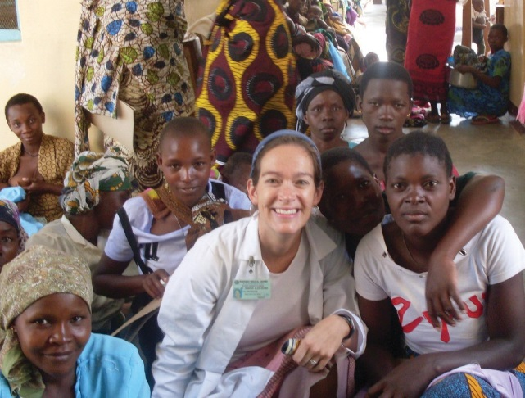
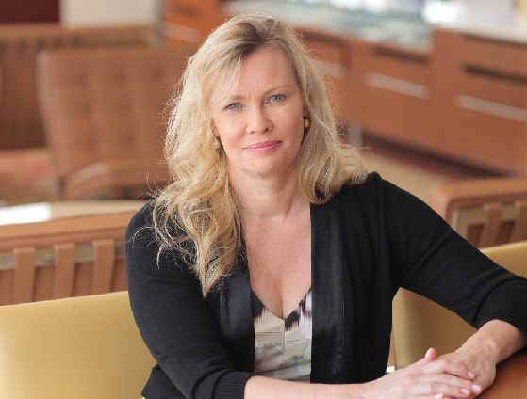
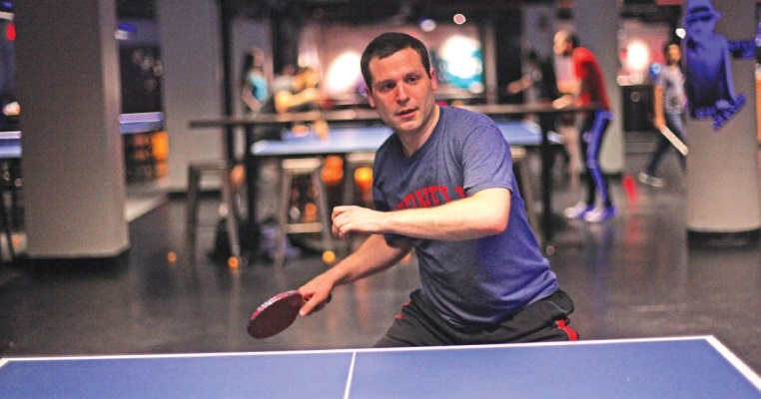

weillcornellmedicine
THE MAGAZINE OF WEILL CORNELL MEDICAL COLLEGE AND WEILL CORNELL GRADUATE SCHOOL OF MEDICAL SCIENCES

Published by the Office of External Affairs Weill Cornell Medical College and Weill Cornell Graduate School of
Medical Sciences

WEILL CORNELL SENIOR ADMINISTRATORS
Laurie H. Glimcher, MD The Stephen and Suzanne
Weiss Dean, Weill Cornell Medical College; Provost for Medical Affairs, Cornell University

Larry Schafer
Vice Provost for External Affairs

WEILL CORNELL EXECUTIVE DIRECTOR OF COMMUNICATIONS AND PUBLIC AFFAIRS
Mason Essif

WEILL CORNELL DIRECTOR OF CREATIVE AND EDITORIAL SERVICES
John Rodgers

WEILL CORNELL SENIOR EDITOR
Jordan Lite
Weill Cornell Medicine is produced by
the staff of Cornell Alumni Magazine.
PUBLISHER
Jenny Barnett
EDITOR
Beth Saulnier
CONTRIBUTING EDITORS
Chris Furst Adele Robinette Sharon Tregaskis
EDITORIAL ASSISTANT
Tanis Furst

ART DIRECTOR
Stefanie Green

ASSISTANT ART DIRECTOR
Lisa Banlaki Frank

ACCOUNTING MANAGER
Barbara Bennett

EDITORIAL AND BUSINESS OFFICES
401 E. State St., Suite 301
Ithaca, NY 14850
(607) 272-8530; FAX (607) 272-8532
Printed by The Lane Press, South Burlington, VT.
Copyright © 2015. Rights for republication of all matter are reserved. Printed in U.S.A.
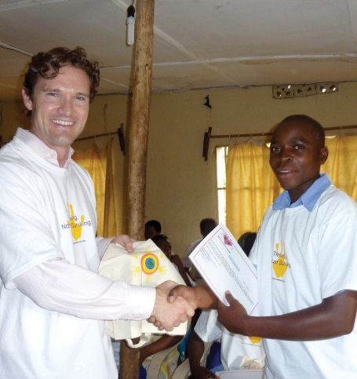
18
19


23
48

DEPARTMENTS

- DEAN’S MESSAGE
Comments from Dean Glimcher

- SPEEDING BREAKTHROUGHS
6 SCOPE
WCMC recruits Nobelist Harold Varmus, MD. Plus: New neuro-oncology program, Belfer earns LEED Gold, ACO joins Medicare savings program, a record Match Day, NIH-funded TB research, new radiation oncology department, an honor for Cantley, symposium on women in global health, and a fourth edition of WCMC-Q’s literary journal.

10 TALK OF THE GOWN
Farewell chats with David Skorton, MD, and Robin Davisson, PhD. Plus: Preventing child- hood blindness, the return to consciousness, an Alzheimer’s breakthrough, the health impact of “fracking,” keeping older adults active, battling diabetes in the developing world, faculty on social media, Superstorm Sandy’s aftereffects, and our ping-pong champ.
40 NOTEBOOK
News of Medical College and Graduate School alumni

- IN MEMORIAM
Alumni remembered

- POST DOC
What’s cooking?

Weill Cornell Medicine (ISSN 1551-4455) is produced four times a year by Cornell Alumni Magazine, 401 E. State St., Suite 301, Ithaca, NY 14850-4400 for Weill Cornell Medical College and Weill Cornell Graduate School of Medical Sciences. Third-class postage paid at New York, NY, and additional mailing offices. POSTMASTER: Send address changes to Office of External Affairs, 1300 York Ave., Box 123, New York, NY 10065.

Dean’s Message

From Bedside to Bench

ranslational research is more than just a guiding principle in academic medicine.
T
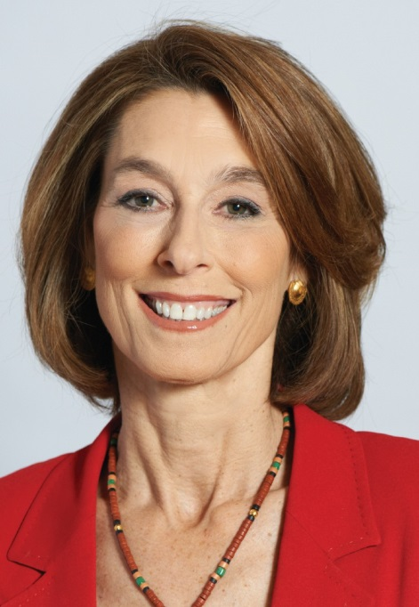
It is at the heart of what we do, and it forms an indispensable bridge between the laboratory and the patients we strive to heal. Weill Cornell’s distinguished physician-scientists derive inspiration for their research from their patients. Passionate about what they do,
they use the knowledge gleaned from the clinic to make key observations that open new lines of scientific inquiry in the lab.
While I often speak about the importance of bench-to-bedside research
—where discoveries made in the lab can be rapidly translated into next-generation treatments and therapies—it’s just as important that discoveries flow the other direction: from the bedside to the bench. In this issue, we highlight some of our faculty and alumni who exemplify how creativity and communication are integral to biomedical research and who employ a fluid, collaborative approach to infuse the lab with patient insights.
At the Jill Roberts Institute for Research in Inflammatory Bowel Disease, David Artis, PhD, is seeking answers to an

Laurie H. Glimcher, MD,
Dean of the Medical College

for translational medicine. At this center, every patient is part of a research protocol, with their treatment adding to the body of knowledge that will foster tomorrow’s cures. Director John Gallin, MD ’69, calls the facility “one of the greatest gifts that Congress ever gave the American public,” noting its proud history of breakthroughs in diseases from childhood leukemia to hepatitis to HIV/AIDS. Last fall, Gallin and colleague Anthony Fauci, MD ’66, director of the National Institute of Allergy and Infectious Diseases, helped oversee the care of one of the nation’s most famous patients: Nina Pham, the Texas nurse who was cured of Ebola. And as Gallin points out, treating such rare dis- eases often offers invaluable insights into more common conditions.
We see this passion, too, in the work of James Min, MD, a cardiologist working within the Department of Radiology, who imagines a world without heart disease. To achieve it, he and his colleagues at the Dalio Institute of Cardio- vascular Imaging are employing such familiar tools as MRI, CT, and PET, as well as novel technologies like 3D printing and computer modeling of blood flow dynamics. Their goal: to fine-tune prevention strategies so that physicians

LISA BERG
intriguing question: what role might the
can catch vulnerable patients before they ever

microbiome—the tiny ecosystem that coevolved with us—play in the development of chronic conditions of the digestive tract? Along with colleagues Carl Nathan, MD, Greg Sonnenberg, PhD, and others, he is gaining new insights not only into disorders such as IBD, but also into cancer, rheumatic conditions, and behavioral disease. Hands-on work with patients at the related Jill Roberts Center for Inflammatory Bowel Disease informs that effort immeasurably. Our alumni who lead the NIH’s Clinical Center in Maryland also epitomize this passion
exhibit a single symptom. Their efforts mirror those of the Institute’s clinical program, HeartHealth, which takes a highly proactive, individualistic approach to preventive medicine. The common denominator in these stories is that for Weill Cornell’s physicians and alumni, passion for our patients is what drives us. We are grateful for the ways in which our patients teach us, inspire us, and galvanize us. And we’re grateful for the opportunity to take those lessons back to our laboratories, where we continue the inter- locking cycle of research, treatment, and discovery.

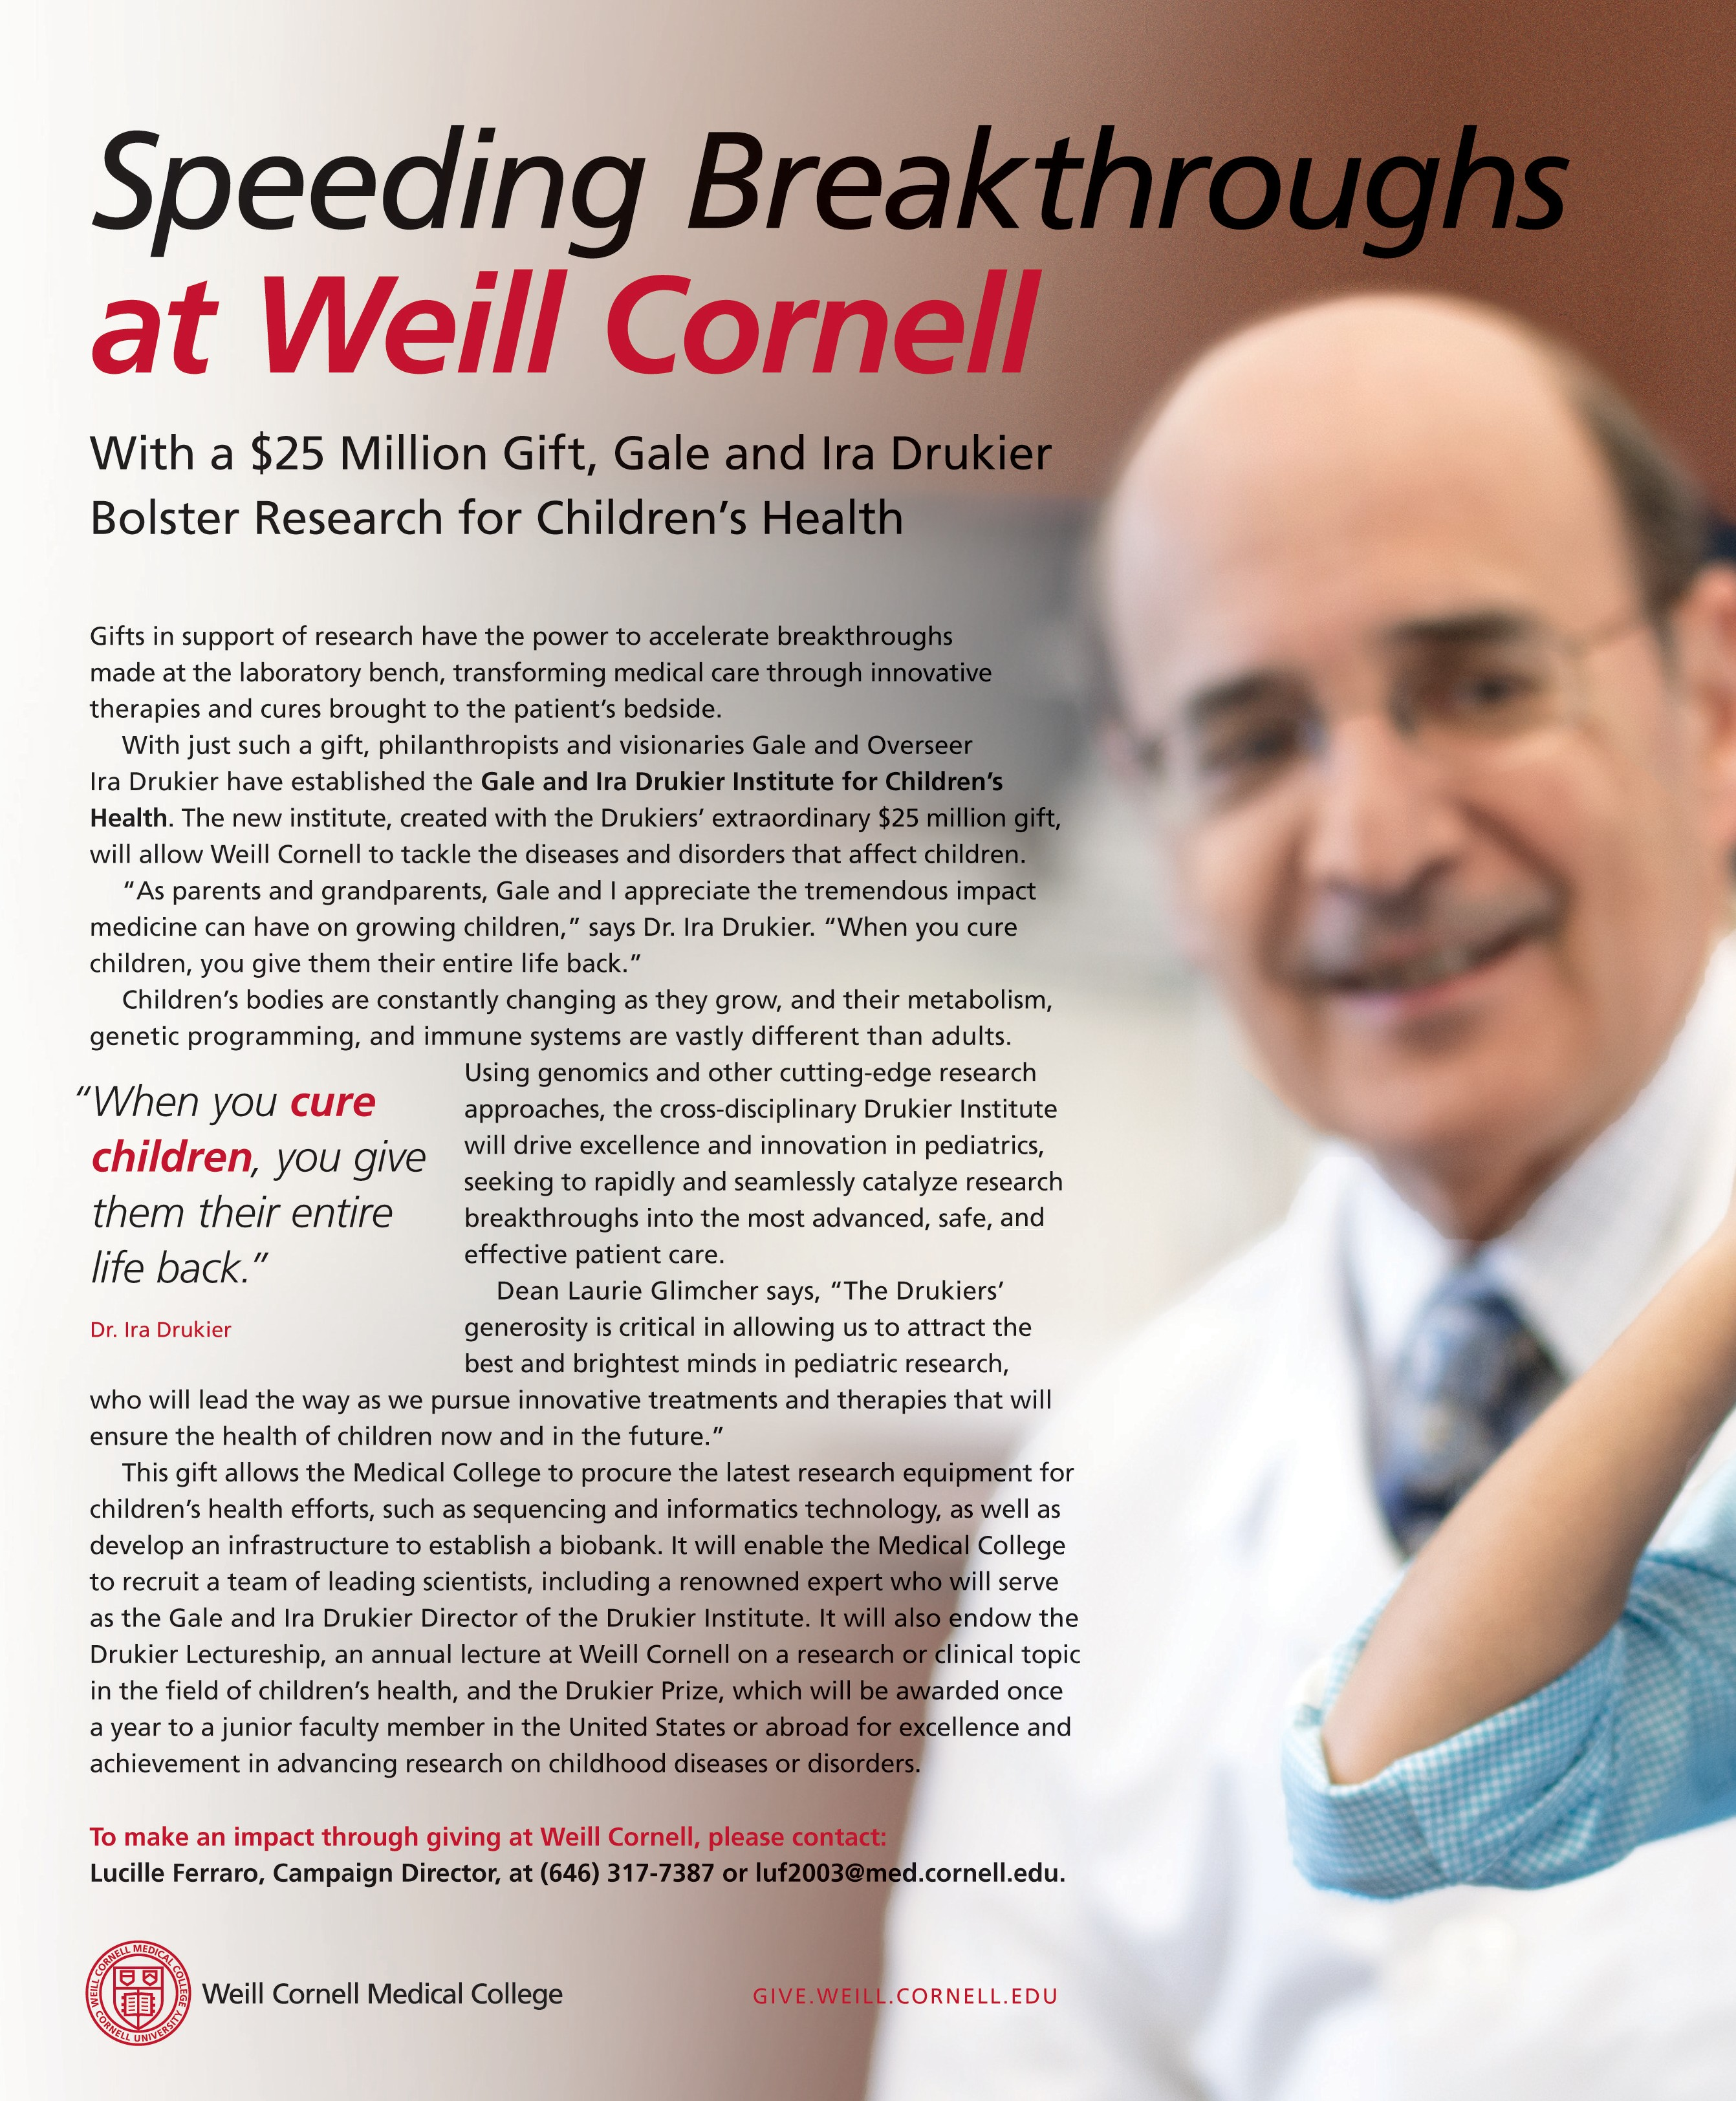

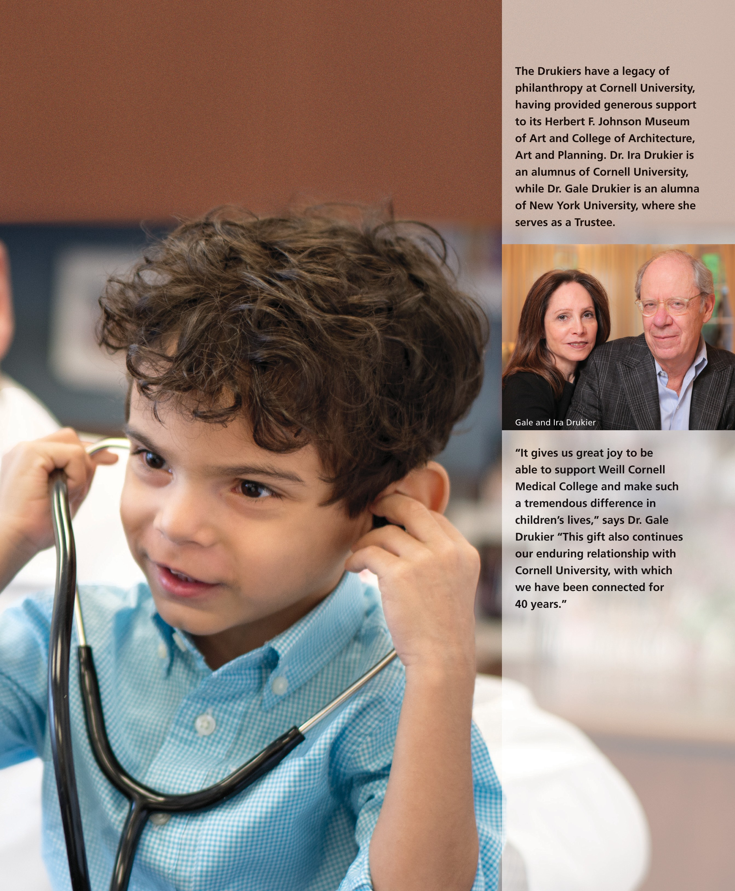

Scope
News Briefs

WCMC Welcomes Nobelist Varmus to Faculty
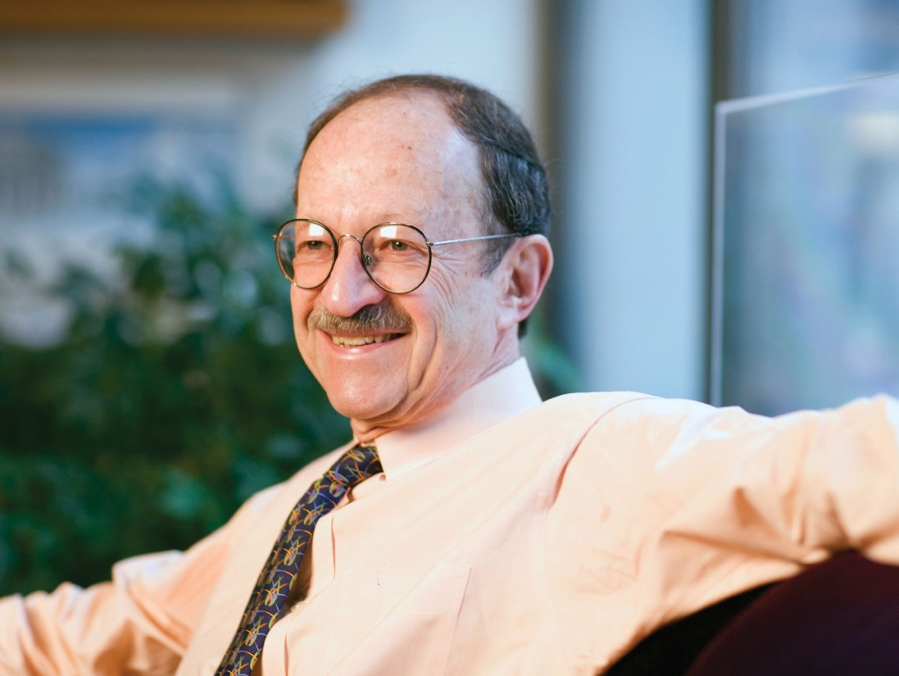
Nobel laureate Harold Varmus, MD,

MATTHEW SEPTIMUS/MEMORIAL SLOAN KETTERING CANCER CENTER

has joined the faculty as the Lewis
Thomas University Professor. A for- mer director of the NIH and of the National Cancer Institute, Varmus is renowned for his research on
retroviruses and the genetic basis of cancer. In addition to his Weill Cornell appointment, Varmus will work with the New York Genome Center as a senior associate core member.
In his new position, Varmus will continue to con- duct research on fundamental aspects of cancer, in collaboration with investigators at the Sandra and Edward Meyer Cancer Center, led by Meyer Director Lewis Cantley, PhD ’75. He will also serve as a senior adviser to Dean Laurie Glimcher, MD, and have an appointment in the Graduate School of Medical Sciences. “This is a remarkable time in cancer research,” Varmus says. “Technological advances have enabled sci- entists to conduct comprehensive genomic studies that are revealing detailed portraits of cancer cells, sparking new opportunities to develop next-generation therapies, diagnostics, and prevention strategies.”
Varmus comes to Weill Cornell from the National Cancer Institute, whose directorship he assumed in July
2010. He served as president and CEO of Memorial Sloan Kettering Cancer Center from 2000 to 2010 and as NIH director from 1993 to 1999. His Weill Cornell laboratory in the Belfer Research Building will focus on lung adenocarcinoma and the mutations that drive it, which affect cell signaling, cell growth, and RNA processing. “As one of the world’s leading cancer geneticists, Dr. Varmus, a physician, has dedicated his career to driving excellence in cancer research by inves- tigating the underlying mechanisms that cause these diseases,” Glimcher says. “We are delighted and honored that Dr. Varmus, an esteemed leader, scientific pioneer, and champion of cancer research, will continue this distinguished and vital work at Weill Cornell, catalyzing groundbreaking discoveries into improved patient care.”
Varmus shared the 1989 Nobel Prize in Physiology or Medicine for work that demonstrated the cellular origin of the oncogene of a chicken retrovirus—a discovery that led to the isolation of many cellular genes that normally control growth and development and are frequently mutated in human cancer. A member of the National Academy of Sciences and the Institute of Medicine, Varmus has authored more than 350 scientific papers and five books, including the 2009 memoir The Art and Politics of Science.

Harold Varmus, MD

Brain Tumor Expert Howard Fine, MD, Leads New Neuro-Oncology Program
Howard Fine, MD, has assumed the leadership of Weill Cornell’s newly established neuro-oncology program, which will develop and provide cutting-edge treatments for patients with brain tumors. Fine, who was recruited as the Louis and Gertrude Feil Professor of Medicine, will serve as director of the Brain Tumor Center, associate director for translational research in the Sandra and Edward Meyer Cancer Center, and chief of the Division of Neuro-Oncology in the Department of Neurology, and will hold faculty positions in medicine and neurosurgery.
Before joining Weill Cornell, Fine built two of the nation’s lead- ing neuro-oncology programs, at Harvard Medical School and at the NIH. A veteran of more than 100 brain tumor clinical trials, he has authored more than 200 scholarly articles, reviews, and book chap- ters and served on the editorial boards of Neuro-Oncology and the Journal of Clinical Oncology.

JEFF GOLDBERG/ESTO FOR ENNEAD ARCHITECTS


Sustainable structure: The Belfer Research Building by night
Belfer Research Building Certified LEED Gold
The Belfer Research Building has received LEED Gold certification from the
U.S. Green Building Council—only the second laboratory facility in New York City to do so. Gold is the second-highest of the four ratings. “High- impact medical research, by its very nature, requires and consumes a sub- stantial amount of energy,” says William Cunningham, Weill Cornell’s campus architect. “It was important for Weill Cornell to build a research facility that harnessed energy-efficient technologies and sustainable build- ing practices, minimizing its environmental impact and contribution of greenhouse gases. This recognition is a reflection of our commitment to do just that.” The $650 million, 480,000-square-foot facility, which opened in January 2014, uses sustainable materials and highly efficient mechanical systems. Its design elements include a double-layer glass curtain wall that greatly reduces the demand for air conditioning.

ACO Joins Medicare Program
NewYork Quality Care—the accountable care organization (ACO) of NewYork-Presbyterian, Weill Cornell, and Columbia—has been selected as one of eighty-nine new ACOs to join the Medicare Shared Savings Program. ACOs are collaborations among doctors, hospitals, and other healthcare providers, who work together to provide coordinated patient care while helping to curb costs. The additions bring the total number of ACOs in the program to 405, serving more than 7.2 million beneficiaries. If ACOs meet standards for high-quality care, they can share in the savings they generate.

TIP OF THE CAP TO...

Elizabeth Arleo, MD, assistant professor of radiology, elected to the board of the American Association for Women Radiologists.

Charles Bardes, MD, associate dean of admissions and professor of clinical medicine, winner of the Alpha Omega Alpha Robert
J. Glaser Distinguished Teacher Award from the Association of American Medical Colleges.

Dean Emeritus Antonio Gotto, MD, winner of a Lifetime Achievement Award from the American College of Cardiology.

Katherine Amberson Hajjar, MD, associate dean of research, professor of pediatrics, and the Brine Family Professor of Cell and Developmental Biology, elected a fellow of the American Association for the Advancement of Science.

Linda Heier, MD, professor of clinical radiology, inducted as a fellow of the American College of Radiology.

Neil Khilnani, MD, associate professor of clinical radiology, named president-elect of the American College of Phlebology.

Fabrizio Michelassi, MD, chair of the Department of Surgery and the Lewis Atterbury Stimson Professor of Surgery, winner of a Castle Connelly National Physician of the Year Award and elected chair of the American College of Surgeons’ Board of Governors.

Anne Moore, MD, professor of clinical medicine, elected president of the American Clinical and Climatological Society.

Susana Morales, MD, associate professor of clinical medicine, winner of the Elnora M. Rhodes Society of General Internal Medicine Service Award.

Dattatreyudu Nori, MD, professor of clinical radiation oncology, awarded an Ellis Island Medal of Honor.

Cam Patterson, MD, professor of medicine, winner of the Distinguished Scientist Award from the American College of Cardiology.

Peter Schlegel, MD, chair of the Department of Urology and the James J. Colt Professor of Urology, winner of the Star Award from the American Society for Reproductive Medicine.

Manikkam Suthanthiran, MD, the Stanton Griffis Distin- guished Professor of Medicine, winner of the International Society of Nephrology’s Jean Hamburger Award, which recog- nizes outstanding research with a clinical emphasis.

Roger Yurt, MD, the Johnson & Johnson Distinguished Professor of Surgery and director of the William Randolph Hearst Burn Center, winner of the Maurice R. Greenberg Distinguished Service Award from NYP/Weill Cornell.

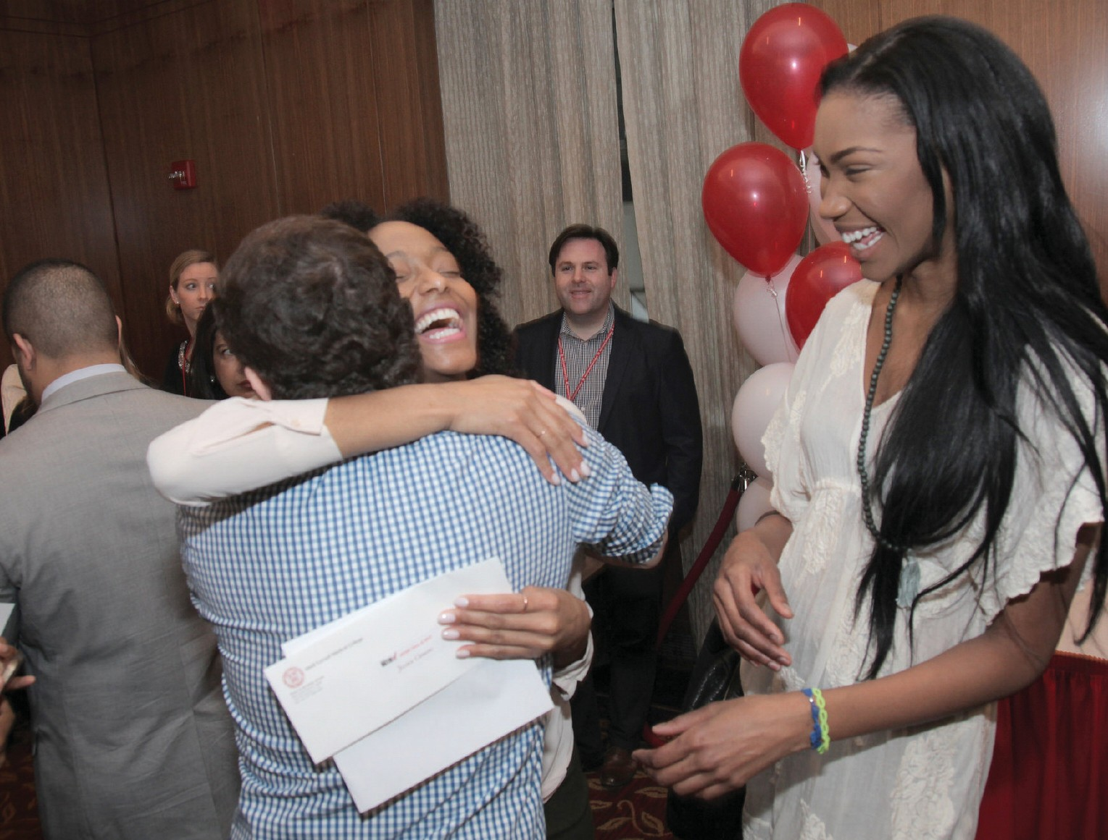

WCMC

A record match: In March, graduating medical students participated in the largest Match Day in history, with some 38,000 people competing for about 30,000 residency positions. Weill Cornell celebrated its best match ever: 91 percent of candidates secured residencies at institutions ranked in the top fifty by U.S. News & World Report, and 99 percent of those who entered the match found placements.

NIH Funds Battle Against Tuberculosis
New Radiation Oncology Department
The Medical College has established a new department: radiation oncology. It will be chaired by Silvia Formenti, MD, an internation- ally known expert in the field. Formenti, who comes to Weill Cornell from NYU, will also serve as associate director of radiation oncology at the Sandra and Edward Meyer Cancer Center and radiation oncologist-in-chief at NYP/Weill Cornell. In her new role, she will expand and enhance Weill Cornell’s existing radiation oncology program, building upon its achievements in translational research. “One of the biggest scientific breakthroughs of our genera- tion is the revelation that not all cancers are the same—and as such, neither should their treatments be the same,” says Dean Glimcher. “Dr. Formenti is on the forefront of this personalized approach to cancer, devoting her career to investigating immune responses to radiotherapy and designing therapies that are tailored to each patient’s specific tumor. Her distinguished work in radiation oncolo- gy has left a lasting mark on cancer care, and I can think of no one better to lead Weill Cornell’s efforts to develop the most effective, next-generation cancer treatments that improve the lives of patients in New York and beyond.” A graduate of Italy’s University of Milan, Formenti has published more than 170 scholarly papers.

Cantley Wins Gairdner Award
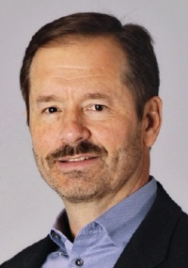
Lewis Cantley, PhD ’75, has won the 2015 Canada Gairdner International Award for his groundbreaking discovery of a family of enzymes that are fundamental to understanding cancer. Administered by the Gairdner Found- ation, the awards—which each carry a prize of 100,000 Canadian dollars—are given annually to five biomedical scientists from around the
WEST VIRGINIA WESLEYAN COLLEGE

Weill Cornell will play a leading role in a major effort to stem the
global tuberculosis epidemic. The National Institute of Allergy and Infectious Diseases has awarded the Medical College more than
world who have increased understanding of human biology and disease. Cantley is the Margaret and Herman Sokol Professor in
Lewis Cantley, PhD ’75

$6.2 million in first-year funding to support a research collabora-
tion among six institutions, which will work closely with pharma- ceutical partners. The total funding over seven years could top
$45 million.
The effort will be spearheaded by Carl Nathan, MD, chair of the Department of Microbiology and Immunology and co-principal investigator of the TB Research Unit. He notes that TB-causing bacteria are increasingly becoming resistant to the most common treatments, requiring more than two years of therapy with multiple, toxic, and expensive alternatives, which often fail. In 2013, accord- ing to the WHO, an estimated 9 million new cases were reported— and 1.5 million people died of the disease. “Neither academia nor pharma can solve this problem working alone,” says Nathan, also director of the Abby and Howard P. Milstein Program in Translational Medicine. “We have to work together to improve treatment of tuberculosis, or it will continue to spread and become even more resistant to treatment than it is today.”
The TB Research Unit is pursuing two parallel tracks: one study- ing the biology of TB infection in patients, the other seeking to accelerate the development of new drugs. The disease is particular- ly challenging, Nathan says, in part due to its ability to lurk in the body in a latent form for decades. Because the TB bacterium has co- evolved with humans for tens of thousands of years, he notes, “it has learned enough about our immune systems to survive our efforts to eliminate it.”
Oncology Research, the Meyer Director of the Sandra and Edward Meyer Cancer Center, and a professor of cancer biology in medicine.

Symposium on Women in Global Health
Participants from fourteen universities and six countries gathered in the Belfer Research Building in February to discuss challenges affect- ing women in the global health research field, and to formulate strategies to address them. The symposium featured female researchers sharing their experiences of coping with such issues as work-life balance, childrearing, and sexual harassment. “When we look at the medical students and residents who come to our inter- national sites in Tanzania, Haiti, Brazil, and India, 70 to 80 percent are women—but that number drops substantially when you look at global health leadership positions,” notes Jennifer Downs, MD ’04, MS ’11, one of the event’s organizers and an assistant professor of medicine and of microbiology and immunology.

WCMC-Q Publishes Fourth Qira’at
The Qatar branch has released a new issue of its literary journal, Qira’at (Readings), which is published biennially. The journal’s fourth volume features essays on such topics as medical ethics, Muslim women healers of the Ottoman Era, doctor-patient commu- nication, and Islamic perspectives on human cloning and abortion.

FROM THE BENCH
Study Quantifies HIV Prevention Savings
Preventing just one high-risk person in the U.S. from contracting HIV offers a substantial financial savings, says a new study published in Medical Care. By

smoke results in cell death, a contributing factor in COPD. In the past, researchers have zeroed in on the lung’s cellular and inflammatory responses to cigarette smoke to help explain how
smoking contributes to COPD. But Choi and his team have found mounting evidence that cigarette smoke causes the lung’s air sacs to die at irregular rates. In the Journal of Clinical
Gender Differences Found in Learning
Investigators at Weill Cornell and the Nathan Kline Institute for Psychiatric Research have discovered that high levels of estrogen may lead to a unique kind of learning that could explain why women are more susceptible to addiction

estimating lifetime
medical costs for such patients—compared to what expenses would have been if they had not become infected— the researchers quantified the savings at between
$229,800 and $338,400,
depending on the

Bruce
ABBOTT
Investigation, they tied COPD development to a cellular pathway, called mitophagy, which selectively identifies and removes a cell’s energy source. The researchers hope the finding can lead to new treatments for COPD.

Lymphoma Genome Is Sequenced
Researchers have sequenced the genome of
than men are. The findings—published in the Journal of Neuroscience, with Teresa Milner, PhD, professor of neuroscience in the Feil Family Brain and Mind Research Institute, as co-senior author—are based on work in adult rats. They show that females have different activity within the hippocampus that’s important for what’s known as associative learning—when ideas and experiences become associated with one another. While the phenomenon can be

continuity of treatment.
Schackman, MD
classical Hodgkin lymphoma (cHL), illuminating
beneficial, it can prove harmful when it

“This study shows the
continued value of HIV prevention, even in an era when people effectively treated with HIV medications can have a close-to-normal life expectancy,” says lead author Bruce Schackman, MD, the Saul P. Steinberg Distinguished Professor of Psychiatry and Public Health. “There is still significant value in avoiding infection, from both cost and quality of life points of view.”
With Cancerous Tumors, Environment Matters
which proteins are altered in individual patients. The findings could point the way toward personalized treatments and more effective options, since current therapies can be toxic and don’t work for nearly 20 percent of patients. “Now we have a better idea of what

ABBOTT

Ethel Cesarman, MD, PhD
strengthens the connections that lead to addiction, such as associating a place with a drug or a drug with a feeling. In addition to offering potential new avenues for addiction treatment, the team’s related discoveries in brain chemistry have implications for epilepsy and other seizure disorders, as well as for the development of new painkillers.

‘Butterfly Project’ Fixes Infant Ear Deformities

When cancer cells develop in a healthy organ, the surrounding area, called the microenvironment, directly influences tumor growth and the spread of disease. How that happens was previously unknown. Now, a team of scientists at Weill Cornell and Houston Methodist Research Institute has identified complex communication networks between tumors and their surrounding milieu, which contains blood vessels, immune cells, connective tissue cells, and structural cells. The work, published in Cell Reports, could directly affect the way cancer is treated. “Current therapy rarely
targets the organ cells that aid and abet tumor
mutations there are,
and going forward, therapies can be adapted to specific patient populations according to their genomic composition,” says senior author Ethel Cesarman, MD, PhD, professor of pathology and laboratory medicine. The research was published in the journal Blood.

Mathematic Model ‘Maps’ Alzheimer’s
In Cell Reports, a team led by Ashish Raj, PhD ’05, associate professor of computer science in
Newborn ear deformities
could be corrected in just two weeks—much less time than previously reported—thanks to an improved, nonsurgical procedure, Weill Cornell researchers say. In their study, published in the Journal of Plastic and Reconstructive Surgery, researchers showed how a rigid plastic mold can
PROVIDED

Melissa Doft, MD

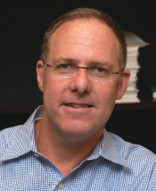
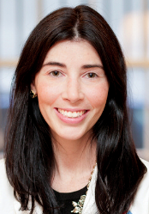
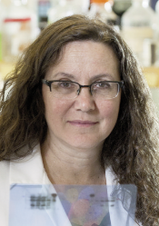
growth, so treatment of cancer is incomplete,” says senior author Vivek Mittal, PhD, associate professor of cell and developmental biology in cardiothoracic surgery, noting that a tumor wounded by treatment can call on the microenvironment to survive. “If you know how the microenvironment supports the growth, progression, and spread of cancer, you can begin to take apart these communications networks to find molecules that are vulnerable. You might stop the cancer by disengaging the crosstalk.”
Cellular Pathway Implicated in COPD
Cigarette smoke has long been known as a primary driver of chronic obstructive pulmonary disease (COPD), though the reasons behind it have been mostly unclear—until now. A study led by Augustine Choi, MD, the Sanford I. Weill Chairman of the Weill Department of Medicine, shows how
radiology, describes a mathematical model that
can accomplish something that has become increasingly vital as the population ages: it can map Alzheimer’s disease. The model determines where in the brain Alzheimer's has spread and predicts where it will appear next. It can also tell when mild cognitive impairment (MCI), which could be a precursor to Alzheimer's, is just simple memory loss. “Neurologists today cannot tell with any certainty what a person with MCI or Alzheimer’s is going to experience in the future,” says Raj, also an associate professor of neuroscience at the Feil Family Brain and Mind Research Institute. “This is a very debilitating problem if you are the person who is undergoing early signs of dementia and you want to know what will happen to you and when.” The model is based on the new understanding that two toxic proteins that are the hallmarks of Alzheimer’s spread through the brain in a predictable way.
be used to reshape deformed ears—softening
curves and re-contouring cartilage—when applied within the first few weeks of life. They also discovered that the procedure—which is pain-free and non-invasive—could transform ear shape much more quickly than the six to eight weeks doctors have historically advised. “This research represents a breakthrough in how we treat ear deformities,” says lead author Melissa Doft, MD, clinical assistant professor of plastic surgery. “Through innovation, we have an opportunity to truly make a difference in children’s lives, helping to decrease the bullying that many children with ear deformities face and eliminating the need for invasive surgical correction later in life.” Doft dubbed her research the Newborn Butterfly Project because the device coaxes ears into normal shape through a natural metamorphosis, similar to how a caterpillar becomes a butterfly.

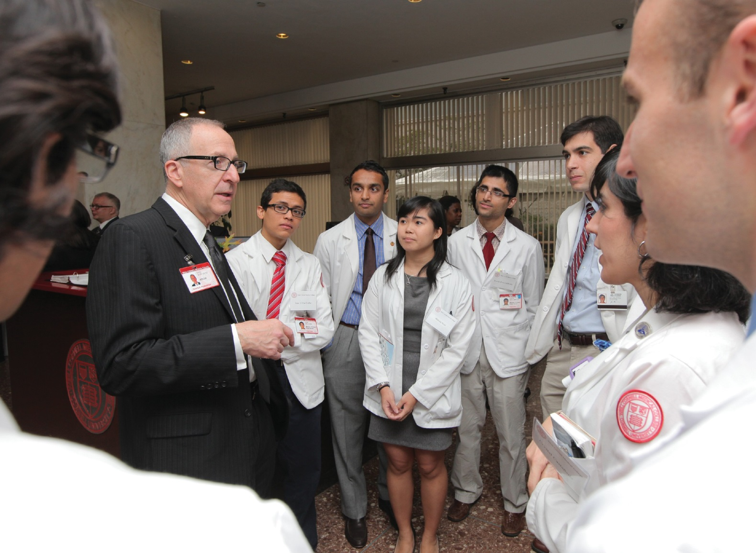
Talk of the Gown
Insights & Viewpoints

Cardiologist at heart: David Skorton, MD, with medical students in 2011

WCMC

Parting Words

David Skorton, MD, reflects on his tenure as Cornell president
A

t the end of June, President David Skorton leaves
Cornell to become Secretary of the Smithsonian Institution in Washington, D.C. In advance of his departure, Weill Cornell Medicine sat down
with him for a chat in his office in Day Hall, the university administration building.

Weill Cornell Medicine: How has your background as a physician influenced your leadership of Cornell?
David Skorton, MD: Never in a hundred years did I think I’d end up in a general leadership, executive type of job. If you asked me what I was really trained to do—what I had a passion for—it was patient care and bedside teaching. But as opportunities came along to do leadership work, it occurred to me that becoming a clinician is great training for executive function. You might ask why.

WCM: OK, why?
D.S.: Number one, physicians and other healthcare workers have to make decisions under conditions of uncertainty all the time. When a patient tells you about a concern, a fear, a pain, you can’t say, “We’re going to impanel a faculty task force; we’ll get back to you
in three months.” So you have to deal with uncertainty, and being
an executive is loaded with uncertainty. Secondly, the patient encounter starts by asking, then shutting up and listening. And good executive leadership has a lot to do with listening—and not just to the three or four people in the immediate vicinity of the chief, but throughout the organization.
A third thing is to be humble about the fact that not all problems are solvable, and to be honest about that. Even the most mature therapies and diagnostic techniques fail; even the best- cared-for patients do worse; we all die at various times for various reasons. Understanding that you can’t really control things is important, because when you’re at the top of any organization, it’s easy to believe that your job is to solve all problems. But some problems cannot be solved, and that demands honesty—to have you say, “There’s not much we can do about this. Let’s get used to it together; let’s find some way to live with it.”

WCM: As you reflect upon your tenure as president, was there a moment when your medical background served you particularly well?
D.S.: When the recession hit hard in the fall of ’08, schools with

substantial endowments like Cornell in some cases were in worse shape than those without them, because they depended on endowment payout for some of their operating funds. That was the time I realized with the most clarity, in such bold relief, that I needed to listen. I am no finance
ten years, and I was approaching that. I was gratified that the board asked me to renew, but I declined. I love Cornell and higher ed, but I think the institution deserves a fresh pair of frontal lobes.
My intention was to go on sabbatical and then work at Weill Cornell. But when the Smithsonian opportunity came, it was immediately attractive. As I’ve often ranted, we spend too much time talking

wizard; I didn’t have the professional skills to do it all, to put it mildly. And I knew there’d be a lot of uncertainty, yet decisions still had to be made.

WCM: These days, the relationship between the University and the medical school is closer than ever—and given your medical background, many people credit you with forging stronger ties between the two.
D.S.: I don’t take the credit, but I’ll tell you some people who should get it. When Tony Gotto was dean, he was very interested in trying to bring the places closer together. Adam Law, who’s a physician at Cayuga Medical Center [in Ithaca], and others wanted to establish a rapprochement between the medical trainees, students, and residents and the wonderful clinicians in Ithaca; now students can come here on elective rotations. My wife, Robin Davisson, did it by example; she has funded labs, both at Weill Cornell and at the Vet college. I would credit the biomedical engineering faculty for reaching out to neurosurgery and

Commuting Couple
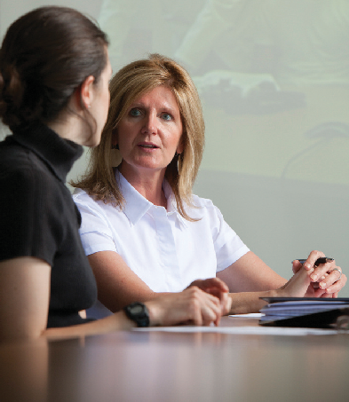
Skorton’s wife, Robin Davisson, PhD, will retain University ties for 2015–16

Weill Cornell Medicine: Could you talk about your future plans?
Robin Davisson, PhD: We’ll be moving to D.C. in late June, but I’m staying on at Cornell for an additional year. I’ll be commuting back to Weill Cornell and to Ithaca frequently to continue my labs’ research efforts and finish up some NIH-funded projects, including one on the role of the brain in obesity. Maybe most important is making sure that the people in the labs—the postdocs, techni-
cians, and other personnel—have a soft landing to the next step in their careers.

WCM: Will you be continuing your collaborations with Cornell faculty?
R.D.: As of the end of June 2016 I’ll no longer be doing laboratory research; I’m making a career change. So it won’t be collaboration in the usual sense, but I do look forward to continued intellectual collaborations.

WCM: What new career will you pursue? R.D.: I hope to use my background and skills in science in the context of policy or non- profit work. So I’ll still be doing science, just

orthopaedic surgery, and I would credit
neurosurgery and orthopaedic surgery for reaching out to the engineering school. Another element is that Cornell Tech has as one of its concentrations a hub on healthier living; Deborah Estrin, the first faculty hire, has a joint appointment at the medical
in a different arena.

WCM: As you look ahead to your life in D.C., what are you most excited about?
R.D.: I’m excited to be in a place where there are so many opportunities in policy and non-
profit work. Also, of course, I’m excited to be
U PHOTO / CORNELL

Intercampus investigator: Robin Davisson, PhD, works with a graduate research assistant at the College of Veterinary Medicine in Ithaca.

school. And finally, Laurie Glimcher has
been great force for cohesion. I did use the bully pulpit to talk about it, but a lot of those seeds were planted already.

WCM: Why did you want to take the Smithsonian job?
D.S.: First, I am a strong believer in term limits for university presidents. Obviously, we’ve had examples of people at this very campus who were president for a long time and did a phenomenal job. But in general, the outside limit should be about
involved with the Smithsonian. My representational role as David’s spouse will be sig- nificant, and I’m looking forward to that. I’ve already begun to learn a lot about the Institution; I’ve focused on tours of the research laboratories and speaking with staff scientists. David and I have been making our way through the museums; we started with the least visited and are working our way to the most visited.

WCM: Is there anything you’d like to add?
R.D.: It’s been a total pleasure to be a member of the medical school community. My work took many different directions and flourished as a result of my interactions with my colleagues there. I’m proud to have been a member of the faculty of such a great college and university.

Talk of the Gown

about science and don’t pay enough attention to humanities, arts, and social sciences. The Smithsonian touches everything under the sun—from the unbelievable Asian art collection in the Freer and Sackler Galleries to Air and Space, Natural History, the nine research centers. It has such a broad range of discovery and inquiry.

WCM: What does the Secretary do, exactly?
D.S.: It’s the chief executive. The Institution
has undersecretaries for science; for history, art, and culture; and directors of the units. My responsibilities will be a lot like an executive of any decentralized organization.
WCM: Are there particular objects in the collection you’re excited about? Inquiring minds want to know if you’ll get to wear Fonzie’s jacket while sitting in Archie Bunker’s chair.
D.S.: That’s hilarious. You know, this is
going to sound corny, but I think the collection is such a public trust of the United States, it’s important that I don’t take advantage of that. There are 138 million things, so no matter how long I would stay as secretary, I would only have a chance to touch, so to speak, a tiny fraction.

WCM: What plans do you have for your medical career?
  - .: I don’t know yet. I’ll apply for a
license in D.C. and renew my license here; I always want to be attached to the medical world in some fashion. I won’t have time to have a practice. But I’ll try to keep up with things, I’ll read my journals, I may go to some grand rounds. It’s a wonderful medical city, but you won’t be queuing up to make an appointment with me.

WCM: Anything else you’d like to add? D.S.: I would like to thank the faculty, students, staff, alumni, and leadership at Weill Cornell. When I go there to do a little teaching or see patients, they’ve been welcoming and wonderful. It has meant a lot to me, and I’ll miss that.
— Beth Saulnier

Through the Eyes of a Child

An emerging therapy—and close collaboration between specialties—preserves vision in kids with a rare syndrome

few years ago, Shaquasia Butler lived through a mother’s nightmare. She had brought her seven-year-old daughter,
A
Qar’zma, to the doctor for a simple case of strep throat and gotten a pre- scription for an antibiotic. But as she put Qar’zma to bed, the girl’s skin erupted all over in terrible hives, as though she were being scalded. Terrified, Butler immediately rushed her to a Brooklyn hospital, where doctors eventually diagnosed Stevens-Johnson Syndrome (SJS)—a rare, debilitating, and even deadly condition that predominately strikes children.
In SJS, the injury is similar to a burn: skin sloughs off and mucous membranes cease to function. Swallowing becomes painful, blinking is excruciating, and the cornea is soon damaged. First identified in the 1920s, SJS is often triggered as a severe allergic reaction to common antibiotics. Exactly why is still a mystery, one with terrible consequences. Fortunately, though, Qar’zma was a short ambulance ride from NYP/Weill Cornell, home to the William Randolph Hearst Burn Center—one of the country’s largest such units—and an ophthal- mology department pioneering a novel treatment

that is saving children’s sight. That work is being led by Kimberly Sippel, MD, associate professor of ophthalmology and an expert in ocular surface disorders.
Sippel is one the first clinicians to use amniotic membranes as a key part of acute eye treatment. Translucent sheets of amniotic tissue are laid on top of the cornea, then sutured in place—providing a highly bio-compatible, pro- tective barrier that gradually melts away, sparing further damage to the cornea and minimizing the eventual accumulation of scar tissue. (The amniotic technique complements more con- ventional treatments, such as application of topical corticosteroids.) Why amniotic tissue is so effective is not completely understood—it’s possibly due to its growth factors or to its specialized structure, which acts as a scaffold for dividing cells to grow on—but it has been used for years to treat burns and other eye conditions. Sippel’s success with SJS patients has helped make the treatment the emerging standard of care. In a 2010 American Journal of Ophthalmology article, she and colleagues reported on eight patients with significant improvement (none went blind or had significant scarring), more than all others treated elsewhere at the time. But

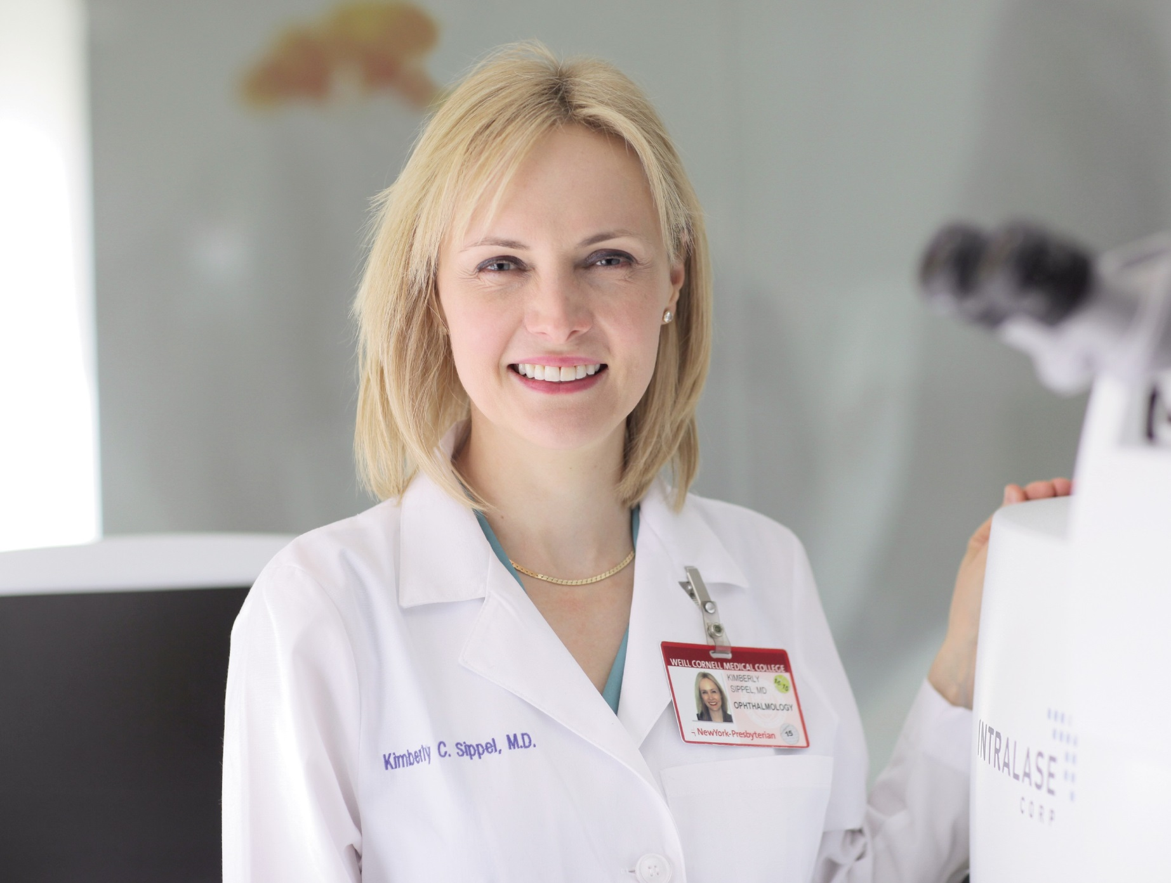
ABBOTT

for the technique to become standard practice, it will require closer cooperation between burn units and ophthalmologists at hospitals nation- wide. It means applying the eye treatment in the acute phase, even as the patient’s life may be hanging in the balance. “Are ophthalmologists going to argue forcefully enough to take someone who has just been ambulanced in with Stevens- Johnson to an operating room right away?” wonders Donald D’Amico, MD, the John Milton McLean Professor of Ophthalmology and chair of the department. “For many ophthalmologists confronting the complexity of these patients in an ICU, the strong tendency is to delay more aggressive interventions for a day or two, and unfortunately the window for success may pass. We need to understand that at times these new therapies demand that we do things that are a bit out of our comfort zone if we are to secure the best long-term results for these patients.”
That takes working closely with burn experts—and Weill Cornell’s burn unit has been receptive to these earlier ocular interventions,
yielding important dividends. “It is so gratifying that these kids are often OK in the end; they can go back to be being kids, they can go back to regular school,” Sippel says. “Otherwise, if they are not blind, they are in pain, they don’t have normal lives—that’s often what happens.”
That’s a fate Qar’zma was spared. With help from the Boston Foundation for Sight, she was fitted with custom-made contact lenses that continually hydrate the ocular surface—the eye’s mucous membranes do not recover—and was soon able to rejoin her schoolmates. Today, more than four years later, she is an avid reader, even winning an award for reading more than her peers. While vision in her left eye is limited to 20/40, Sippel says, her right eye is fully correctible to 20/20. “Dr. Sippel being there every step of the way made an extremely big difference—she is the reason why Qar’zma can see now, as well as she can,” Butler says. “I can’t thank her enough.”
— Ken Stier
Kimberly Sippel, MD

Talk of the Gown


Wake-Up Call

An anesthesiologist traces the pathway back to consciousness
E

ven after years in practice, Alex Proekt, MD, PhD, still finds it remarkable that anesthesiologists like him can induce a coma-like state,
allowing patients to undergo surgery without feeling pain. But Proekt’s amaze-
ment doesn’t end with putting people under; he’s equally awed by how they wake up. As he puts it: with billions of neurons that interconnect in myriad, complex ways, it’s astounding that patients regain consciousness and are exactly as they were before. “The total number of activity patterns that the brain can produce is absolutely enormous,” says Proekt, assistant professor of anesthesiology. “It’s essentially infinite—yet the brain is able to navigate this landscape to find its way back to a normal state. That’s not at all trivial.”
The process is also far more complicated than previously thought, as a new study that Proekt spearheaded now proves. Scientists have long assumed that the brain returns to full function in a gradual, linear fashion as anesthetic drugs wear off. Instead, Proekt’s findings, published last summer in the Pro- ceedings of the National Academy of Sciences, reveal that the brain reboots erratically, powering through a series of distinct states to reach wakefulness. “Brain activity doesn’t change smoothly—it changes abruptly,” explains Proekt. “And it’s not necessarily a direct path.”
To understand the strategy that the brain uses to navigate its way back to consciousness, Proekt and his research team administered the anesthetic isoflurane to rats and then slowly decreased the amount, as is done to humans during a medical procedure. As the rats recovered, the team measured electrical activity in regions of the brain associated with sleeping and waking; recordings of this activity, known as local field potentials (LFPs), look similar to that of an electroencephalogram (EEG). Proekt and his colleagues found that this neuronal activity happens in clusters, and that the brain transitions from cluster to cluster in unpredictable bursts. Each animal’s brain took different routes as it moved from unconsciousness to consciousness—but in all of the rats, researchers identified a few hubs of activity that link otherwise disconnected clusters. In other words, the report concluded, the brain must eventually arrive at these specific hubs in order to awaken.
Proekt compares the process to the way a metropolitan transit system works, with a set map that restricts the places where one can travel. “There are different stations and you can take different

subway lines to get to a destination,” he says. “But if you want to change from one train line to the other, you have to go through a hub—like Grand Central Terminal—that connects them.”
While the study shows that these so-called hubs exist, it’s still unclear why they’re there—and researchers don’t yet know what prompts the brain to suddenly shift from one state of activity to another. As Donald Pfaff, PhD, head of the Laboratory of Neuro- biology and Behavior at the Rockefeller University and a study co- author, puts it: “It’s like knowing Mars is out there, but we’re just beginning to know what its composition is.” Such knowledge could help anesthesiologists pinpoint when a patient is about to wake up; currently, doctors can’t know with complete certainty whether someone is fully unconscious. Proekt says that cases of those who are partially awake during surgery are rare, but “some of those patients who have these conscious experiences go on to be really traumatized.”
The study could have great significance, too, for patients with a brain injury or neurological disease. Proekt says that if scientists can understand why the brain leaves one state of activity and segues to another, perhaps a therapy can be developed for comatose patients. “What this implies is that we might be able to repair the pathway toward consciousness,” he says, adding, “Perhaps a person is trapped in a state of depressed consciousness because some of the subway lines, if you will, are blocked.”
But to aid such patients, researchers must first determine whether this phenomenon exists in human brains. Nicholas Schiff, MD, the Jerold B. Katz Professor of Neurology and Neuro- science in the Feil Family Brain and Mind Research Institute and co-director of the Consortium for the Advanced Study of Brain Injury at Weill Cornell, hopes to apply Proekt’s methods to human subjects in his own studies. “Out of the large number of config- urations in this vast space, Dr. Proekt and his colleagues looked to see if there was a standard path the brain took, like a road in the forest, and found evidence for it,” Schiff says. “Their results suggest a robustness—that there’s something consistent in the brain that we could potentially understand from a biological point of view. And that’s very exciting.”
— Heather Salerno

The Transporter

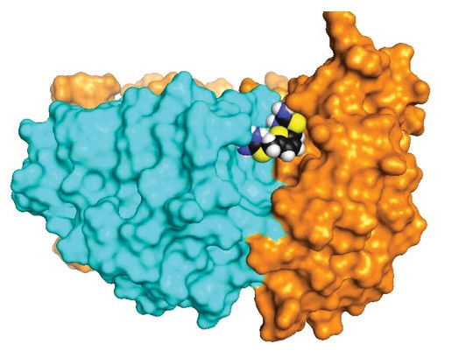
Could ‘retromer’ be the key to Alzheimer’s treatment?

key to cellular function—and to life itself—is the movement of proteins and lipids within a cell. As these substances follow their paths, a part of
A
NATURE CHEMICAL BIOLOGY/LAB OF SCOTT SMALL, MD, COLUMBIA UNIVERSITY MEDICAL CENTER
the cell called the endosome acts as the traffic hub, sorting them to be recycled, diverted, secreted, or degraded. When the endosome sends them to be recycled back to the cell surface, a

Brainstorm: Gregory Petsko, DPhil (below), is studying the retromer protein complex, seen at left in blue and orange. The multicolored molecule at its center represents one of a new class of compounds that can stabilize retromer, pointing

complex of proteins plays a role like that of a school crossing guard: it encircles them and helps them on their way. That complex is known as retromer—and its performance may be key to treating Alzheimer’s and Parkinson’s diseases.
Last spring, in a paper published in Nature Chemical Biology, biochemist Gregory Petsko, DPhil, revealed a potential new therapeutic approach for these devastating neuro- degenerative diseases—one that boosts the function of retromer. In an editorial highlighting the work, Science noted that the results, while preliminary, have impressed veteran researchers in the Alzheimer’s field. As one neurologist told the journal: “The new pro-retromer drug is brilliant.”
Petsko, director of the Appel Alzheimer’s Disease Research Institute and the Arthur J. Mahon Professor of Neurology and Neuro- science in Weill Cornell’s Feil Family Brain and Mind Research Institute, began his work on retromer function a decade ago, not long after retromer was discovered in yeast cells in 1998 and in mammalian cells in 2003. “We were looking for an approach to Alzheimer’s research that was different from what other people were doing, an approach that got to something fundamental in the cell,” says Petsko. He found it by collaborating with Scott Small, MD, a neurologist at Columbia who in 2004 found that retromer levels were low in the area of the brain where Alzheimer’s originates; other collaborators have found that genes active in Alzheimer’s disease regulate retromer levels.
Retromer transports amyloid precursor protein (APP). It’s a protein thought to be
essential for the health of brain cells—but which, when it breaks into fragments, becomes amyloid-beta peptide (or “a-beta”), the sub- stance that clumps into the hallmark plaques of Alzheimer’s disease. The researchers hypothe- sized that when retromer levels are too low or when retromer malfunctions, it allows APP to linger too long in the endosome—an area that’s enlarged in the brains of Alzheimer’s patients— and there APP encounters the enzyme that begins to break it down. The a-beta plaques are the final fragment of APP’s disintegration, and there is some evidence that the intermediate fragments may actually (or also) be what’s toxic to the neuron. So Petsko and his collaborators aimed to find a way to keep APP flowing quickly through the cell by increasing retromer levels. “This was a difficult problem for us experimentally,” says Petsko. “Most therapeutic studies require that you inhibit something, but it’s quite another matter to get more of it.”
He and his team turned to a strategy they’d pursued, along with the biotechnology company Amicus Therapeutics, for the treatment of Gaucher and Fabry diseases, two genetic, lipid- storage disorders that affect children. By binding a small molecule to an enzyme, they’d increased its stability, thus inducing its levels to rise; drugs based on this work are now in clinical trials. “If you made an origami bird and you wanted to keep it from falling apart, you’d tape one of the seams,” Petsko explains. “The idea would be to use a drug as a kind of molecular tape and hold the protein together more tightly.” Petsko’s lab found a site between two of the proteins in the retromer complex into which a drug could fit,
toward new treatments for
Alzheimer’s and related disorders.

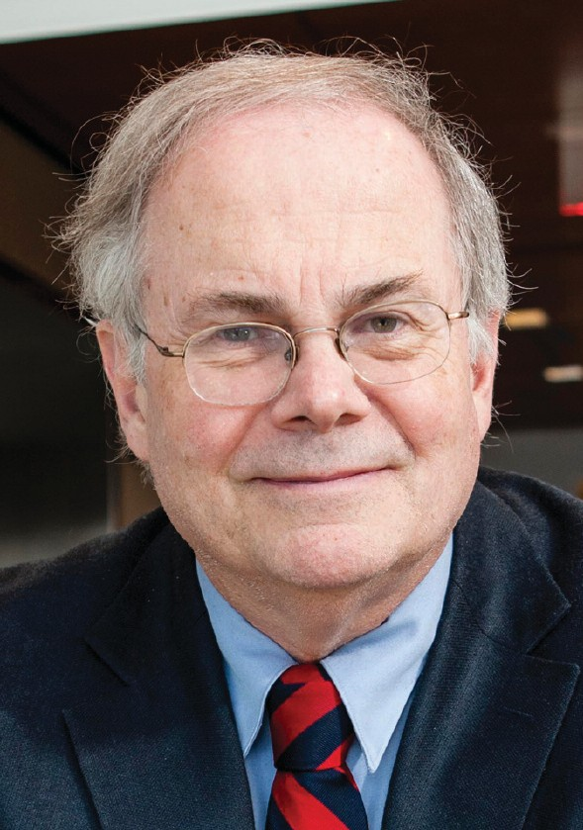
CARLOS RENE PEREZ

Talk of the Gown

interacting with both at the same time. The compound, which acts as what scientists call a “chaperone,” stabilized the retromer structure, boosted its overall numbers, and reduced levels of amyloid- beta and other APP misprocessing products in neurons. While it isn’t viable as a drug—it is not very stable and would require too-frequent dosing in humans, for one thing—it was proof of concept. “It has shown, I think fairly conclusively, that retromer deficiency is a key issue, and that there is therapeutic promise in fixing that deficiency,” Petsko says. “That tells us a lot more about the nature of the disease—that it isn’t just a protein- misfolding disease, but it also involves issues of trafficking in the cell.”
The idea that fixing an imbalance in a cell could remove the issue of toxicity is exciting, Petsko says. Rather than attacking plaques—an approach he likens to traditional thinking about cancer treatment, in which clinicians hit the disease with the equivalent of a nuclear weapon—this approach opens up the possibility for thinking about this disease in a more subtle way. “Philosophically,”

Drilling Down


PENNLIVE.COM

Petsko says, “my colleagues and I feel this has real merit.”
Petsko and his collaborators are now researching other conditions that may be affected by retromer levels, including
lysosomal storage diseases—such as

In a new book, public health expert Madelon Finkel,
PhD, explores the potential perils of ‘fracking’

Sandhoff disease, a rare disorder in which neurons are destroyed—and osteoporosis. Retromer has already been shown to play a

Unnatural gas?: A hydraulic fracturing site in Pennsylvania
The controversial fuel-extraction method

role in Parkinson’s, and the team is
currently seeking to identify the mech- anism by which it does so. That effort holds considerable promise for drug discovery, as it’s easier to design clinical trials for Parkinson’s than Alzheimer’s, given that the former is simpler to diagnose and has a well-defined pro- gression. And until scientists determine how to prevent neurodegenerative diseases completely, Petsko says, the goal is to either stop them in their tracks or turn them into manageable chronic conditions. “Alzheimer’s typically progresses over a ten- to fifteen-year period,” he notes. “If it progressed over a thirty-year period, it wouldn’t be so much of an issue. To really win, we might not have to do much more than change things a little bit.”
— Andrea Crawford
known as hydraulic fracturing is a hot
topic in states from New York to California. Supporters call the technique a safe and affordable method of obtaining
natural gas—while opponents argue that it threatens public health by polluting water supplies and exposing people to toxic chemicals.
Madelon Finkel, PhD, has been at the forefront of research into the threats that the process, also called “fracking” or unconventional gas extraction (UGE), may present to human health. But proving a causal link is no easy task, she says, because so many other factors are at play. For example, one cancer cluster in a heavily drilled area of southwestern Pennsylvania proved to be more complicated than it first appeared. “Using a fabulous database from the state health department, I can see where active and inactive wells are; I can see where the cluster is, and I have cancer data by township,” Finkel says. “And what I found is that I can’t with certainty say that people are sick because of unconventional gas

extraction. Further, I uncovered the fact that there was a huge uranium mining operation there in the Forties and Fifties. So is it the urani- um? Or is it something in the water? We know that streams get polluted because of the uncon- ventional gas process. What’s going on?”
Finkel, a professor of clinical healthcare policy and research, explores the causation dilemma and many other issues in a book enti- tled The Human and Environmental Impact of Fracking: How Fracturing Shale for Gas Affects Us and Our World. Published by Praeger in February, the volume (for which she served as editor) fea- tures chapters addressing UGE on a variety of fronts—effects on human health, implications for food safety, air quality, climate change, regu- latory issues, the toll of boom-bust cycles on communities, and more. It includes contribu- tions from several Weill Cornell faculty including Adam Law, MD, clinical assistant professor of


medicine, who discusses the effects of fracking- related chemicals on the endocrine system, and Inmaculada de Melo-Martin, PhD, professor of medical ethics in medicine, who teams up with former Weill Cornell research associate Jake Hays to tackle the technology’s ethical issues. The book also offers an industry perspective, with a chapter by an environmental health advisor from Exxon Mobil. “This is one of the more important public health issues of our day,” Finkel says. “I felt that this issue was attracting so much atten- tion—and there was a lot of misinformation out there—that I wanted to get independent experts
to write chapters based on the best evidence and present the facts as we know them.”
Finkel became interested in fracking through a daughter who lives in Pennsylvania, where the method is widely practiced. She teamed up with Law, who practices endocrinology in Ithaca, a hotbed of anti-fracking sentiment; he’d become involved in public health research about frack- ing after some of his patients expressed concern about its potential for hormone disruption. “The main thrust of what she and I have been doing has been educating people—whether they be doctors, the public, or policymakers—about the potential effect of this technology on the health of populations,” says Law, co-founder of the nonprofit Physicians, Scientists & Engineers for Healthy Energy. The two co-wrote a seminal arti- cle on the subject, “The Rush to Drill for Natural Gas: A Public Health Cautionary Tale,” pub- lished in the American Journal of Public Health in May 2011. “We were there at the beginning of this literature, and at this point it’s growing very fast,” Law says. “But a lot of questions are still unanswered.”
For Law, the issue hits close to home. Many landowners in Upstate New York leased their property for drilling, and fracking was a divisive issue for years—until Governor Andrew Cuomo announced in December that he’d ban the prac- tice on the grounds that it presents a danger to public health. And that, of course, is a finding about which the dueling sides strongly disagree. Proponents hold that not only is fracking safe, it’s essential to lowering America’s dependence on foreign oil in the post-9/11 world; opponents argue that in addition to its public health haz- ards, it contributes to global warming by releas- ing methane during the extraction process, and that drilling harms nearby communities through higher crime rates, skyrocketing rents, and other ills.
Finkel isn’t calling for a ban on fracking, which she notes would hardly be a practical goal given its ubiquity and the fortunes at stake. But if unconventional drilling methods are going to be used, she says, she wants them done safely and responsibly. With the potential perils still unknown—and the industry exempt from key environmental regulations—she stresses that solid research is essential to protecting the pub- lic. “As an epidemiologist, to me the focus on human health is of paramount importance,” Finkel says. “How do you start doing something that has such significant potential for harm without really doing your homework?”
— Beth Saulnier

‘As an epidemiologist, to me the focus on human health is of paramount importance.‘
— Madelon Finkel, PhD

Talk of the Gown

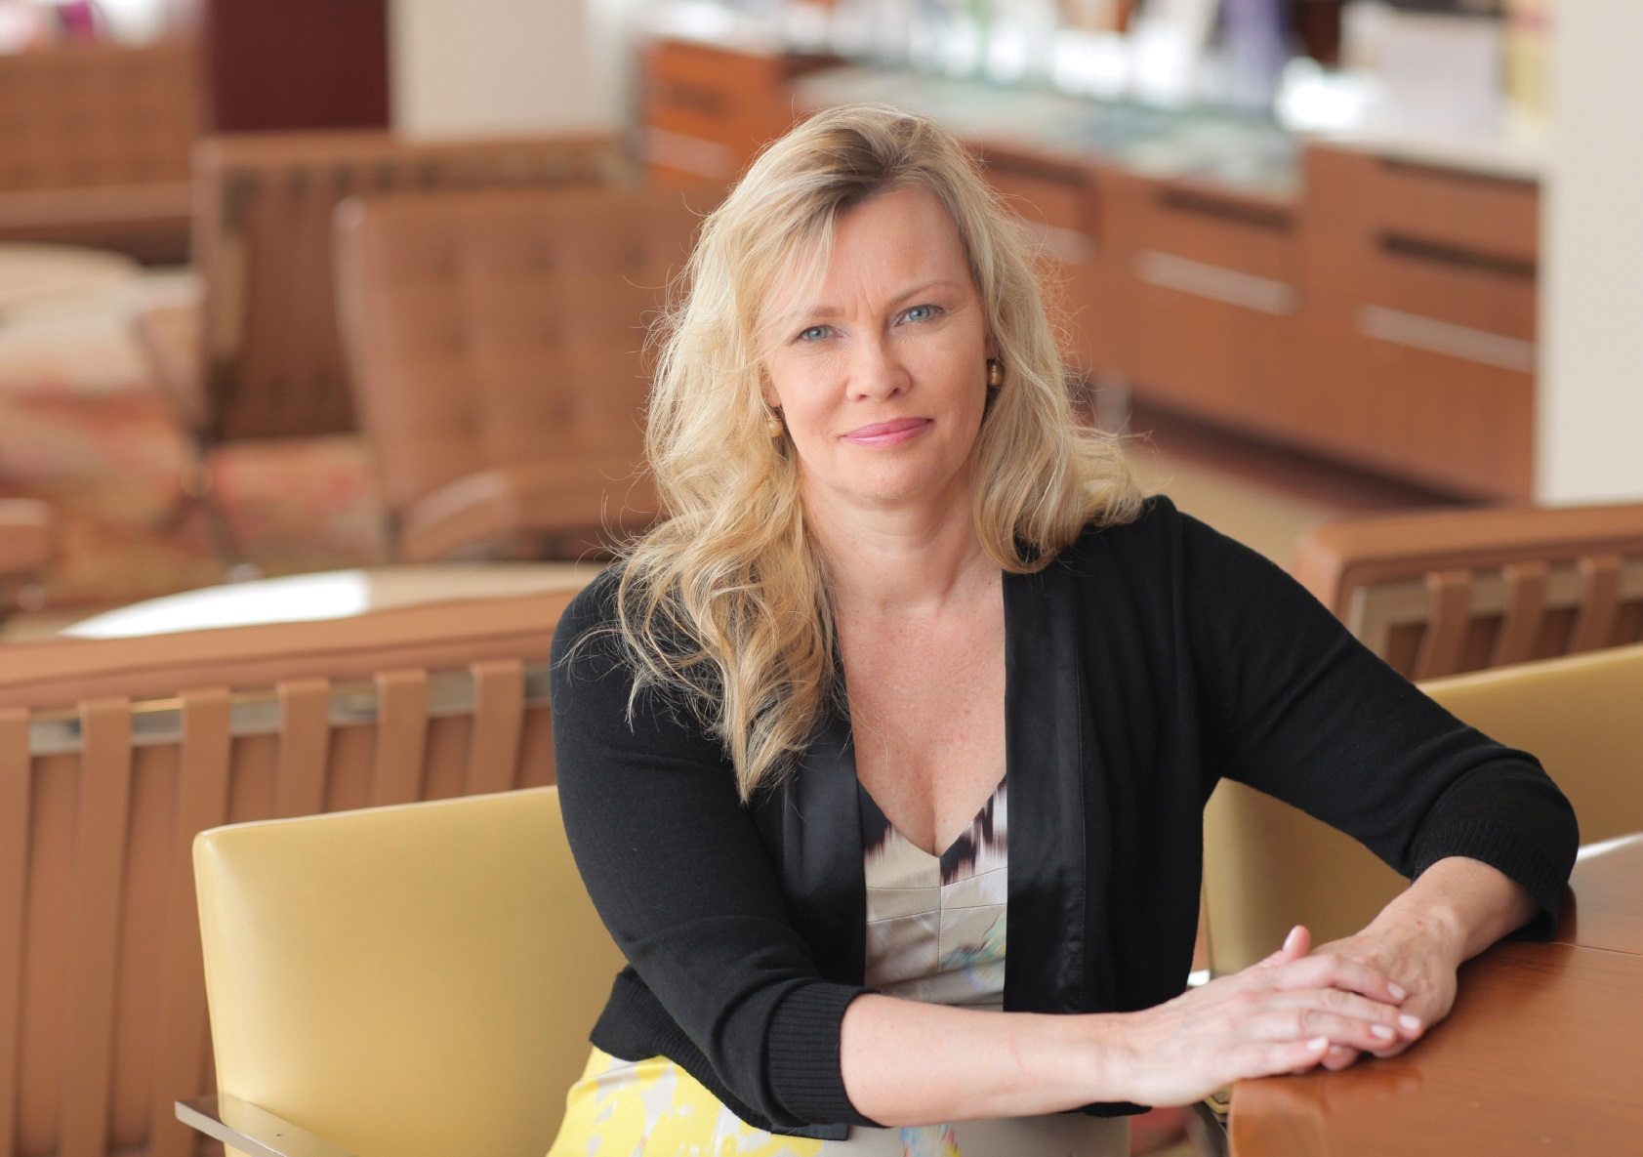
The Walking Cure

ABBOTT
Janey Peterson, EdD, RN, MS ’07

AClinical epidemiologist aims to help ailing older adults stay active

surprise gift arriving in the mail. A grandchild’s
photo on the bedside table. The memory of a long-ago college graduation. Could such small pleasures contribute to big differences in the
health and exercise habits of the sickest elderly patients?
Janey Peterson, EdD, RN, MS ’07, is betting that they can. And two leading organizations in the field of aging research are putting their money on it too, by funding her study on interventions that can help older adults with multiple chronic illnesses become more physically active, thereby improving their health and overall well-being.
Peterson is an associate professor of clinical epidemiology in medicine, cardiothoracic surgery, and integrative medicine who is trained as a registered nurse. She has gained attention from both her peers and the mainstream media for her work as a clinical epidemiologist and behavioral scientist on issues affecting older patients, from financial exploitation of the elderly to later-life pain management. In 2013, she became the only registered nurse to receive a Beeson Career Development Award in Aging Research, just 200 of which have been given over the past twenty years.
Peterson is now using the more than $720,000 she garnered
from the award (which is funded by the National Institute on Aging and the American Federation for Aging Research and supports investigations by outstanding junior faculty at medical schools nationwide) to apply lessons she has learned from her past work on motivating healthy behaviors to help a population typically excluded from clinical studies and exercise recom- mendations because of the complexity and seriousness of their health issues. “As people age, they often have multiple chronic conditions such as diabetes, congestive heart failure, or a history of heart attack,” Peterson explains. “Physicians prescribe exercise to only about a third of older adults, and research demonstrates that doctors lack training in how to offer exercise recom- mendations to this high-risk group. Older adults who have a high number of chronic illnesses have a two to three times greater risk of becoming disabled over just a few years—but physical activity can both prevent disability and improve function in older adults who have early disability.”
To take advantage of that window of opportunity, Peterson and her team motivate physical activity through an intervention she

has named PAIRE (Positive Affect Induction for Regular Exercise). Positive affect—a feeling of happiness and well-being—has been shown in non-clinical studies to promote self-efficacy, flexible thinking, and healthy behaviors, among other benefits. To induce it, Peterson uses small surprises—like the gift of an inexpensive blanket—to make patients feel good and reflect on their participation in the study. Through brief, scripted phone calls, she also encourages patients to induce positive affect on their own by thinking pleasant thoughts or looking at pictures of loved ones whenever they need motivation.
Peterson’s ultimate goal is to find out how much—or how little—exercise will make a difference for older adults facing complex health issues. She notes that for the nation, the socioeconomic stakes are high: 32 percent of Medicare bene- ficiaries suffer from two to three chronic illnesses, 23 percent have four to five, and 14 percent are struggling with six or more. And while the Surgeon General recommends at least 150 minutes of moderate to intense physical activity a week for adults, Peterson believes that much smaller amounts of regular activity can help patients with chronic conditions avoid disability and major morbidity and mortality. “People underestimate the value of regular physical activity,” she says. “My pilot data suggests that if we can get older adults with chronic disease walking just a little bit and they can sustain it, they have significant reductions in morbidity and mortality.” Moreover, Peterson notes that regular exercise can increase hippocampal mass by 2 percent over a year—meaning that new neurons are being generated in the brains of older adults—while those who don’t exercise lose 1.4 percent of their hippocampal mass. Recent work has also shown that exercise enhances DNA methylation in muscle cells, which helps explain the mechanisms by which exercise reduces the risk of disease. “My work in this area won’t be finished,” she says, “until we translate our data into clinical guidelines for physicians to use when prescribing physical activity for older adults with chronic disease.”
Peterson points to projections that more than 20 percent of Americans will be sixty-five or older by 2040. She believes that guidelines and interventions to promote exercise can help older adults take better control of their own health—and ease the national burden of caring for chronically ill patients who go on to become disabled, in large part through inactivity. Her colleagues and research partners in fields as varied as oncology, cardiology, and urology share her sense of urgency. “As the population ages, we need to find new strategies to help patients change behaviors and manage complications from serious conditions,” says John Leonard, MD, associate dean for clinical research, the Richard T. Silver Distinguished Professor of Hematology and Medical Oncology, and one of Peterson’s collaborators. “By applying a scientific approach to the develop- ment and assessment of such strategies, Dr. Peterson is making a major contribution to the field.”
Leonard notes that the implications of Peterson’s research go beyond geriatric medicine; for example, she has studied how cancers such as lymphoma affect mindset and behavior. Her current focus, on helping older adults, was inspired in part by caring for her own parents. “The more I learn from my family’s experiences and the more I work with this population, the more passionate I become,” says Peterson. “Our country is growing older and older. Every hole in the safety net, every gap in the research, is an opportunity to advance care for older adults.”
— C. A. Carlson

In Memory of Marjorie

A special patient inspires an endocrinologist to battle type 1 diabetes in Africa
H

er name was Marjorie Namayanja, and by the time endocrinologist Jason Baker, MD, met her on a trip to Uganda in 2010, she was already gravely ill with complications of type 1 diabetes. She was just twenty- nine when she passed away the following year after
suffering kidney failure—a death that could have been prevented if she’d had access to more advanced types of insulin and more con- sistent medical care. “I have no doubt in my mind that if she had been in the U.S., her diabetes would have been much better con- trolled—and if she’d developed kidney issues at some point, she would have gotten a transplant, and she’d be alive today,” Baker says. “But in that area of the world, when you develop a complication like she did, it’s a death sentence.”
Even as Namayanja grew sicker, she remained an ardent advocate for her fellow type 1 patients. And today, her memory lives on through the nonprofit that Baker established in the hope of sparing others a similar fate. With programs in three African countries so far, Marjorie’s Fund aims to empower type 1 patients in developing nations to take control of their care. “We’re not

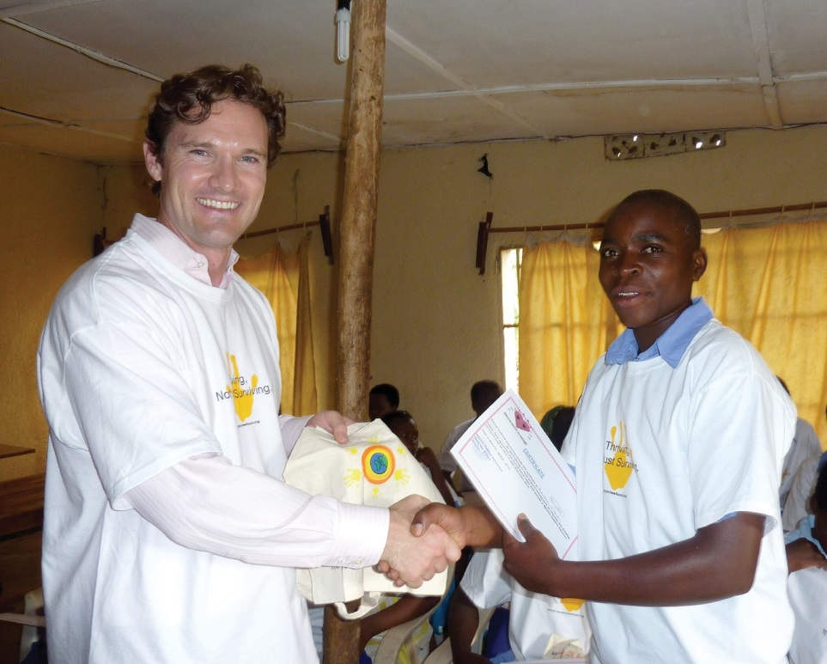
Life lessons: Jason Baker, MD (left), on graduation day for a diabetes education program in Rwanda

PROVIDED

Talk of the Gown

interested in going in with just goodwill, and giving supplies and the like,” says Baker, assistant professor of clinical medicine. “We really want to teach people how to fish rather than just giving them the fish.”
Formerly called juvenile-onset
What if I was Ghanaian? It planted the seeds of managing type 1 in these areas where air conditioning, refrigeration, and the typical diet are so challenging.” Then, after the September 11 terrorist attacks, Baker had another epiphany while helping to run a morgue at Ground Zero.

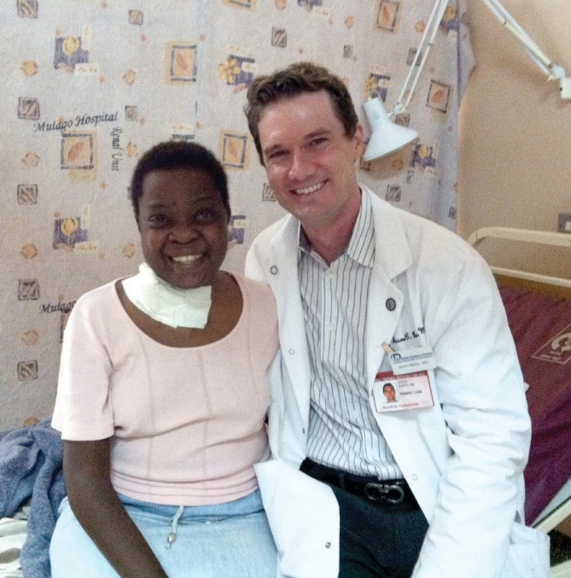
PROVIDED
diabetes, type 1 is the much rarer form of the disease; unlike type 2, it’s not spurred by risk factors like obesity and isn’t considered preventable. In Uganda, Marjorie’s Fund works with a patient-run advocacy group to support education initiatives, and in Ethiopia it helps train endocrinology fellows in the treatment of type 1. (The group also does work in India—where it supports research, educational initi- atives, and access to testing supplies— and in New York City, where it’s involved in patient advocacy and other activities.) But its major effort is in Rwanda, where it works with a local diabetes association to run a compre- hensive education program for adolescents and young adults. The program supplies participants with insulin and glucose testing strips
“I remember excusing myself and going over to a burned-out corner to check my blood sugar,” he says. “I realized that even in the most insane and unorthodox situations, I can’t ignore type
    - Otherwise, it’ll conquer me.”
Baker founded Marjorie’s Fund in 2011; run almost entirely by volunteers, it’s supported by private donations and small grants. He travels to its various program sites every few months, staying for about a week while managing his Weill Cornell patient load remotely. And last fall, he marked his fourteenth year with type 1. These days, Baker wears a continuous glucose monitor—and he’s been known to show his read-outs to his patients to demonstrate that even with his advanced knowledge, his blood sugar levels sometimes go high. “He’s a terrific role model,” says colleague Madelon Finkel, PhD, professor of clinical healthcare policy and research and director of the Office of Global Health Education. “He’s a caring endocrin-

In her honor: Baker with the late Marjorie Namayanja
during their stay, and offers lessons in diabetes management and nutrition; it also provides vocational training in fields like sewing, baking, and hairdressing, so graduates have the means to afford their own treatment resources once they go home. “They don’t just get the education—they get the tools to actually use it,” Baker says. “We’ve started to see really good outcomes: decreased rates of complications, fewer hospitalizations, and lower hemoglobin A1c levels, which are average blood sugar levels.

‘They don’t just get the
ologist to his patients, but he also has a broader view of expanding treatment and education to those less fortunate. This is also great from a global health perspective, because it shows our medical students that you really can make a difference. It’s not just going someplace for a couple of weeks and forgetting about it. He lives this.”
Among the students whom Baker has mentored is Amare Assefa ’16, whose research grant Marjorie’s Fund supported. The summer after his first year at Weill Cornell, Assefa traveled to his native Ethiopia in an
attempt to understand why the mortality rate for type 1 there is so grim. He surveyed nearly 200 subjects,

education—they get the tools
to actually use it.’
split between sites in the capital of Addis Ababa and the smaller town of Gondar. In addition to conducting a basic health screening, he asked questions about the treatment they’d

So we’re working to enhance that program, and we hope to take it to other sites.”
For Baker, diabetes management isn’t just a professional issue; it’s a profoundly personal one as well. He was diagnosed with type 1 at age twenty-five, as a third-year medical student at Emory University. The following year, while in Ghana for a six-week radiology project, he got his first taste of what it’s like to live with type 1 in a developing country. “It was a huge learning curve for me to manage myself in this environment,” Baker recalls. “It really started me thinking, What if I lived here full time?
received, their attitudes toward their disease, their knowledge of proper management, and more. Among his distressing —if unsurprising— findings were a severe lack of patient education and blood-sugar testing gaps as long as six months. “It opens your eyes,” says Assefa, whose parents and two sisters suffer from the type 2 form of the disease. “It was something you had to see for yourself. You feel for the people, but you feel for the healthcare providers as well. There are so many patients who need help, and only so much you can do.”
— Beth Saulnier


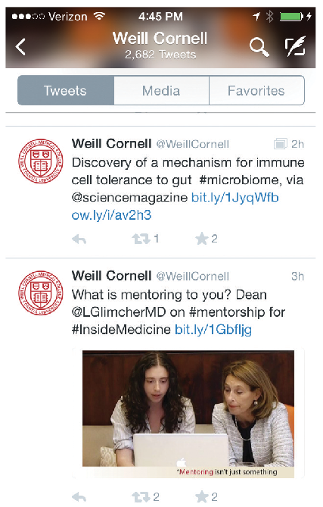
The Tweet Life

Faculty are becoming more social-media savvy

espite Twitter’s broad appeal and millions of users, John Leonard, MD, the Richard T. Silver Distinguished
D
Professor of Hematology and Medical Oncology, had little experience in using it professionally. But that changed last fall, when he attended Weill Cornell’s inaugu- ral Social Media Summit. Today, Leonard is a shining example of the effective use of social media by physician-scientists, the event’s organizers say—and Leonard, who is also the director of the Joint Clinical Trials Office and associate dean for clinical research, is happy to be tweeting, too. “I’m using Twitter every day now,” he says. “It’s a quick way for me to catch up on research and to keep up with what’s happening at Weill Cornell and elsewhere.”
Tweeting from @JohnPLeonardMD, he has amassed more than 500 followers who now have access to his thoughts on new research and endorsements of col- leagues’ accomplishments. “I have found it to be a fun, nice way to reach out to a reasonably broad audience,” he says. But it’s not just about sharing. Social media offers a way for Leonard and others in the medical community to engage in an online conversation—a back and forth that’s as much about taking in informa- tion as it is putting it out there. “It has connected me with colleagues and patients,” he says, “helped to publicize our clinical and research programs, and allowed me to learn about ideas and activities of many others, both within my field and from outside areas of interest."
Social media is playing an increasingly vital role in research and clinical care. Twitter, LinkedIn, Facebook, and other social media platforms can facilitate collaboration, spread the word about new discoveries, aid in recruitment for clinical trials, help doctors connect with pros- pective patients, and much more. Social media’s growing importance in the medical sphere prompted Weill Cornell’s Office of External Affairs to host the summit, which included thirty-eight

hand-picked faculty members. “We chose a range of faculty who were familiar with social media to meet with colleagues who are relatively new to it,” says Larry Schafer, vice provost for external affairs. “We wanted to show how social media can help them amplify their scientific messages.”
In a period of shrinking federal grants, as Dean Laurie Glimcher, MD, noted in her remarks at the summit, it’s of the utmost importance for institutions like Weill Cornell to tell the public what they do and why their work is necessary. Online platforms offer an immediate and direct way to highlight cutting-edge work. “Social media provides us with a valuable forum to further emphasize our scientific messages and to showcase Weill Cornell’s reputation as a leader in biomedical research, clinical care, and medical edu- cation,” she said.
Schafer says that in the aftermath of the summit—which included talks and hands-on activities in small groups—there was a surge in the use of Twitter, LinkedIn, and microblogs among Weill Cornell faculty. Its success makes it likely that similar events will be held in the future, he says, stressing that professors are being encouraged to adapt social media use to their own needs and interests, not the other way around. “If a faculty member’s communication style is a PowerPoint presentation to 300 people in a lecture hall, they can use social media to get that lecture out to a wider audience,” Schafer says. “We’re not asking anyone to switch from e-mail to Twitter, but to give social media a chance to prove itself.”
These days, he says, more professors are seeking tactical and practical support on the subject from experts in External Affairs, and some departments and divisions are embracing social media to better publicize their patient care and research activities. “Branding their services is important,” Schafer says. “When they open a new clinic or office, that news has to get out to the lay person. And scientists in general could be doing a better job of explaining why their

research is important, especially to the general public.”
Brendon Stiles, MD, an associate professor of cardiothoracic surgery, was among the more media-savvy participants going into the summit. His goal in attending, he says, was to optimize his use of Twitter with networking utilities like LinkedIn. But as it turned out, the summit was a great forum for meeting colleagues he’d previously encountered only online. Stiles, who specializes in lung cancer surgery and tweets to his more than 700 followers from @BrendonStilesMD, notes that sharing best practices is vital to advancing his work as a researcher and a teacher. And he and Leonard both emphasize that it’s important to monitor information on medical websites perti- nent to their fields. Patients, they say, can Google themselves into a state of fear and frustration searching for information on their diseases and conditions. Twitter can help doctors serve as gatekeepers, halting the spread of misinformation and dir- ecting patients to sites that can help them. “Twitter can assist doctor-patient relations when I can’t be there in person,” Stiles says. “If I direct an individual to a lung cancer advocacy link, the patient knows I’m thinking about them—that even though I’m not physically with them, there is a human out there working
for their well-being.”
— Franklin Crawford

Rough Waters

A new program explores the lingering effects of Superstorm Sandy

Sandy Mobilization, Assessment, Referral, and Treatment-Mental Health (SMART-MH)—is designed to assess how well older residents displaced by the storm are doing, and help connect those in need with appropriate services and counseling.
With $1.4 million in FEMA funds, SMART-MH has hired and trained an interdisciplinary team of two dozen outreach workers. Many are bilingual, speaking such languages as Spanish, Cantonese, Mandarin, Russian, Japanese, and Farsi. Armed with
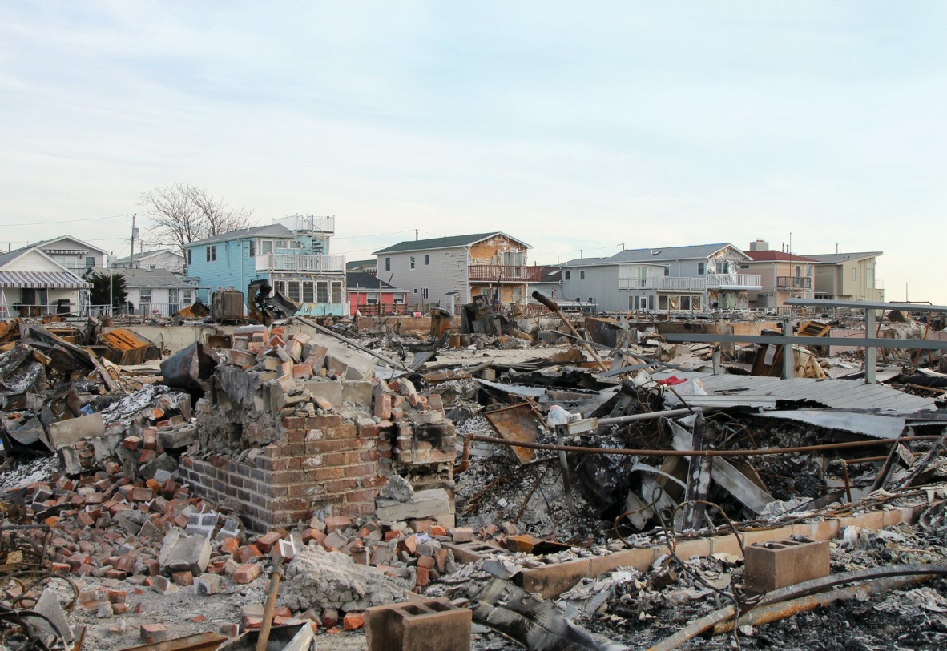
dedicated mobile phones and note- book computers, these clinicians, social workers, and student trainees can enter data on the spot and, when merited, make immediate referrals for counseling or support services. The outreach began last fall, and by year’s end had assessed more than 100 individuals; the project runs through September.
After the storm: The neighborhood of Breezy
Point, New York, was especially hard hit.
In addition to documenting the ongoing concerns of Sandy victims— and essentially putting them on an emergency services map should another storm strike—another goal of SMART-MH is to function as a social services matchmaker. One of those contacted is Birdella McGreachy, a seventy-year-old African American and lifelong New Yorker. McGreachy spent two days without power or running water in her sixteenth-floor Coney Island apartment, which is located a block from the beach and boasts views of the Atlantic. She

LEONARD ZHUKOVSKY / SHUTTERSTOCK.COM

M
moved in with her sister in an unflooded part of Brooklyn, but relations grew tempestuous as her stay

ore than two years after the floodwaters of
Superstorm Sandy receded, it’s not only homes that remain unrepaired. Less visibly, the lives of many New Yorkers disrupted by the stress and physical destruction of that
epic event are nowhere near back to normal. Especially impacted were senior citizens. How many are still suffering? What services do they need?
Those are some of the questions that a recently launched service project hopes to answer. “There’s emerging data out of New Orleans after Hurricane Katrina that the mental health effects are long-standing,” says the project’s designer, Jo Anne Sirey, PhD, associate professor of psychology in psychiatry, who explains that major storms strike especially hard at adults over sixty who have pre-existing mental health conditions. “But even individuals who may not be suffering from depression, anxiety, or alcohol abuse watch the news, and when we head into another hurricane season it brings back a kind of anniversary response and they worry.”
Sirey estimates that at least 10 percent of the 500,000 older residents in the five boroughs may still suffer Sandy aftereffects. By interviewing as many as 2,000 New Yorkers, the project—dubbed
pushed into the second week. Nor did finally putting the key in her
own front door return McGreachy’s life to normal. The elevators to her building weren’t working for the first couple of days, so she had to take the stairs, carrying up food from the Red Cross truck parked across the street. “I look at the ocean every day, and I think, it’s so beautiful but so deadly,” she says. “That storm put the fear of God in me. It was like the beach came to the people instead of the people going to the beach. The other day, when it was raining so hard and they were calling it a Nor’easter, that was nothing. But I’m always watching that water.”
McGreachy and her SMART-MH outreach worker have discussed the possibility of counseling, and he put her in touch with a city social worker to address a difficult family issue unrelated to the storm. He’s also arranging for assistance in cleaning her apartment and getting groceries; before the storm, she got shopping help from a nearby senior center, which only recently reopened. “As we’re meeting with senior centers, mental health providers, and faith- based communities, we’re hoping we’ll leave behind some connections that didn’t exist before,” Sirey says. “We’re creating relationships that may live on beyond this program.”
— John Grossmann

Follow the Bouncing Ball

Maccabiah Games medalist Matthew Simon, MD, is a table tennis whiz

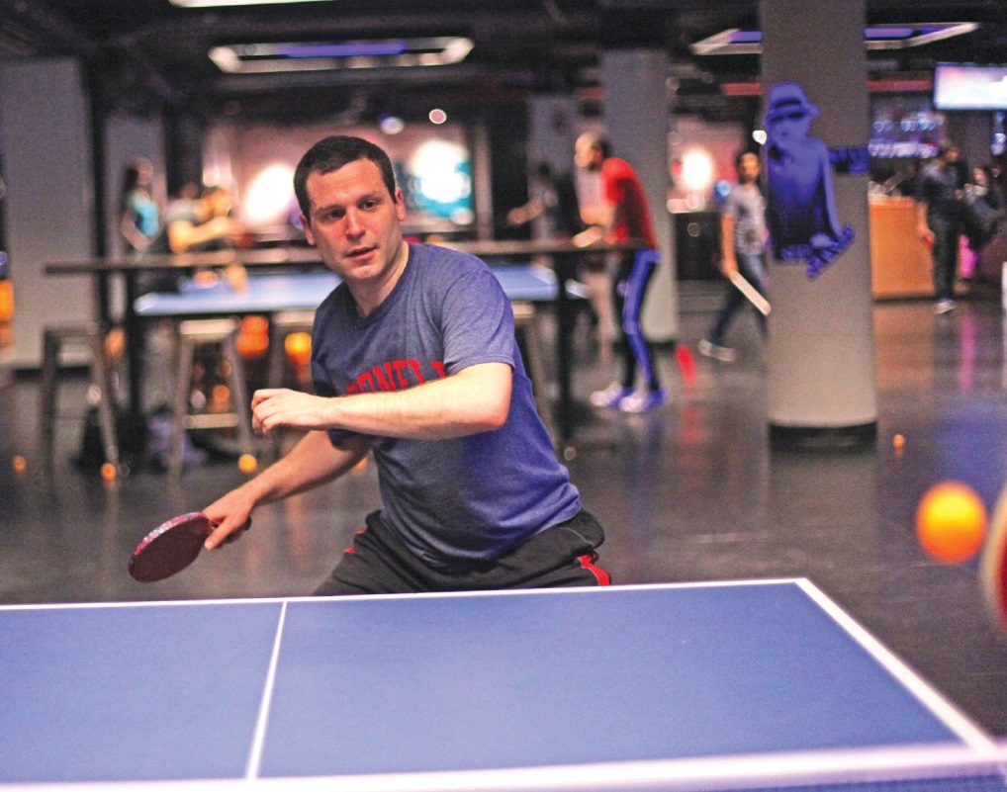
What do infectious disease

ABBOTT

and internal medicine
have to do with compet- itive table tennis? Not a lot. And that’s one
reason why Matthew Simon, MD, loves the game. “Ping-pong is so totally different from what I do as a doctor,” says Simon, an assistant professor of medicine and of healthcare policy and research and a member of the Division of Infectious Diseases. “And it’s simply a great stress reliever.”
Simon is no casual player. He’s a former Junior Olympian and top-ranked paddle master whose aggressive game and tricky forehand lend new meaning to the phrase “spin doctor.” Last summer, Simon played for Team USA at the nineteenth annual Maccabiah Games in Israel, commonly known as the Jewish Olympics. Team USA won the bronze after toppling the U.K., ping-pong’s country of origin.
It was a highlight of an athletic career that began in the family basement in Syracuse, New York, when Simon was twelve. Eventually his father, an internist, introduced him to competitive ping-pong at places like the Polish American Citizens Club, a far cry from the family den. “Watching the games was just mesmerizing,” Simon says. “There was this whole underworld of competitive table tennis that I discovered.” From the local table tennis club in Syracuse, he went on to hone his skills at ping-pong camps and tournaments; by high school, he was nationally ranked in the top fifteen among players under sixteen. Simon continued to play competitively in college, helping start a team at the University of Pennsylvania. He took a seven-year hiatus from the sport during medical school and residency, but picked it up again when the Manhattan table tennis club Spin opened in 2009. By 2013, he was back in form and qualified for the Maccabiah Games, training and practicing several evenings a week.
What began as a leisurely British parlor game in the nineteenth century is now one of the fastest ball sports in the world—particularly given the close quarters in which it’s played— with projectiles traveling up to eighty miles per hour across a nine-by-five-foot surface. “It’s

fantastic exercise, but it’s not just about speed,” says Simon. “A lot of the game is strategy. It’s as much mental as physical.” Simon likens it to a mix of boxing, running, and chess. “You have to think fast and think ahead.” Even if there is little direct connection to his profession, those are transferrable skills—and Simon has used them well. In spring 2013, he collaborated with New York City’s Department of Health in responding to an outbreak of meningitis; last fall, he helped NewYork-Presbyterian Hospital deal with the Ebola threat.
Considering the demands of his day job, Simon has thought of retiring from the competitive ping-pong circuit. But he says he’ll keep working on his game, in part because the sport has a rejuvenating quality. “When I’m playing, I meet a completely different circle of people, from all nationalities and walks of life,” he says. “I love how the sport brings together people from such diverse backgrounds. So the game and my work do relate. Table tennis helps refresh my desire to find out what’s unique about each of my patients.”
— Franklin Crawford

Good sport: Matthew Simon, MD, practices at a table tennis club in Manhattan.

Researchers explore the microbiome, medicine’s newest frontier

he most exciting discoveries can begin with the humblest material— and for researchers in the lab of
T
immunologist David Artis, PhD, that often means mouse droppings. Once an obliging rodent provides a stool sample, a technician uses a chemical buffer to break down bacterial cell walls, unleashing the coils of DNA within. After further chemical preparation to enrich the genetic information, the sample is fed into an Illumina MiSeq, a desktop machine half the size of an office photocopier that, over the course of about forty-eight hours, sequences billions of base pairs to reveal a catalog of hundreds of types of bacteria: the mouse’s microbiome. “After painstaking collection and preparation, you load your samples and allow the machine to run overnight,” explains post- doctoral researcher Lisa Osborne, PhD, who has analyzed her share of murine fecal bacteria in the name of better understanding how the microbiome works in humans. “A lot of sophisticated magic happens inside that box.”

Symbiotic Relationship

By Amy Crawford
Portraits by John Abbott
The technology may not look flashy, but it’s enabling a revolution in how scientists think about the bacteria that share our bodies—no longer as mere pathogens, but as members of a tiny ecosystem that coevolved with us, and on which our health depends. Artis and his colleagues hope these communities of microbes can offer insight into one of the most confounding prob- lems in modern medicine: the set of painful chronic conditions known as inflammatory bowel disease (IBD). But IBD is not the only reason scientists at Weill Cornell and elsewhere are increasingly interested in microbiota. It turns out that the human microbiome may have far-reaching impact throughout the body, influencing how our immune systems develop, how our food is metabolized— and even, perhaps, the peculiarities of our personalities. New knowledge about the complex web of relationships between humans and the microbes that live within us is calling into

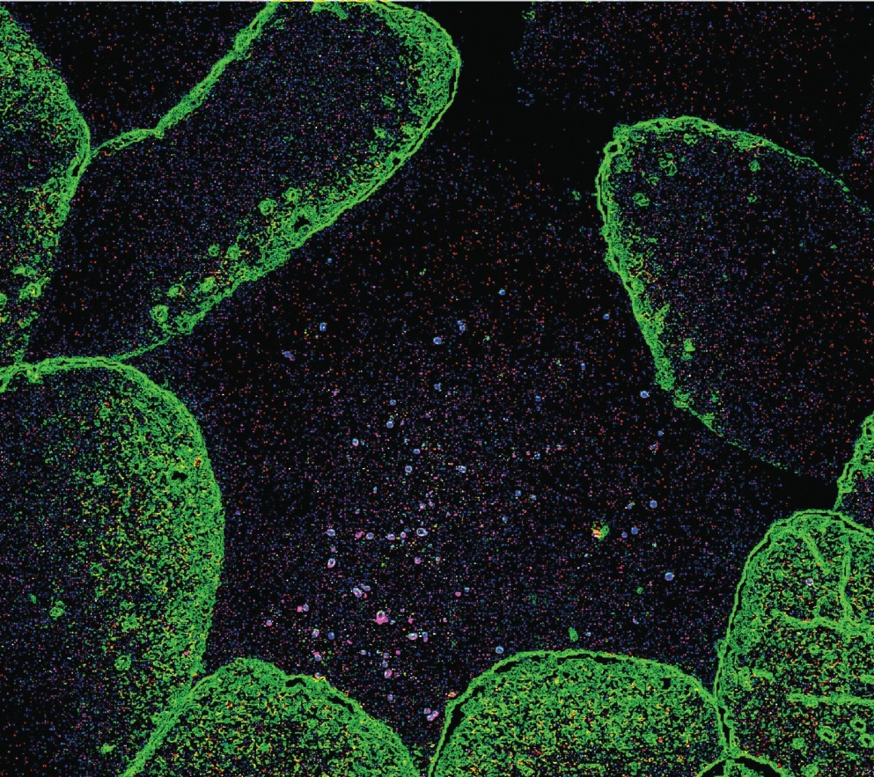
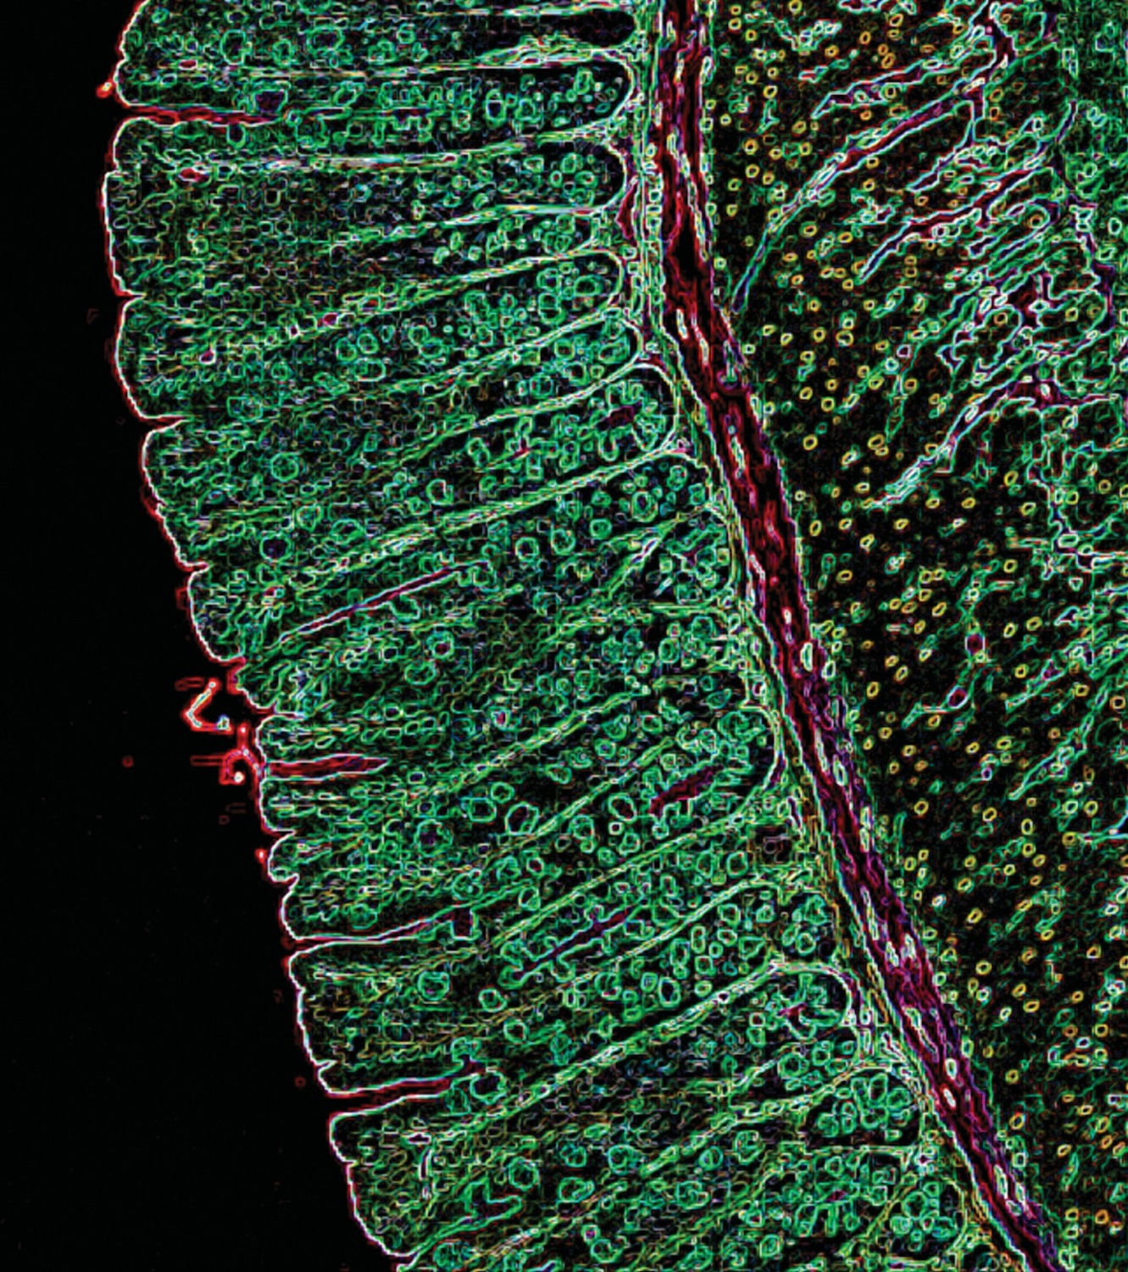
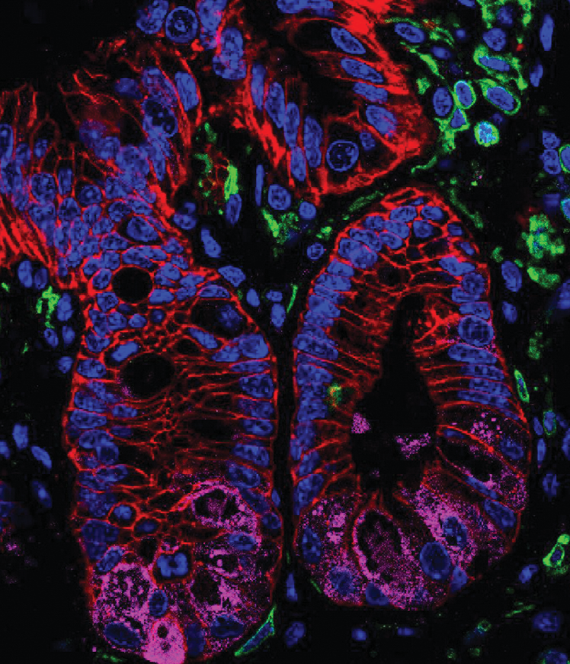

Digestive systems:
A color-enhanced image (left) of the intestinal epithelium that lines the gastro-intestinal tract of a mouse. Below left: a stained histologic section of intestinal tissue isolated from healthy mice. Below right: a color-enhanced tissue section from a healthy mouse showing the presence of normal microflora.
GREGORY SONNENBERG, PHD; DAVID ARTIS, PHD, WEILL CORNELL MEDICAL COLLEGE

question not only our understanding of disease, but of what it means to be human. “This is one of the major topics in contem- porary biomedicine, and it’s profoundly reshaping the way we think about health and disease and individuality,” says Carl Nathan, MD, the R. A. Rees Pritchett Professor of Microbiology and chairman of microbiology and immunology. “I grew up thinking that a given person has one genome, one set of genes that you inherit from your two parents. That’s much too simple.”
Medical training taught Nathan that the hereditary genome he learned about in school was not the only one that makes us
who and what we are. There’s also the somatic genome—the accumu- lated mutations and re-arrangements that some cells undergo, either as part of an abnormal process that can lead to cancer or as part of a healthy immune system, which adapts to recognize the myriad pathogens a person encounters throughout life. Another code is found within mitochondria, organelles that power our cells and, scientists believe, evolved in multicellular organisms like humans from symbiotic bacteria. “Then there’s the fourth genome,” Nathan says. “That’s the collective complement of genes of all the bacteria that normally reside in us. And the ways that this impacts medicine are almost countless.”
In a suite of gleaming new labs on the fifth floor of the Belfer Research Building, some twenty people are working to unravel the mysteries of the microbiome. Some are hunched over laptops, while others collect data from a machine called a flow cytometer set up in a corner. In a culture room, several sit at biosafety cabinets, manipulating cells collected from mice or human patients.
The team is led by Artis, who was recruited as the Michael Kors Professor in Immunology. Widely considered a world leader in his field, he has recently been involved in studies that uncovered links between the immune system’s response to gut bacteria and systemic allergies, as well as how the immune system keeps gut bacteria where they belong. Last year, Artis, along with some of his longtime collaborators, was lured away from the University of Pennsylvania to head Weill Cornell’s new Jill Roberts Institute for Research in Inflammatory Bowel Disease.
When Artis, who grew up in Scotland, was an undergraduate in the early Nineties, he took a course on evolution and became fascinated by how the mammalian immune system had evolved in conjunction with the pathogens that infect us. After earning a PhD in immunology at the University of Manchester, he crossed the Atlantic to do postdoctoral work at Penn, where he would later join the faculty. Some of his early research there centered on the immune system’s interaction with helminths, tiny worms that can make their home in human intestines, into which they find their way via under- cooked meat or contaminated water. Broader interest in the human microbiome as anything but pathogenic had yet to take hold, but Artis and other researchers were beginning to recognize something that ran counter to our previous understanding of these parasites as little more than uninvited passengers that make us sick. “We were interested in the pathogens that infect us, and one class of pathogens is worms,” Artis explains. “The interesting thing is that to eradicate worms, the body mounts the Type 2 inflammatory response. It’s the same type of response in allergies, only there it’s reacting to innocu- ous antigens in peanuts and milk products and so forth.”
Over most of human history, the Type 2 response was an effective way to combat common parasites, and it’s still called into action in much of the world, where helminths remain a problem. But in the U.S. and other industrialized countries, sanitation and medicine have virtually eliminated intestinal worms, leaving the

‘Sequencing technology allows us to identify the microbiota at a level that we would never have been able to understand before.’
—David Artis, PhD
Type 2 response a weapon without a proper target. That mismatch may contribute to the startling increase in allergic disease, asthma, and other immune disorders, including certain forms of IBD.
As Artis’s research looked at the ways in which immunity in the presence or absence of parasites could be involved with allergic reactions and chronic inflammation, a great shift was taking place in how researchers, doctors, and even the general public think about other organisms that live in our bodies. It was a shift that paralleled the discovery of microorganisms themselves in the late seventeenth century, when the Dutch scientist Antonie van Leeuwenhoek trained his homemade microscopes on droplets of rainwater. “Like most discoveries in science,” Artis says, “these quantum leaps are triggered by new technologies that allow us to see differently.” A decade ago, studying the organisms living in someone’s colon would have required culturing them in a petri dish, a time-consuming technique that could only begin to reveal the multitudes of bacteria that make up a complete human micro- biome. That has changed, largely thanks to an international science project that some have compared to the 1969 moon landing in both its historical importance and its legacy of innovation.
In 2000, President Bill Clinton and British Prime Minister Tony Blair appeared on television to announce that an international team of scientists had completed a rough draft of the human genome, some 3 billion base pairs that make up roughly 20,500 genes. The project had been a massive undertaking, involving researchers in six countries working for more than a decade. In addition to the invaluable information about our own DNA that the project provided, it also spurred the development of new technology that would enable further discoveries. Today, commer- cially available genetic sequencing platforms like the Illumina MiSeq are considered de rigueur for any well-stocked research institution—Weill Cornell’s Genomics Resources Core Facility has several—and what took the Human Genome Project years to accom- plish can be done overnight. Now, researchers are using that technol- ogy to read and understand that fourth human genome, that of the bacteria that make their homes in our bodies. “Sequencing technolo- gy allows us to identify the microbiota at a level that we would never have been able to understand before,” Artis says. “That technology has really accelerated our ability to profile the organisms in this com- plex ecosystem, and it also allows us to report how their composition changes in the context of disease.”
Much as the sequencing of the human genome
inspired the popular imagination a decade ago,
today studies of the human microbiome have filtered from scientific journals and into the popular press. Breathless newspaper articles have
told us how gut bacteria influence the workings of the mind, and that they might determine why some of us get fat while others stay

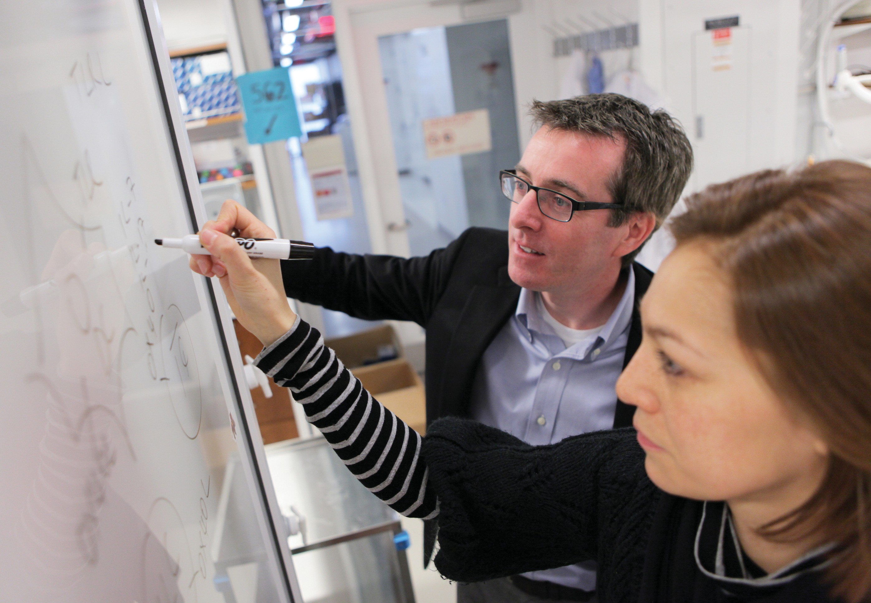

In the lab: David Artis, PhD, with postdoc Anne-Laure Flamar, PhD

slim on the same diet. In a 2013 New York Times Magazine cover story, the writer Michael Pollan recounted how sequencing the genes of the 100 trillion bacteria in his own body led him to think of himself “in the first-person plural—as a superorganism, that is, rather than a plain old individual human being.”
Greg Sonnenberg, PhD, assistant professor of microbiology and immunology in medicine, sees this as an asset to science. “The current level of excitement is fantastic,” says Sonnenberg, who has collaborated on seminal studies with Artis and who was also recruit- ed to lead a lab at the Roberts Institute. “The more you learn about the microbiome, the more it just touches upon everything; it is involved in probably every human disease out there. It’s like the rainforest, where you can go through and find different bugs that may have the ability to provide therapeutic benefit in many diseases. And that’s where the field is today. Now we need to get down to the nitty gritty in determining which species are impor- tant, which species are doing what, and how are they interacting with each other. It’s an extremely complex system.”
Sonnenberg cautions that many recent papers based on sequencing data have likely uncovered mere correlations. While some members of the microbiome are clearly associated with cer- tain medical conditions, he explains, that doesn’t mean the bacte- ria caused the conditions. Much more work must be done to understand the functions of the bacteria that make up the human microbiome, and how the chemical signals and byproducts they
produce affect us and each other. “Hopefully,” he says, “that’s going to translate to more research being done that advances us to the point where it will benefit patients more directly.”
There is already one way in which doctors are using knowledge of the microbiome to benefit patients. Clostridium difficile (C. diff.) is a highly antibiotic-resistant bacterium that causes severe diarrhea and kills some 14,000 Americans each year. Patients most at risk are those in whom antibiotics have wiped out beneficial gut bacteria, leaving the coast clear for C. diff. to grow unimpeded. So far the most successful treatment involves replacing those good bugs with a fecal transplant—that is, inserting the stool of a healthy volunteer into the colon of a C. diff. sufferer —and restoring the normal, healthy balance of gut bacteria. “The concept is both intriguing and somewhat repulsive,” admits Charlie Buffie, PhD, who will finish his medical degree at Weill Cornell in 2016, having completed his doctoral work at Sloan Kettering through the Tri-Institutional MD- PhD program. “But the efficacy of a fecal transplant has been strik- ingly high under the right circumstances.” Fecal transplant cures about 90 percent of C. diff. patients, but doctors aren’t sure exactly why. And because the treatment by its very nature is impossible to standardize, government regulators are uneasy and doctors are reluctant to use it in immunocompromised patients. Buffie, however, may have found a partial answer to those quandaries.
The components of a fecal transplant are as numerous as those of the human microbiome itself. But one that seems to be especially

Living Underground
The New York subway system hosts a complex bacterial ecosystem, too

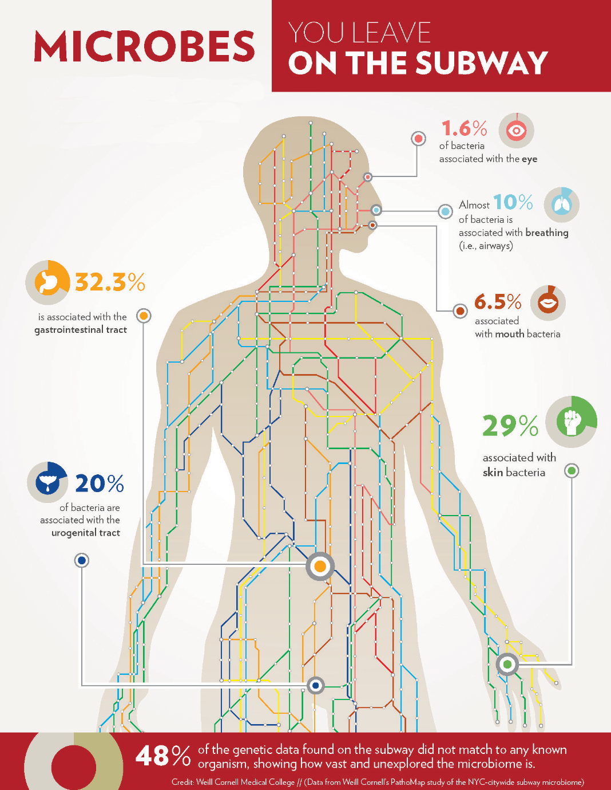
ust as each human body holds a complex ecosystem of bacteria in the gut, every major metropolis is home to a

HUMAN BACTERIAL DNA COMPRISE ONLY 1% OF THE TOTAL GENETIC MAKEUP OF THE SUBWAY MICROBIOME. OF THAT:
J
medley of bacteria and pathogens, coexisting with that city’s residents. Until recently, little was known about these native microbial communities, which surround us in streets, buildings, and public transit areas.
Using the subway system as their testing ground, Weill Cornell investigators fanned out beginning in June 2013 and collected samples of hundreds of DNA from bacterial, viral, fungal, and animal species—like insects and domestic pets—in the underbelly of New York City. They then compiled the data and turned it into an interactive pathogen map, dubbed PathoMap, and recently published their findings in Cell Systems.
While most of the collected microbes are harmless, some are not—including live, antibiotic- resistant bacteria, which were found in 27 percent of the samples. Two samples included DNA fragments of anthrax, and three carried a plasmid associated with Bubonic plague.
Reassuringly, those five were discovered at very low levels and showed no evidence of being alive. Other DNA—half of what was collected, in fact—could not be identified as any known organism, because the databases against which they are compared are still incomplete.
While this might sound troubling, there’s no need to worry right now, says the study’s senior investigator, Christopher Mason, PhD, WorldQuant Foundation Research Scholar and an associate professor in Weill Cornell’s Department of Physiology and Biophysics and in the HRH Prince Alwaleed Bin Talal Bin Abdulaziz Al-Saud Institute for Computational Biomedicine. These

apparently virulent organisms are not linked to widespread sickness or disease in this environment, Mason says. “They are instead likely just the co-habitants of any shared urban infrastructure and city,” he says, “but additional testing is needed to confirm this.”
The knowledge that these bacteria are present and having no obvious negative effect on the 5.5 million daily subway riders demonstrates that most of them are neutral to human health, he adds. They may even be helpful, as they can out-compete dangerous bacteria. “The presence of these microbes and the lack of reported medical cases is truly a testament to our body’s immune system,” Mason says, “and our innate ability to continuously adapt to our environment.” Would these pathogens be typical for other cities? With the aim of answering that question, collaborators are collecting samples from airports, taxis, and public parks in fifteen other cities around the world under a recent grant from the Sloan Foundation.
The PathoMap project involved investigators from Weill Cornell, five additional New York City medical centers, and more than a dozen national and international institutions. Over the course of seventeen months, medical students and other volunteers used nylon swabs to collect DNA from turnstiles, benches, railings, trashcans, and kiosks in all operating subway stations across the five boroughs. The team also collected samples from inside trains, swabbing seats, doors, poles, and handrails. They time- stamped each sample and tagged it using a GPS system, later sequencing about 1,500 samples (out of more than 4,200 collected) and analyzing those results. “PathoMap establishes the first baseline data for an entire city,” Mason says, “revealing that ‘molecular echoes’ of commuters appear on all surfaces— from the bacteria on their skin to the food they eat, and even from the human DNA left behind, which matched U.S. Census data.”
The data on New York City’s ecosystem—an ingredient in building a smart city—already has potential
real-world applications. Researchers could monitor the system for changes that would signal disease or a potential threat, or someday create a live model tracking real-time changes to this urban microbiome. The PathoMap, Mason says, is just the beginning.
— Anne Machalinski

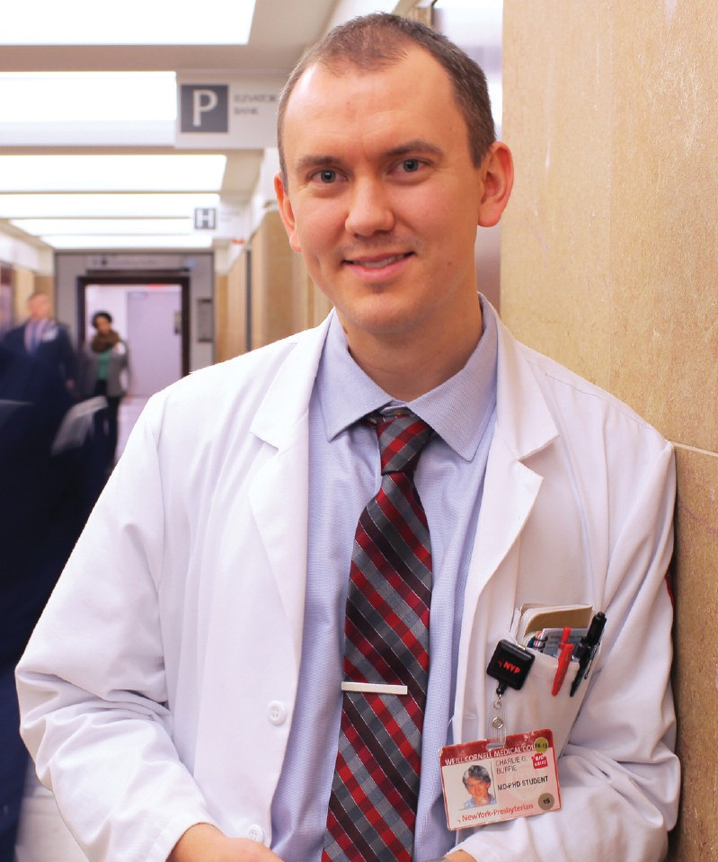

Charlie Buffie, PhD

effective in controlling a C. diff. infection is a related species called Clostridium scindens. In a study published last year in Nature, Buffie and colleagues in the Sloan Kettering lab of immunologist Eric Pamer, MD, used
C. scindens to defeat C. diff. in mice whose normal microbiomes had been disrupted with antibiotics. In the future, Buffie says, patients with C. diff. might be given pre- cisely calibrated mixtures of beneficial bac- teria or drugs that mimic the metabolic products of C. scindens that seem to prevent
C. diff. from propagating. That would allow patients to avoid the potential safety risks— not to mention the ick factor—of a fecal transplant. Says Buffie: “Being able to isolate, define, and construct compositions of bacte- ria that we know have positive effects and that do not have negative effects—that’s def- initely an attractive solution.”
This line of research also holds promise for IBD patients, says Randy Longman, MD ’07, PhD, an assistant professor of medicine in gastroenterology and alumnus of the Tri-Institutional MD-PhD Program who joined the Jill Roberts Center for Inflammatory Bowel Disease in 2013. Preliminary evidence suggests that fecal transplantation could help those with a form of IBD called ulcerative colitis, and Longman and his colleagues are working to figure out why. “The idea is to be able to get specific about the microbes,” he says. “If we isolate some of these bugs from patient samples and then put them into gnotobiotic mice we may be able to understand how these microbes interact with the immune system within the intestine.”
Although Longman’s primary occupa-

tion is research, he spends one day a week in clinical practice, working to help patients manage their illness. “Inflam- matory bowel disease, epidemiologically, affects people in the prime of life,” Longman notes. “So many of the patients that I’m seeing for initial diagnoses are young people with so much of their lives in front of them. There is a tremendous need for new medicines and new therapeutic strategies.” Like his colleagues, Longman is optimistic that cracking the secrets of the microbiome will lead to better treatments, and his patients will one day get relief from the stress of living with a chronic condi- tion. “Right now, treating IBD is a manage- ment thing,” he says. “We don’t cure it right now. But we do hope for that.”
T

oday, fecal transplantation remains the best microbiome- based treatment available. But as research points to gut bacteria’s
involvement with a variety of other ailments, scientists are hoping that future patients could be helped by targeted probiotics or drugs modeled after the chemical signaling of good bacteria. “There may be a point where it isn’t necessary to cultivate certain bacteria in your body,” Nathan says, “but rather to take a pill that provides the compounds those bacteria are making—to do the job they do, but in a more orderly, defined, predictable, consistent, safe way.” In the future, such treatments might be used not only for C. diff. and IBD, but eventually for metabolic disorders, obesity, and even neurological problems. “Whether the food you eat influences a predisposition to atherosclerosis—that’s controlled by the bacteria in the body,” Nathan says. “There are influences on behavior, on weight gain, probably on asthma. There’s a connection to autism that’s recently been reported.” The micro- biome may have an impact on every system in the human body, he stresses, and its importance is inestimable.
Artis echoes Nathan’s enthusiasm, and notes that most breakthroughs are yet to come. He draws an analogy to the years after van Leeuwenhoek’s microscope first revealed the hidden world in a water droplet. “The pace of discovery is so rapid; this field has really exploded,” he says. “But in terms of understanding the com- plexities of microbiota in the body, we’re
in our infancy.” •

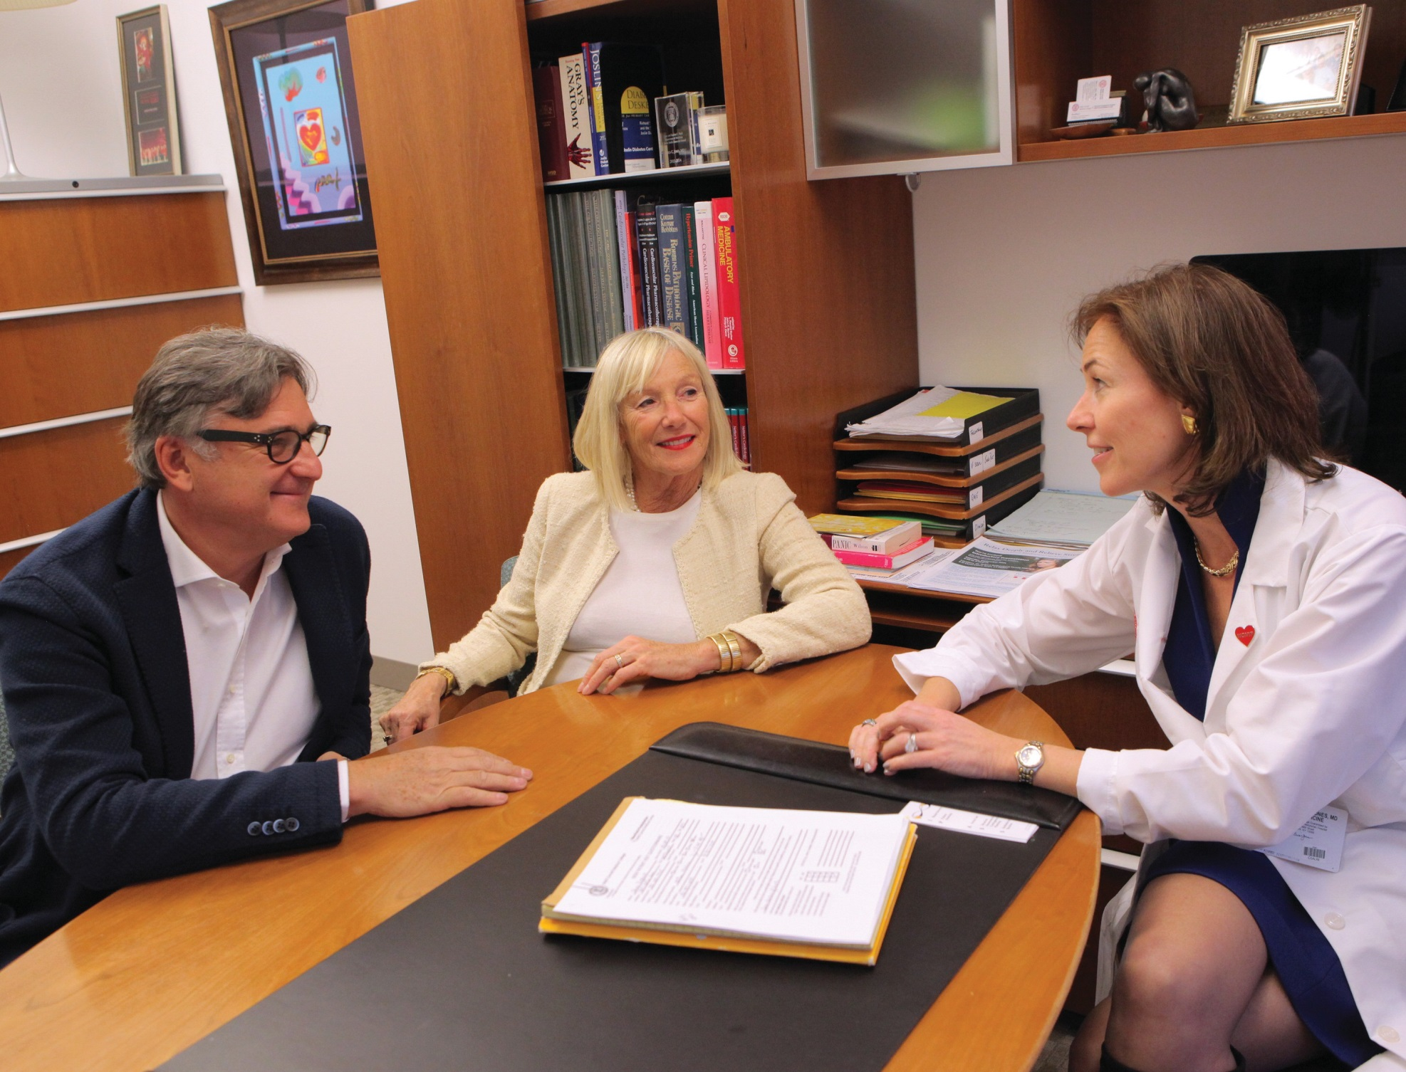
True Hearted

By Beth Saulnier

Photographs by John Abbott

The Dalio Institute of Cardiovascular Imaging and its clinical program, HeartHealth, aim to revolutionize cardiac disease prevention and treatment

lain Baume is fifty-nine, the same age his father was when he died of heart failure in their native Italy. Because of that family history, Baume has
A
long been concerned about his cardiac health; when he’d get out of breath from hurrying up a flight of stairs, for example, he’d worry that it was a harbinger of incipient disease rather than simply a sign of being a bit out of shape.

on the cholesterol-lowering statin drug Lipitor at the same level as before; Marialuisa has had her dose doubled and is working to quit smoking. Jones is moni- toring the murmur, and Marialuisa is heart- ened by the fact that even if a valve replacement becomes necessary down the road, it can be done non-invasively. “I did- n’t know what to expect, so when I went there I was a bit nervous, but the people

His wife, sixty-seven-year-old Marialuisa Baume, on the other hand, has no family history of heart disease. Although she does smoke cigarettes on occasion, she exercises regularly—“more than him,” she says with a laugh, in her lyrical Venetian accent— and has no worrisome symptoms. But dur- ing a routine visit to the family internist, Serena Mulhern, MD, assistant professor of medicine, the physician detected a moderate heart murmur and referred her to a colleague, cardiologist Erica Jones, MD. Jones, associate professor of clinical medicine and of medicine in clinical radiology, doesn’t run a typical cardiology practice. She has a special emphasis on pre- vention—and when the Baumes came to see her, she was gearing up an ambitious new program that aims to curb heart dis- ease long before symptoms appear. “Right now we’re in our infancy, but we have a lot of vision,” Jones says of the program, dubbed HeartHealth. “We’re going to be able to take patients who are at risk and show them significant change.” Formally launched this winter, HeartHealth combines tried-and-true strategies—promoting a nutritious diet and regular exercise; pre- scribing medications like statins —with
state-of-the-art imaging technologies that promise to revolutionize how medicine approaches heart disease. “What’s the prob- lem in cardiac care?” Jones muses. “More than half the time, it’s that we find people in the end stage of disease. They have a positive stress test, they’re having angina, they’ve had a heart attack. Most cardiologists are very interested in prevention—it’s just that by the time we see our patients, it’s often too late. They tend to be referred to us after they’ve had an event.”
The Baumes, who live in Manhattan and run a high-end shoe company with offices on Fifth Avenue, routinely attend their medical appointments as a couple, and both signed on as Jones’s patients. They each had a comprehensive exam, plus CT scanning that sought to identify calcium in the arteries that could lead to heart attack. The results were surprising. “He, with the bad risk, ended up having a completely beautiful, clean scan, but hers actually showed a lot of calcium,” says Jones, who spoke about the Baumes’ cases with their permission. “It showed he was at less risk than he thought he would be, and she was at more.”
Based on those results, Alain is continuing
there are so nice they make you feel relaxed,” Marialuisa says of her experience at the practice, located on the eighth floor of the Weill Greenberg Center. “I feel like I’m in good hands. I would recommend it to everyone.”
HeartHealth’s special focus stems from its affiliation with the program that over- sees it: it’s the clinical arm of the Dalio Institute of Cardiovascular Imaging, a joint venture between NewYork-Presbyterian Hospital and Weill Cornell that was estab- lished in fall 2013 with the aim of better understanding heart disease through the use of such tools as MRI, CT, PET, and novel technologies such as 3D printing and computer modeling of blood flow dynam- ics. Funded by a $20 million gift from NewYork-Presbyterian life trustee Raymond Dalio through his Dalio Foundation, the Institute has set an ambitious goal. “Our hope,” says director James Min, MD, a pro- fessor of radiology and of medicine who is board certified in cardiology, “is to imagine a world without heart disease.”
Headquartered on the first floor of the Belfer Research Building, the Dalio Institute is involved in some two dozen multicenter trials, with ongoing investiga- tions into a wide variety of topics—from

Personalized care: Cardiologist Erica Jones, MD, director of the new HeartHealth program, chats with patients Alain and Marialuisa Baume.
the efficacy of absorbable stents to the role that endothelial wall shear stress (pressure

‘There are many people “at risk” who do great until their nineties and hundreds—and many who are at “no risk” and have their first heart attack at forty.’
—Erica Jones, MD
that runs perpendicular to the artery) plays in heart disease. Dalio researchers are casting their net wide, partnering with experts in engineering, fluid dynamics, genetics, metabolomics, molecular imaging, and a host of other specialties.
They’re studying data from healthy patients
—one project, for instance, is examining the coronary calcium scores of members of an Amazonian tribe that never gets heart disease— as well as from people who have died of heart attack, and from those in between. In an effort to develop more accurate guidelines for diagnosis, for example, Dalio researcher Quynh Truong, MD, MPH, assistant professor of radiology and of medicine and co-director of cardiac CT, is leading a clinical imaging program for patients who come into the ED with chest pain. “In more than 50 percent of patients who have coronary heart disease, their first symptom is either a heart attack or death,” Min notes. “That accounts for more than 500,000 sudden cardiac deaths per year. It’s a true public health epidemic, and it occurs in people who are healthy and asympto- matic. So if we have early detection and good treatments, we can cut into that.”
The essential takeaway, says Jones, is that not all plaques are created equal—and while medicine has become much better at assessing cardiac risk in recent decades, it still has a long way to go. “There are many people ‘at risk’ who do great until their nineties and hundreds—and many who are at ‘no risk’ and have their first heart attack at forty,” Jones says. “Who are these people? We’re not good at understanding that yet.”
F

or researchers and clinicians working in the field today, the canonical example of a patient that the current system failed is Tim Russert. In 2008,
the journalist died suddenly of a heart attack due to an arterial blockage at age fifty-eight, just weeks after having passed a stress test. “They told him, ‘You’re OK,’ ” says Min. “But we didn’t use the proper tools to assess his risk, and I think we can do more for patients like that.” The key— and the Dalio Institute’s holy grail—is to identify what’s known as “vulnerable plaque,” the kind that actually causes heart disease and leads to ill health and death. “Dalio is challenging the exist- ing paradigm with new ways to see the coronary arteries—and not just seeing them broadly, but looking at aspects that can’t be easily seen on noninvasive or even invasive tests,” says Joshua Schulman-Marcus, MD, a fellow in clinical cardi- ology at NYP/Weill Cornell. “Does the way they look affect how they’re going to behave or respond to medication? That kind of research is only being done in a few places in the country.
And while not all of it is ready for clinical prime time, it’s a game-changing, paradigm-challenging research that will advance the field as a whole, and may advance prevention in a way that we just can’t anticipate right now.”
Schulman-Marcus—whom Jones lauds as “the future of prevention”—is working with Min on a project analyzing cardiac CT data with the aim of ascertaining which medications have the best results in patients with arterial blockages; he’s also collaborating with Truong on the study of cardiac CT in the emergency department. In July, he begins a one-year fellowship in cardio- vascular disease prevention at HeartHealth, which ultimately aims to offer patients such risk- reduction resources as behavioral psychology, nutrition counseling, and exercise physiology. “Clinically, the most interesting aspect to me, and the part that I want to spend more of my career focusing on, is how to change behavior,” Schulman-Marcus says. “It’s easy and nice to talk about risk factors, but it’s hard to change people’s behavior from a lifestyle standpoint.”
In addition to altering patient behavior, the clinicians note, change is needed in the health- care funding system to promote early detection. Jones points out that while technologies like CT angiogram—which illustrates blood flow through the heart—can help cardiologists better assess risk, they’re new enough that insurance companies often have to be convinced that they’re necessary. Sometimes, she says, her patients opt to pay $100 to $150 out of pocket for a blood test to assess calcium score, which is increasingly seen as a predictor of a potential heart attack, or even foot the $650 to $800 bill for a CT angiogram. “I have to tell some of my patients, ‘The insurance company will pay for x, y, or z, but it isn’t the study that I want,’” Jones says. “For whatever reason, insurers have not jumped on board—which to me is quite shocking, because they’re willing to pay for a nuclear stress test that costs more than $2,000 and gives the patient more than ten times the radiation.”
As an example, Jones cites a hypothetical patient who’s forty-five, the same age his father was when he died of a heart attack—but who’s so fit that he runs marathons. “I don’t need a stress test on that gentleman,” she says. “He’s not symptomatic; his EKG is normal. I want to know if he’s got asymptomatic disease.” Ultimately, she says, the right testing doesn’t just save lives—it can offer a solid return on invest- ment. “What we need to do as clinicians and researchers is to keep at it, to prove that this is changing care,” she says. “We need to work with these large insurance companies and HMOs to say, ‘Look, if I show you that this forty-five-year- old with a terrible family history has no calcium, then you don’t have to pay for his statin for ten

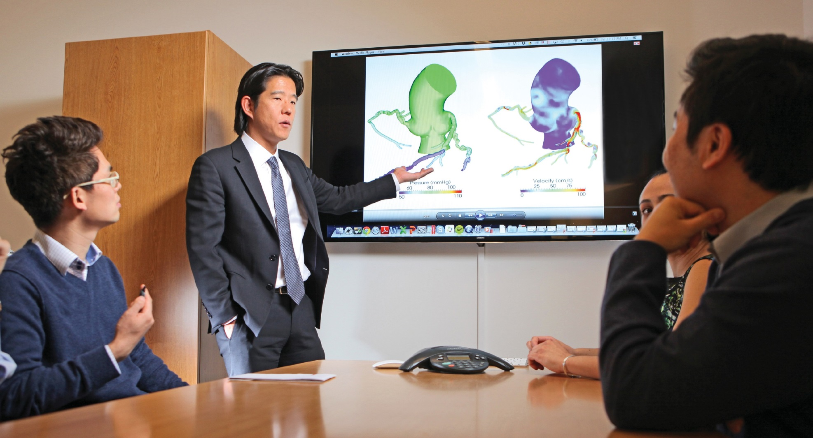
Where the heart is: James Min, MD (center), and colleagues at the Dalio Institute of Cardiovascular Imaging in the Belfer Research Building

years, because he’s safe. If I end up telling you that he does have significant calcium, fine; you end up paying for generic statin, which is very inexpensive, but I’ve possi- bly just saved you from a hospitalization for a heart attack.’”
Michael Wolk, MD, clinical professor of medicine, is a past president of the American College of Cardiology and the chief contracting officer of the Weill Cornell Physician Organization. He places the new technologies that Dalio and HeartHealth are spearheading in a long line of advances he has seen in his four decades of practice—lifesaving break- throughs that include bypass surgery, angioplasty, percutaneous valve replace- ment, and the development of statins. “I love the concept that Dr. Min has brought forward,” Wolk says, “which is, ‘How early can we diagnose coronary artery disease before there are clinical symptoms, decreasing cardiovascular events and there- fore minimizing the need to do expensive interventions?’ ” While heart disease remains the leading cause of mortality in the U.S., he notes that thanks to such advances, the incidence of vascular-related death has been cut by half in the past thir- ty-five years—and that the World Health

Organization has set an ambitious goal of continuing that trend by reducing mortali- ty from noncommunicable disease by 25 percent by 2025. Says Wolk: “It’s only through people like James Min—who are getting innovative and thinking of how to diagnose people before events occur—that we’ll be able to achieve such progress.”
With the aim of getting patients at elevated risk into the HeartHealth program, Jones has been spreading the word about the practice to her colleagues. She’s been speaking to high-risk obstetricians, for example, because women who had preeclampsia or diabetes during pregnancy are at higher risk of cardiac events later in life. Similarly, she led grand rounds at Hospital for Special Surgery—speaking to rheumatologists about patients with inflammatory disorders, also at increased risk—and at Sloan Kettering, since cancer survivors can have arterial calcification due to the higher doses of radiation that were administered in years past. “The purpose of HeartHealth is not to see the patients who’ve already had a heart attack, but to serve the population who isn’t sick enough to have a cardiologist but has risk factors like family history or inflammatory diseases that predispose them to heart

disease,” says Truong, who is also a cardiol- ogist and will be be seeing patients through the new clinical program. “HeartHealth is unique in that it integrates the latest technology to help patients understand their risk. It’s really important for us to have this armamentarium of imaging modalities and incorporate it into how we treat patients. Even something like a calcium score, which is very inexpensive, will be able to guide us in terms of, ‘Do you need to take that statin for the rest of your life, and how low do we need to bring that LDL cholesterol level?’ These are all beneficial tools to help us decide how aggressively to manage patients in their lifestyle and risk factor modifications.”
For Alain and Marialuisa Baume, Jones’s combination of individual atten- tion and appropriate testing is the perfect fit. They also praise the practice’s patient- friendly logistics. “When we call, we get immediate responses,” says Alain, speaking in the midst of a busy week last February, when the couple was working on their shoe company’s winter 2015–16 collection and Marialuisa was preparing for a trip to India. “You never feel like you’re ‘just another patient.’ It’s so personal, and we
feel so well taken care of.” •

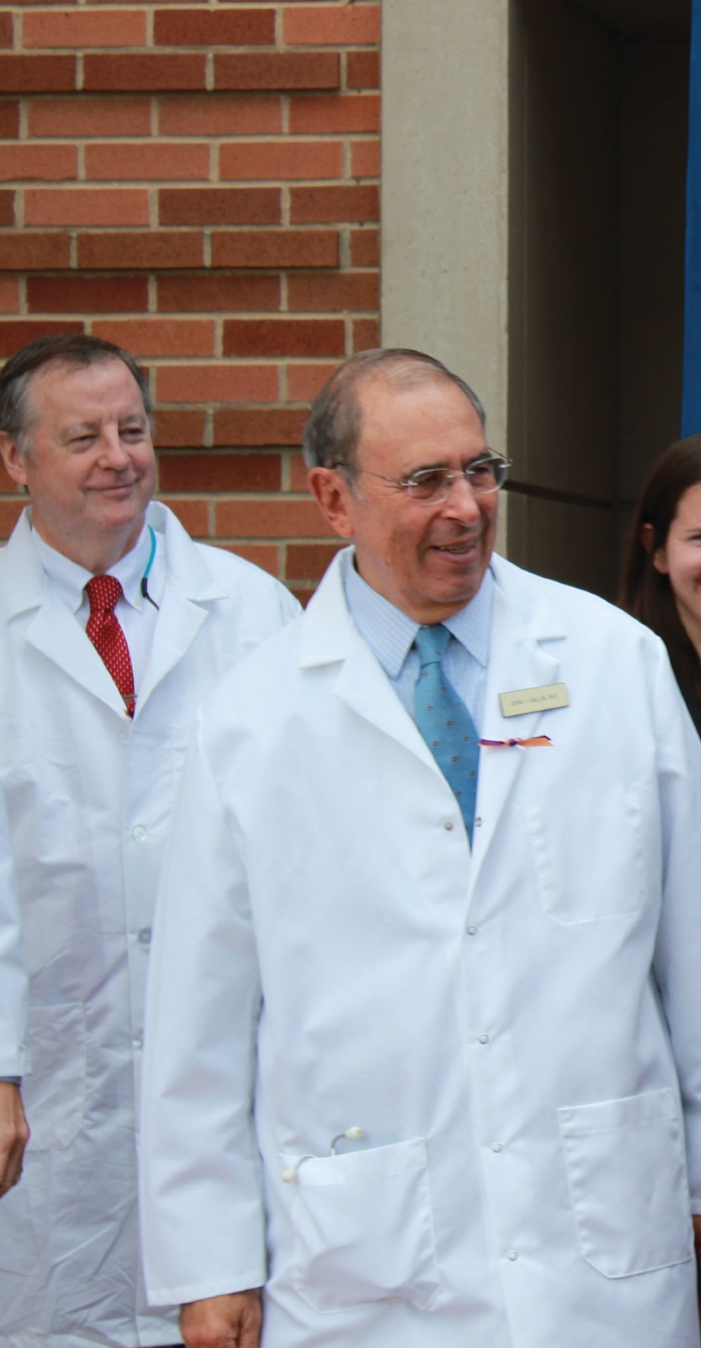
National Treasure

Last fall, all eyes were on the NIH’s Clinical Center in Bethesda, where a nurse with Ebola was being treated. Meet the Weill Cornell alumni who lead it

By Beth Saulnier
T

his may not look like much,” says John Gallin, MD ’69, “but this the most high- containment facility in the country—
probably in the world.”
Gallin is standing in what appears, more or less, to be a conventional patient room: hospital bed; adjacent bathroom; institutional furniture; Web-enabled TV on a telescoping arm; sockets on the walls for attaching monitors and other equipment. But behind the scenes, the facility
is extraordinary.

Negative pressure and heavy doors prevent air from flowing out from the patient room before it goes through a specialized filtering sys- tem. Nearby autoclaves, installed at a cost of $1 million, sanitize protec- tive clothing, which is later incinerated. An anteroom just steps from the bed offers a window through which designated monitors can observe, insuring that staff follow infection-control procedures to the letter. On shelves in the hallway are stacked the constituent parts—

including face shields and battery-powered respirators—for the “space suits” that have become cultural signifiers in the battle against virulent infectious diseases. This is the Special Clinical Studies Unit (SCSU)—no ordinary facility, in a building that’s no ordinary hospital. The unit is located in the Clinical Center at the National Institutes of Health in Bethesda, Maryland; Gallin is the Center’s director.
Last October, the SCSU was home to the woman who was arguably the most famous patient in the country: Nina Pham, the Texas nurse who contracted Ebola in the line of duty. All eyes were on the Clinical Center, with TV news trucks lined up on the

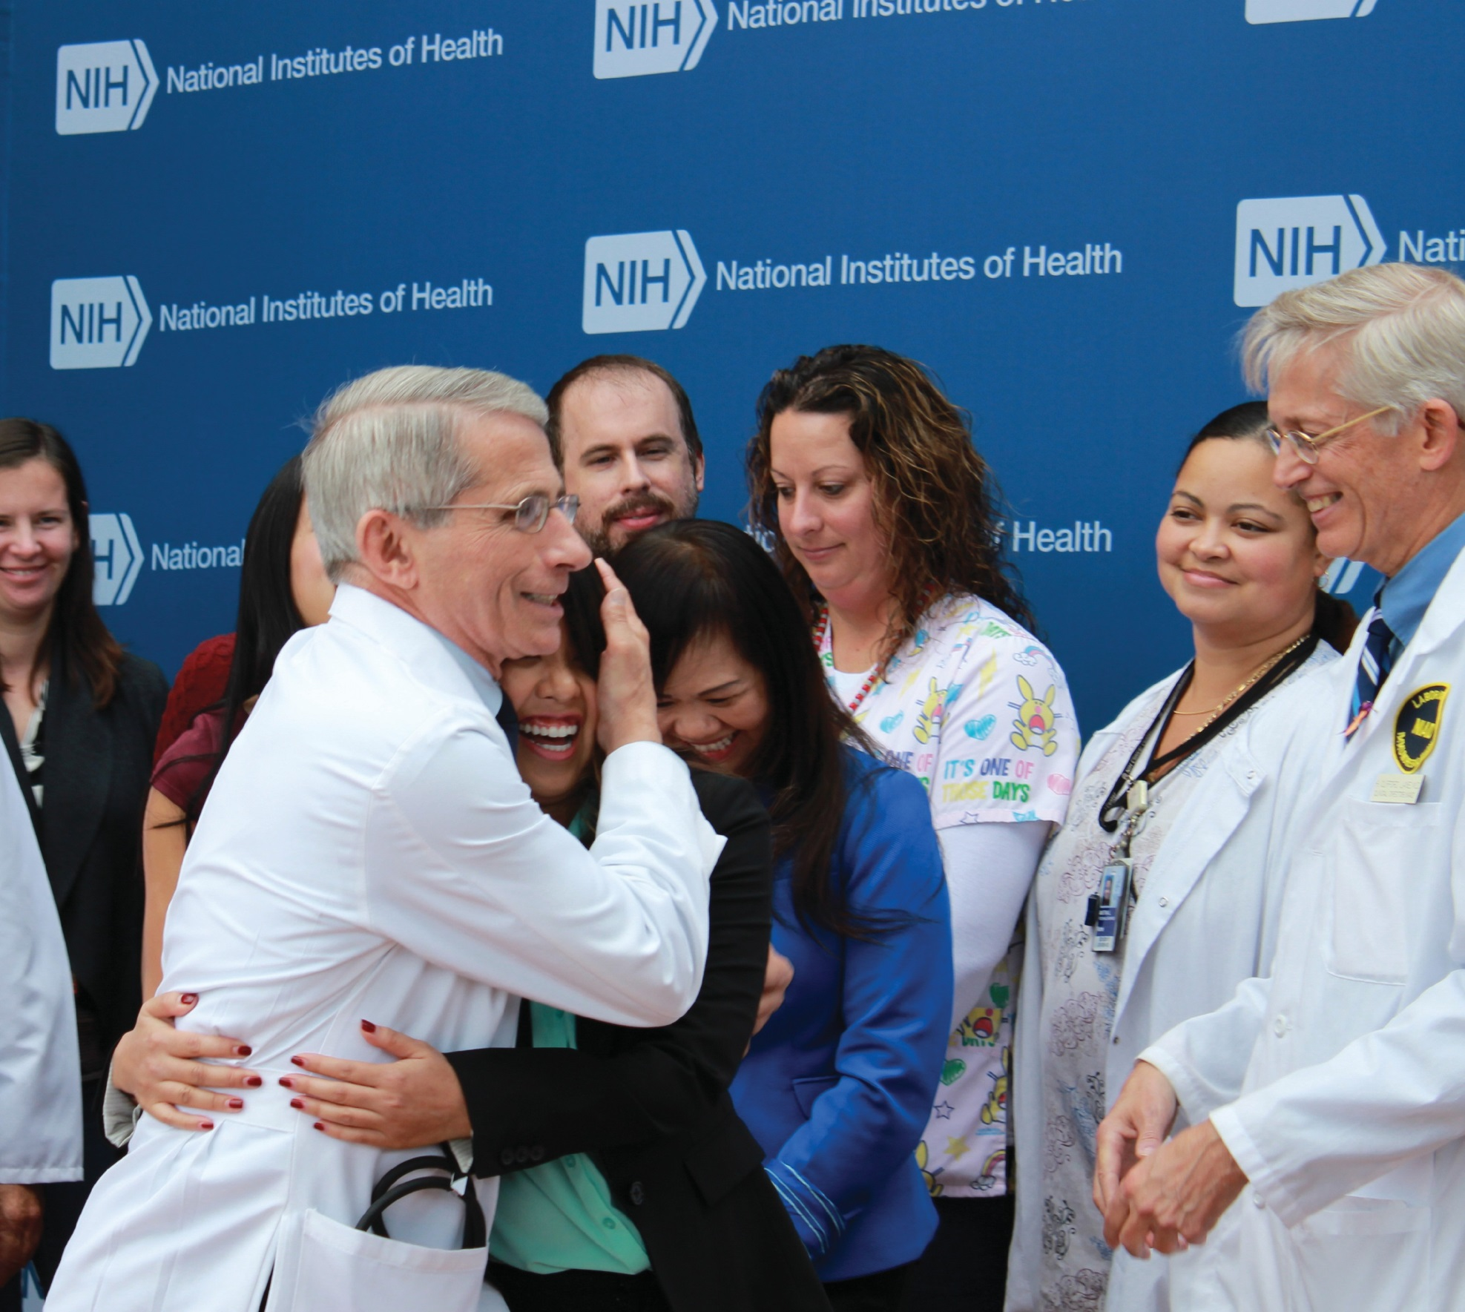
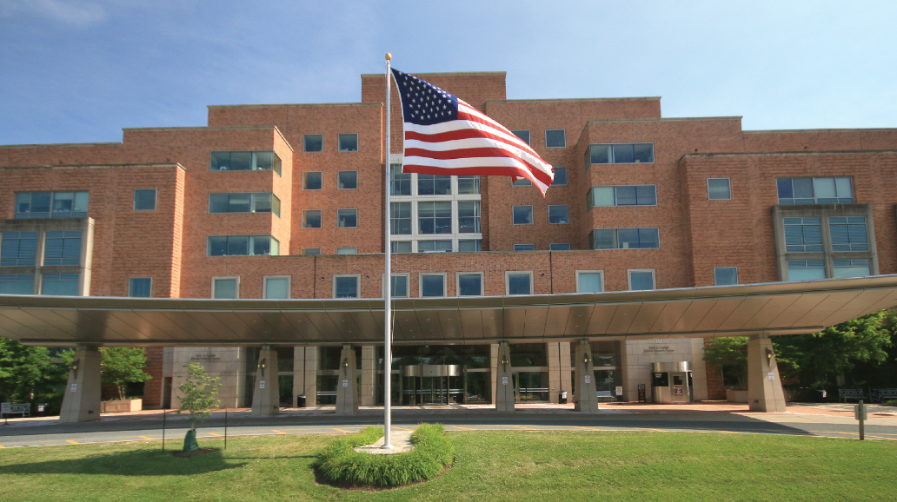

NIH

Good outcome: As John Gallin, MD ’69 (left), looks on, Anthony Fauci, MD ’66, hugs Texas nurse Nina Pham as she’s discharged from the SCSU in October 2014 after successful Ebola treatment. Right: The exterior of the NIH Clinical Center in Bethesda, Maryland.

‘We’re here for discovery,’ Gallin says. ‘That’s the
primary reason.’

RHODA BAER

John Gallin, MD ’69
roadway outside; through the large windows in his sixth-floor office, Gallin had a birds-eye view of the media scrum parked outside. “I had Nina Pham’s mother in my office, and she wasn’t real- ly aware at the time of what a big deal this was,” Gallin recalls. “She looked out and asked, ‘Why are all those things here?’ and I said, ‘For your daughter.’ That blew her away.”
The Ebola case was just one moment—albeit a dramatic one—in Gallin’s long career at NIH. He has worked there since 1971, save for a stint when he returned to Bellevue (where he did his residency) to serve as senior chief resident in medicine. And he’s not alone; a number of Weill Cornell alumni have had long careers at the Clinical Center and its related institutes. They include the physician who became the face of the government’s response to Ebola, as he had for
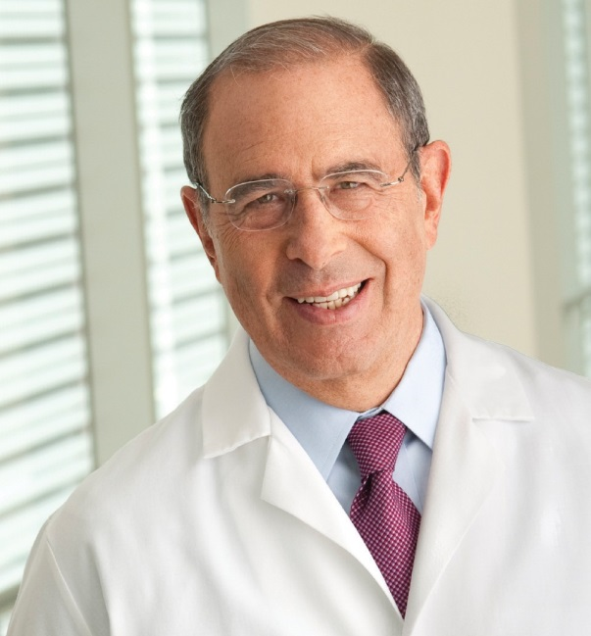
HIV/AIDS a generation earlier: Anthony Fauci, MD ’66, direc- tor of the National Institute of Allergy and Infectious Diseases. Gallin worked across the hall from Fauci in the early Eighties, when the first of what would later be identified as AIDS cases appeared in the CDC’s Morbidity and Mortality Weekly Report. The episode, Gallin says, exemplifies the appeal of working at the NIH. “We were chatting in the hall- way, and Tony said, ‘I’m in the perfect position to study this. This is going to be a real prob- lem,’” Gallin recalls. “This was the second week that it became public. He had that incredible foresight.” Turning on a dime,
Fauci—who’d had great success in the use of chemotherapy agents in non-cancer diseases— refocused his lab to work on HIV/AIDS. “The point I’m making is not that he’s terrific, although he is,” Gallin says. “It’s that he could do it. He could change. And when Ebola came, we could change. If something else comes, we will be able to respond to it.”
Physician-scientists and PhD researchers in the NIH’s intramural program—meaning those who work on the Bethesda campus, rather than investigators at other institutions receiving NIH grants—operate under a fundamentally different funding structure from colleagues elsewhere in academic medicine. Rather than applying for grants to support future work, they receive fund- ing based on a four-year review of their past pro- ductivity. “As everyone knows, it’s a tough environment for investigators, and it’s competi- tive. You have to rely on multiple sources of funding, and if you’ve got a clinical burden as
well, it can be a real challenge,” says Fred Ognibene, MD ’79, the Clinical Center’s deputy director of educational affairs and strategic part- nerships. “Nothing is ever easy or guaranteed, but at least things are a little easier here, given the nature of our business.”
As Gallin points out, he and his colleagues aren’t wedded to a particular project and can follow an interest wherever it may lead them—or switch to concentrate on an emerging crisis, as Fauci did. “Here, if you have a good idea, that idea will generally carry the day, and you will develop collaborations because people can be flexible,” says Henry Masur, MD ’72, chief of critical care medicine at the Clinical Center. “They’re not so tied to, ‘I got a grant to do X’; they’ll go where the opportunities are. This is a place where research is the dominant thing.”

The Clinical Center opened in 1953; its original building is now attached to a
state-of-the-art, 870,000-square-foot hospital that opened in 2005. Over the
past six decades, it has been home to many major discoveries. They include the first use of chemotherapy to cure a solid tumor; a revolu- tion in the treatment of childhood leukemia (which, Gallin notes, “went from 100 percent lethal to about 90 percent curable”); landmark work in research and treatment of hepatitis; the development of fluoride for cavity prevention; the use of Lithium to treat bipolar disorder; the treatment of Hodgkin’s disease with chemother- apy; the development of a diagnostic test for AIDS and of AZT, its first therapy; and the cre- ation of screening methods to protect the blood supply from HIV and hepatitis. (As Gallin tells the politicians who regularly visit the Center: “This is one of the greatest gifts that Congress ever gave the American public.”) Today, the 240- bed facility—where labs and patient rooms are housed under the same roof—is home to nearly 1,530 active research protocols. “We’re here for discovery; that’s the primary reason,” Gallin says. “Congress gives us money to discover new drugs, new devices, better preventives and treat- ments. So you can practice medicine here like you can’t anywhere else, because we have the luxury of time. We can easily spend an hour with a single patient over and over again to understand their disease. We can order special tests and do things that you wouldn’t do on the outside, because they’d be too expensive. Morale here is high, because of our mission; everything we do is to discover tomorrow’s cures and improve the management of patients.”
There’s another important distinction about the Clinical Center: its patients are all participants in an

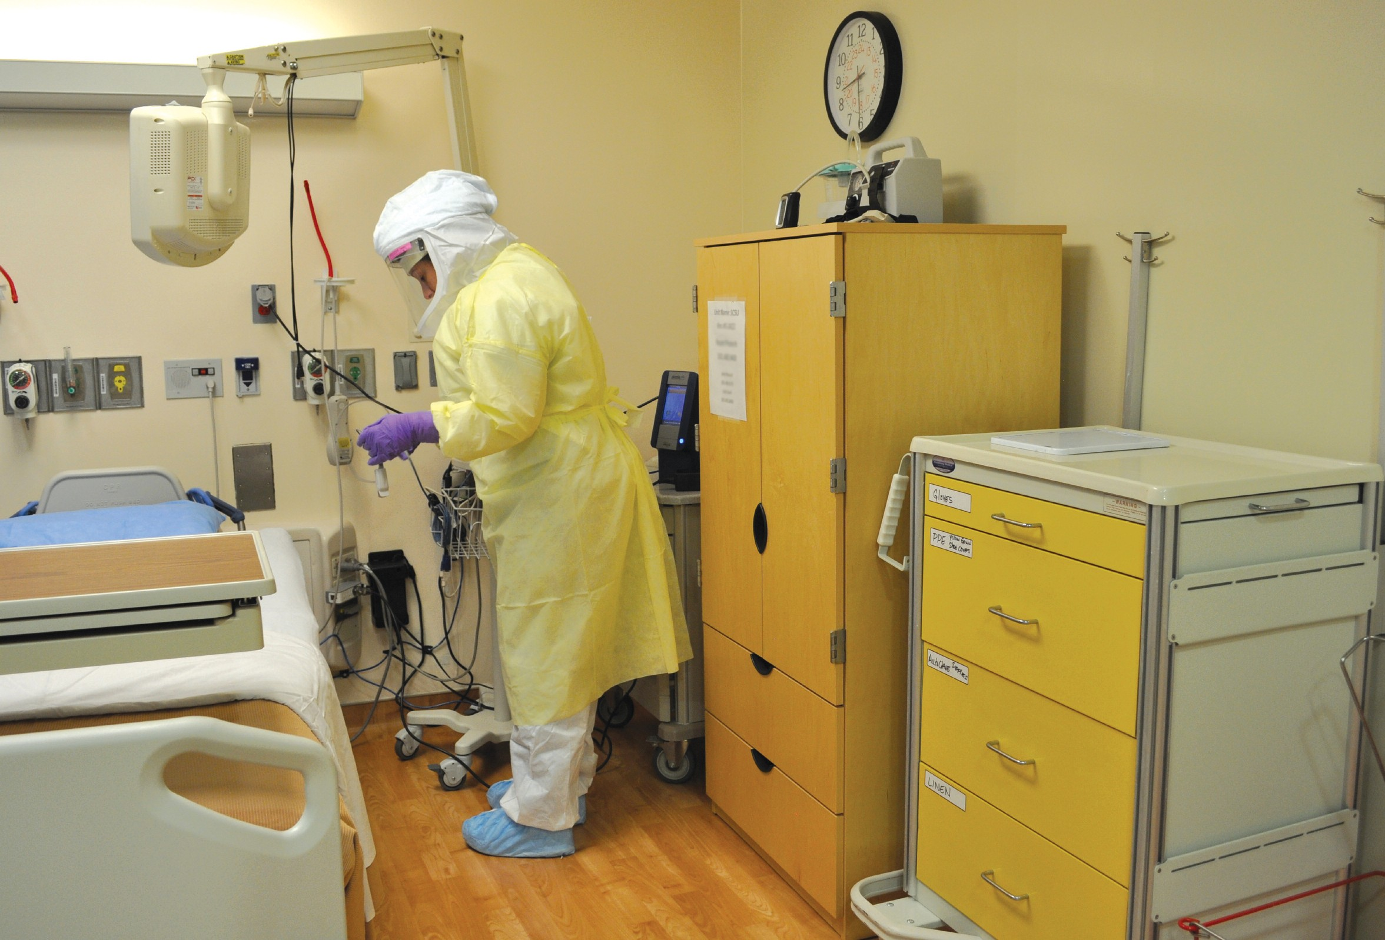

Controlled environment: The primary patient room in the Special Clinical Studies Unit, where patients have been treated for Ebola. Right: Fred Ognibene, MD ’79, with students in the NIH’s research scholars program.

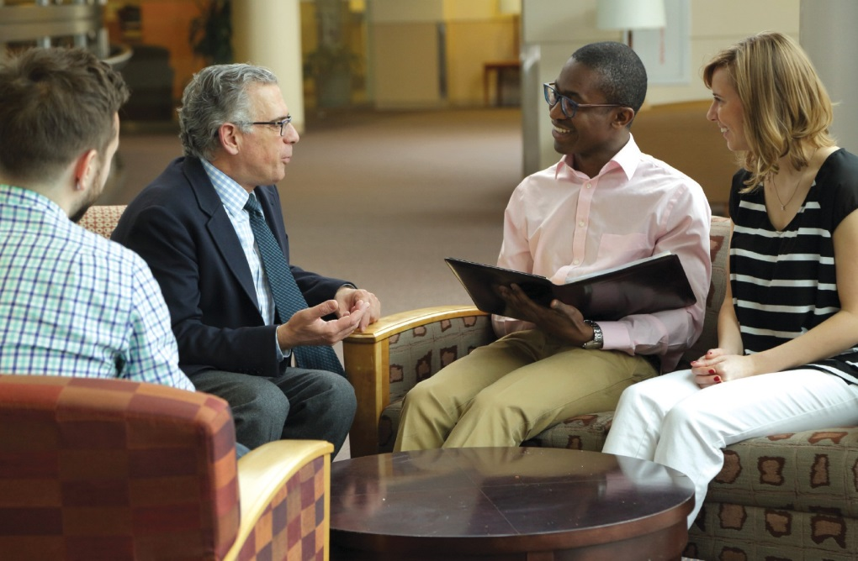
NIH

investigator’s ongoing research. And as such, their treatment comes free of charge. “We’ve never sent a bill, and we’re proud of that,” Gallin says. “Every patient who comes to this hospital is a volunteer for one of our studies. To come here, you have to have a problem that matches a protocol.”
Gallin himself is one of the world’s experts on chronic granulomatous disease (CGD), a rare hereditary disorder in which white blood cells fail to make hydrogen peroxide and bleach, and therefore can’t fight off bacteria. His lab has described the disease and the genes involved in it, and devised treatments that have improved its once-grim prognosis, with sufferers dying at an early age. “It used to be considered fatal,” he says. “Now, children are growing up.” His lab actively follows nearly 300 families with CGD, amounting to two-thirds of the world’s patients. All in all, the NIH is studying about 435 cohorts of people with rare diseases from around the world. “The reason we have such emphasis on rare diseases is that, one, it gives these patients hope,” Gallin says. “But the other reason is that they are often windows to understand common diseases.” For example, he has found that the muted inflammatory response in CGD patients means that they’re

protected from atherosclerosis—pointing the way toward a promising new target for heart disease prevention in the wider population. “We’re a venue for investigators to take these hypotheses from the bench to the bedside, and from the bedside back to the bench,” says Ognibene. “Just by the convenience of where we’re located, there is a free exchange of ideas. We espouse the con- cept of team science; it’s what we say we do, and what we actually do.”
Before shifting to academic administration, Ognibene worked on the pulmonary infectious complications of HIV. He compares his current post to that of a medical school dean of educa-

ERNIE BRANSON

ERNIE BRANSON
fact that everybody has been here so long tells you that something good is going on.”
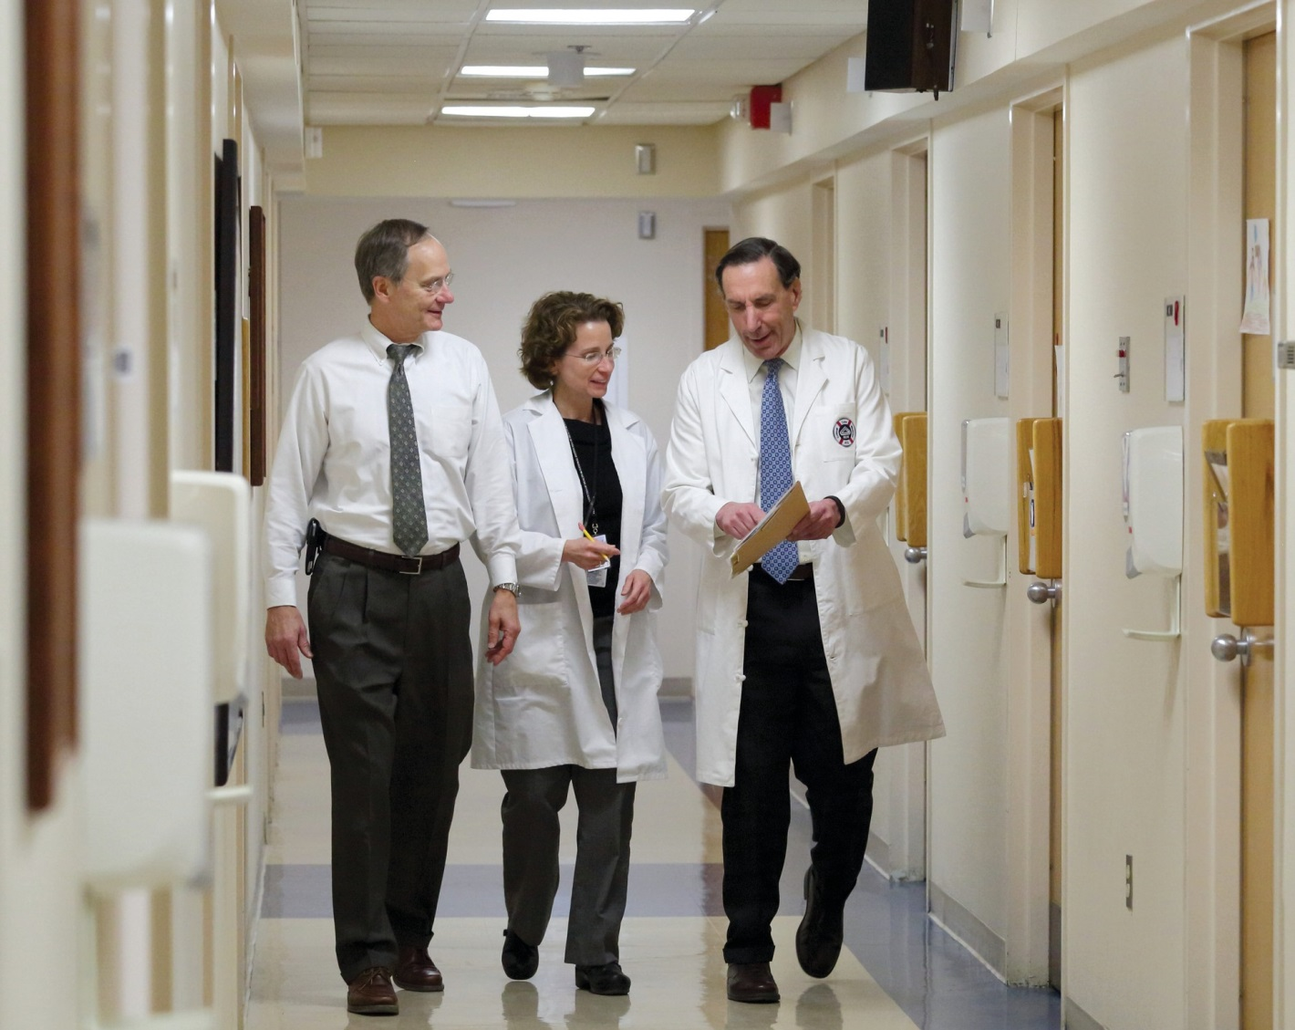
Masur, who came to the Clinical Center in 1982 to estab- lish its critical care department and a program in HIV/AIDS, is a second-generation NIH physi- cian: his father, Jack Masur, MD ’32, had Gallin’s job from 1948–51 and from 1956–69. (The building’s auditorium is named in his honor.) They didn’t overlap at the NIH; the senior Masur passed away when his son was a first-year medical stu- dent. But Masur notes with a laugh that he’s been there so long that sometimes people conflate them, as when he met a pediatrician colleague at another institution. “He said, ‘Isn’t your father at NIH? In the Eighties I used to make rounds with him on pediatric AIDS.’ And I said, ‘That wasn’t my father—that was me.’”
In his role as head of critical

Critical care: Henry Masur,
MD ’72 (right), consults with colleagues.
tion: he oversees the NIH’s extensive clinical
educational programs, which range from summer opportunities and clinical electives for med stu- dents to fellowships for physicians post-residency. “It’s an important training place,” Gallin says. “Many of the leaders in academic medicine in the
U.S. have spent time here as young investigators.” While a research-heavy environment like the NIH isn’t the right fit for everyone—and, of course, salaries in private practice are often more tempting—people who thrive at the NIH tend to stick around. Ognibene has been there since 1982, when he and three other internal medicine residents at what was then New York Hospital (now NYP/Weill Cornell) were recruited to be the NIH’s first clinical fellows in critical care medi- cine. Another member of that quartet, Joseph Kovacs, MD ’79, also never left: he’s now a senior investigator and head of the AIDS section in the critical care medicine department. “We came here partly due to networking, but there’s some- thing special about the NIH, and that’s why a lot of us have stayed,” says Kovacs, an expert in Pneumocystis, the form of pneumonia that was an early bellwether of AIDS infection and remains problematic for other immunocompromised patients. “It’s a great environment where we have a lot of flexibility. The ability to do research in a place where that’s our primary focus, the day-to-day meat and potatoes, is wonderful. The
care, Masur oversees the clinical care of patients and the training of staff who manage highly infectious
diseases like Ebola. One elemental part of that process is properly putting on and taking off the protective gear—which involves, among other things, two sets of booties and gloves, tape, a zip-up suit, a hood and visor, a respirator, and a protective gown. Staff must also learn to do familiar procedures like intubation while wear- ing the bulky gear; use a checklist akin to that of airline pilots; and follow the formal surveillance system, in which some staff are designated sole- ly to observe others. “It’s like preparing for a show: every step has to be rehearsed and rehearsed,” Gallin says. “We won’t let anybody go into the unit until we’re convinced that they know what they’re doing.”
The NIH’s current expertise in Ebola traces back to the months after 9/11, when anthrax attacks riled an already unsettled nation. President George W. Bush asked Fauci to help develop a biodefense program to deal with future bioterror attacks—including, he says, “the five Category A agents that we knew from intel- ligence the Soviet Union had built up supplies of during the Cold War years.” To wit: smallpox, tularemia, plague, botulism, and the hemorrhag- ic fevers including Ebola, Lassa, and Marburg.

‘It’s a great environment where we have a lot of flexibility. The fact that everybody has been here so long tells you that something good is going on.’
de corps. Says Gallin: “I think people went from being scared, and maybe a little angry, to being very proud and thinking, Isn’t it wonderful to work in a place like this and do the things that we do?” In terms of recruiting staff to work with Ebola patients, Masur reports that the advice of an Emory colleague proved true. “He said, ‘50 percent of people will run up to you and ask how

“Congress and the administration gave NIH $1.5 billion in our base budget to do that,” Fauci says. “Since there is no real difference between a deliberate bioterrorist and nature—which can sometimes act like a bioterrorist, such as with outbreaks and epidemics—we said that we would direct our efforts against both naturally and deliberately released microbes.” The SCSU, which opened in 2010, was built in part to treat any staff accidentally infected during research, but also as a venue for testing vaccines on healthy volunteers; an Ebola vaccine developed at the NIH is currently having its first field trials in Liberia.
Nina Pham was one of two Dallas nurses who contracted Ebola from a patient, a man who’d traveled to the U.S. from Liberia and later died. When those cases emerged—the first time that health- care workers had been infected in the U.S. rather than abroad—the SCSU was one of just three facilities in the country capable of handling them. “As soon as it became clear in Dallas that they were over- whelmed [caring for Pham], the CDC called us,” Fauci remembers. “They said, ‘Tony, can you take this patient?’ And I said, ‘Put her on a plane. We’re ready.’ ”
But training for an Ebola case is one thing; coping with the logistics of treating a real patient is another matter. The Clinical Center faced a variety of challenges, from the practical—like scheduling the more than two dozen staff needed to cover the SCSU each week, and coping with the com- mensurate drain on the rest of the hospi- tal—to the emotional, in the form of community fears that far outpaced any actual danger. “Admittedly, there is nothing like actually doing the work,” Masur says. “You learn as you go along. Until you do the real thing, you don’t know what all the problems are. Until you have two liters of diarrhea on the floor, you don’t really know what it’s like to try to clean it up safely.” Colleagues at Emory University—which treated several Ebola patients, including Pham’s Dallas colleague—had warned them that biomedical waste disposal would be a major undertaking. “With Ebola, there’s a
certain irrationality,” Masur says. “The contractors who’ll handle radioactive mate- rial and all sorts of pathogens that are much more hardy wouldn’t touch the Ebola stuff. We wound up incinerating a huge amount of it into ash, which can’t possibly have any virus in it. But nobody would take that, so we had to make a special arrangement and find a landfill that would. It became a big issue, not because it was a scientific problem or an infection problem, but a political, public awareness issue.”

nd then there was a conundrum with a less concrete solution: quelling the concerns—based far more on fear than on sci-
A
ence—of the local community. Some of the staff treating Pham were told that their children were not welcome at daycare. A well-known company, which Gallin declines to name, cancelled its employees’ planned visit to the NIH—even though they were meeting in a building elsewhere on its vast campus. Standing in his office, Gallin points to a line in the middle distance: a street called Cedar Lane. During Pham’s stay, he says, he got a phone call from the principal of a nearby school ask- ing whether students could contract Ebola while traveling on the road, which borders the NIH campus. “We accept risks every day without thinking about it, whether it is driving your car to work or walking across York Avenue,” Fauci muses. “But when a new risk is inserted into our lives— even though it is far less probable than some of the risks we accept—for some strange reason it creates a tremendous amount of anxiety and panic. And when people get panicked, the press reports it— and then when people read it in the press, they become more panicky. It becomes almost a self-propagating hysteria.”
That fearful atmosphere sometimes made life difficult for staff—who, for exam- ple, had to ask spouses to stay home to mind children banned from preschool. But the challenges also fostered a certain esprit
they can help, and the other 50 percent will say, “Don’t call me.” And actually, the 50 percent who run away, most of them even- tually come back.’ ” All the staff who worked in the SCSU during Pham’s stay— and that of two other people who were admitted to rule out Ebola after possible exposure, but weren’t infected—had volun- teered for the duty, Gallin says. “The most amazing thing was how the team stepped up to take care of these folks at every level, from the housekeepers to the X-ray techni- cians to the nurses to the doctors,” he says. “This can be a scary situation, but we called for volunteers, and we had plenty.”
In late October 2014, after an eight-day stay, Pham was discharged—an event cov- ered by the worldwide media that had been parked out front all week. At the press conference, Fauci—who grew so close to Pham that they still keep in touch over FaceTime—made sure to hug her in front of the cameras. “I wanted to show the world that once you are free of Ebola, you are free of Ebola,” he says. “So I thought a picture of me with my arms around her was an important public health message.” Later that day, Pham visited the Oval Office with Fauci and got another hug, from President Barack Obama.
Masur points out that as positive as Pham’s outcome was—and how meaning- ful it was for the Clinical Center’s staff— hers was just one of many cases that the hospital sees each year, many of them nearly as challenging in their own ways. The Center has treated more than 450,000 people since its inception; each year it logs upwards of 50,000 inpatient days and 100,000 visits from outpatients, many of whom return repeatedly for ongoing treat- ment. “We have a lot of patients who’ve run out of other options for therapies, so the victories that one does have are very gratifying,” Masur says. “In a way, if you get out of here after having survived leukemia or some other life-threatening disease, we ought to have a press confer- ence for that, too. Every time somebody walks out of here healthy after having had
some desperate disease, we’re happy.” •

Notebook
News of Medical College and Graduate School Alumni

PROVIDED

Spencer Kubo, MD ’80
Dear Alumni,
Earlier this year, we welcomed eight new members to the Weill Cornell Medical College Alumni Association’s Board of Directors. They reflect a broad range of experiences, but share a common dedication to our alma mater. Here is a brief introduction to these outstanding alumni.
James Auran, MD ’83: Dr. Auran is an ophthalmologist at the Edward S. Harkness Eye Institute at NYP/Columbia. He received the Alfred Markowitz Service Award in 2004, the American Academy of Ophthalmology Achievement Award in 2004, and the Columbia University Department of Ophthalmology Resident Teaching Award in 2008.
Kathleen Foley, MD ’69: Dr. Foley is attending neurologist in the Pain and Palliative Care Service at Memorial Sloan Kettering Cancer Center (MSKCC) and holds the chair of the Society of MSKCC in pain research. Additionally, she is a professor of neurology, neuroscience, and clinical pharmacology at Weill Cornell. Dr. Foley is internationally acclaimed for her work on the assessment and treatment of cancer patients with pain. She has published over 300 papers and edited seven books. She received the WCMCAA Award
of Distinction in 2014.
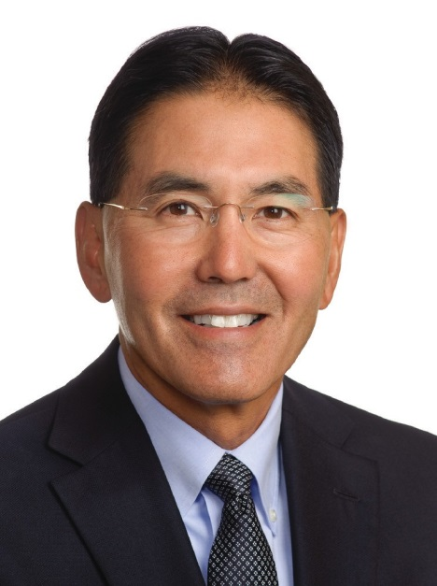
Joseph Habboushe, MD ’07, MBA (Treasurer): Dr. Habboushe is associate chief of service and assistant professor in the Ronald O. Perelman Department of Emergency Medicine at NYU Langone Medical Center. He created the EMRA’s Basics of Emergency Medicine guide book/app series, distributed annually to all emergency medicine residents. He heads three healthcare ventures: MDCalc.com, used monthly by a third of US physicians; Vitalis Pharma, developing medications for cholesterol and jet lag; and Stethos, a new electronic stethoscope for the ICU and OR.
Anthony LaBruna, MD ’90: Dr. LaBruna is director of two ambulatory surgery cen- ters, Manhattan Plastic Surgery PLLC and the Center for Specialty Care, where he is chief medical officer. He holds dual appointments as clinical associate professor in otolaryngology and plastic surgery at Weill Cornell, where he was formerly director of facial plastic surgery. He received awards for outstanding teaching in 2004, 2005, and 2010. Shari Midoneck, MD ’89: Dr. Midoneck works with MD2 Park Avenue, a concierge medicine practice, which grants families access to the most highly sought- after internists and specialists. Prior to this, she served as associate dean of academic affairs and practiced at the Iris Cantor Women’s Health Center at Weill Cornell. She is respected for her commitment to compassionate, personalized care and her interest in preventive care for women. A talented teacher, she won the Weill Cornell
Excellence in Teaching Award four times.
Anthony Rossi Jr., MD ’08: Dr. Rossi is a board-certified dermatologist. He is on the full-time faculty at MSKCC and is an assistant professor of dermatology at Weill Cornell. Dr. Rossi has practiced dermatology and teledermatology in underserved regions such as Tanzania, Ghana, Kenya, and Botswana. Recently, he helped establish a teledermatology program between Weill Bugando in Tanzania and Weill Cornell in New York. He was awarded a Presidential Citation from the American Association of Dermatologists for his advocacy work with the AMA.
Edwin Su, MD ’97: Dr. Su is an associate attending orthopaedic surgeon at Hospital for Special Surgery and an associate professor of orthopaedic surgery at Weill Cornell. He specializes in using new technologies to achieve optimal results for young, active patients with hip and knee arthritis, offering both non-surgical and surgical treatments. Dr. Su is one of the leading hip resurfacing surgeons in the United States.
Karen Zimmer, MD ’98: Dr. Zimmer has twenty-five years of experience as a consultant in health IT, patient safety, and quality. She was the former medical director for the ECRI Institute PSO and the Patient, Safety, Quality Risk Group, and currently sits on the NQF Health IT Expert Panel. Dr. Zimmer is an adjunct professor of pediatrics at Johns Hopkins and a pediatrician at Nemours DuPont Pediatric of Alfred I. DuPont Hospital for Children.
The Alumni Association is fortunate to have such caring and wonderful physicians on its board. We will depend on their commitment, energy, and enthusiasm as we meet our short- and long-term goals. Please feel free to reach out to congratulate them, or to discuss new ways to enhance the connection of alumni to our alma mater.
Warm regards,

Spencer Kubo, MD ’80 spencer.h.kubo@gmail.com

1940s
Solomon Hillel Blondheim, MD ’42: “I am just
turning 97. How many of my colleagues are older than I? To what do I owe my longevity? I am by far the oldest in my family. Since childhood, I have avoided animal fat because of preference. I also never smoked because it made me cough, and drank only for sacramental purposes. I stopped exercising when I finished college gym. I have had a happy life except for the sad death of my first wife, an entomologist, at age 62. We had four children, all of whom have successful careers. So how could I help living so long? I did a one-year post-Pearl Harbor internship. I returned from the European Theater with a Bronze Star and three years in the Army. I did two-year residencies at Montefiore Hospital and at the Hospital of the Rockefeller Institute for Medical Research, got married, and left for Israel (1951) with my wife and infant son. I was back to the U.S. on a one-year sabbatical and again, years later, for a month of fun. I was on the staff of the Hadassah-Hebrew University Medical School (Jerusalem) from its inception. I retired (obligatory at age 60) as a full professor of medi- cine. My publications have been in medical journals and also in the field of Bible research. I was editor of the English section of Harefuah, the Israel National Medical Journal, for twenty years. Among other activities, I founded and ran an orthodox synagogue, which has continued with- out me now for years. For my contributions to Jerusalem’s cultural life, I was elected Yakir Yerushalayim (Worthy of Jerusalem).”
Sherwin Kaufman, MD ’43: “Since retirement some 22 years ago, I began a new career as a songwriter and have received awards for both music and lyrics. I’ve also been writing memoirs, short stories, and much poetry. I’ve written a book called Poetic Humor (self-published, 2014) and expect it to be on Amazon within the next few weeks.”
Charlotte Brown, MD ’45, and David Brown, MD ’45: “We really have no news except that we are still breathing at 94 and are still having a good time.”

1950s
Stanley Birnbaum, MD ’51: “I am still tutor-
ing ob/gyn students at WCMC and enjoying every moment. Michele and I are Manhattanites as are our children and grandchildren.”
Richard T. Silver, MD ’53, was recognized by CURE magazine and Incyte in San Francisco on December 5, 2014, at the 2nd Annual MPN Heroes recognition reception for advancing the science of MPNs and his commitment to the MPN community for more than half a century. Dr. Silver is the director emeritus of the Richard

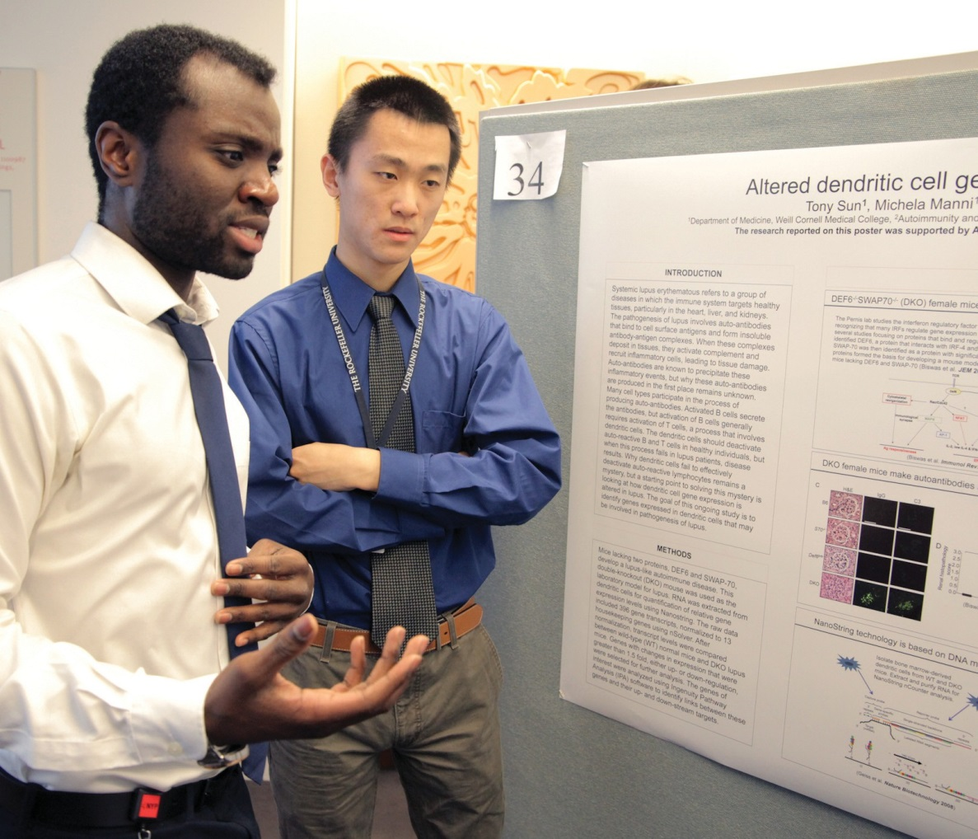
WCMC

T. Silver Myeloproliferative Neoplasm Center at Weill Cornell and the medical director of the Cancer Research and Treatment Fund. He has written four books and more than 275 peer-reviewed articles, has been the principal investigator in multiple clinical trials, has spon- sored bi-annual patient-hematologist seminars, is the co-inventor of the BMB biopsy technique, and was instrumental in founding the MPN Center for Research and Therapy.
Frederick R. Abrams ’50, MD ’54: “The Denver Public Library has accepted for its histor- ical archives my thirty-plus-year collection of material related to my initial founding of hospi- tal medical ethics committees in Colorado, beginning in the late Seventies. The material includes activities assisting other states to form hospital ethics committees in the Eighties and Nineties. This year my wife, Alice, and I will cel- ebrate our 66th anniversary. She has become an internationally renowned jewelry designer. Our oldest son, Reid, is chief of hand surgery at UCSD. Glenn, our middle son, is a producer and director in multi-media. Hal, our animal-loving youngest son, created the nationally syndicated radio program ‘Animal Radio.’ Alice and I are grandparents of three girls and three boys and

Poster session: Presenting results during Medical Student Research Day

recently became great-grandparents of three boys. As a hobby, I maintain a small business that began by using scraps of left- over silver (and a little gold) from my wife’s jewelry-making process to create whimsical animal sculptures. They’ve been sold nationwide, mail ordered from magazines such as Natural History and Smithsonian, and purchased from jewelry stores such as Cartier’s in New York City and local Denver galleries.”
Ivan Gendzel ’52, MD ’56, was married in December 29, 2014 to Lela Garner Noble, PhD, whom he had met at his continuing care retirement community. She is a retired political science professor from San Jose State University (where Ivan’s son is an associate professor) and had been department chair, dean of the college, and university provost. They plan to remain at The Forum in Cupertino, California. Though he is no longer running marathons, he managed to complete a ten- mile hike for Valentine’s Day, with 3,000 feet of elevation. His e-mail address remains igendzel @ gmail.com.
Ed Margulies, MD ’56: “I’m now retired fifteen years and loving it. Paulette and I spend about five months in Naples, Florida, where we have developed a real life full of friends and activities. I’m still playing rather awful golf and better bridge. She has volunteered to teach Spanish to a group of ladies through the Jewish Federation. Our kids are scattered up North, but we see them and our grandchildren as much as possible. Most importantly, we are both enjoying relatively good health.”
Frank G. Moody, MD ’56: “I am still participating in the development of physicians with a strong commitment to improve our healthcare system. My experience as a surgical educator is contained in a recent autobiography fancifully titled Frank Reflections of An Academic Surgeon. For those who are interested, the book is self- published through iUniverse and available through Amazon, Barnes and Noble, etc. If you happen to read it, you will immediate- ly recognize that the message to aspiring physicians is that being a physician is a privilege, and practicing medicine is not only fulfilling but enjoyable. Cornell Medical School and the New York Hospital have played an important role in my academic career, which in turn has brought health and happiness to hundreds of students and thousands of patients. Fortunately I am still fit at 87 except for the signs of aging (pacemaker, slow stooped
gait, small handwriting, dysphonia, chronic obstructive pulmonary disease, anosmia, etc.—all signs of Parkinson’s disease), which I gladly accept compared to the many less kind diseases that afflict the elderly. I am proud to be an alumnus of Weill Cornell Medical College and a surgeon trained at the Cornell-New York Hospital Medical Center (1956–63) under the tutelage of Dr. Frank Glenn and his associates. I am impressed with the current “big science” activity that the school is engaged in.”
Bernie Siegel, MD ’57: “I’m happy to see the American College of Surgeons Bulletin containing articles and essays by surgeons related to their emotions and experiences treating people and their dif- ficulties coping with the death of their patients. We need to humanize medical education so it is about people, not information, and not treating the result while ignoring the cause. I keep writing books and lecturing to empower patients and help them focus on self-induced healing (a term from Solzhenitsyn’s novel Cancer Ward) versus spontaneous remissions.”
James E. Shepard, MD ’59: “I just returned from a nephrology conference in Chicago, which reinforced the wisdom of the move to California. Hope you are all surviving cold, snow, and ice.”

1960s
Ken Barasch, MD ’60: “I practice
medical ophthalmology in New York and am continually grateful for my CUMC medical education and my New York Hospital residency training. I do see Gideon Panter ’56, MD ’60, as a friend and patient, and my wife, Lynne, is his patient. Sadly, Tony Marano, MD ’60, died recently, leaving me as the only remaining member of the Williams College contingent. Our 55th class reunion will be celebrated in 2016 and I hope we will attend in great numbers.”
Donald A. Vichick ’58, MD ’62: “I’m semi-retired, mostly doing consults, sec- ond opinions, and workmen’s comp. Marie and the family are doing well. We have five children, nine grandchildren, and four great-grandchildren. Our oldest granddaughter passed the Colorado Bar exam in March and practices in Aspen. I’m out of the horse business, but one daughter is still training and a grand- daughter is a quarter horse world champ. Life is still fun.”
Richard Ehrlich ’59, MD ’63: “Ten large photographs have been donated to the Belfer Research Building from a conceptual photographic project, ‘The Other Side of the Sky.’ The project can be viewed on my website: ehrlichphotography.com.”
Don Catino, MD ’64: “After being forced out of private practice by lack of fair Medicare reimbursement, I have been doing world- wide, multi-national, multicultural medicine for the last seven years. I have done five tours in Australia, two in New Zealand, and four in Tanzania. I’ve worked on two American Indian reservations, and with the tribes of the Lake Victoria region in Tanzania, the aboriginal Australians, and the Maori of New Zealand. It has been a fascinating experience, and a rewarding chance to give back in my semi-retirement.”
Belle Sumter Carmichael Coleman, MD ’64, has published a follow-up to her first book, Heal: A Psychiatrist’s Inspiring Story of What it Takes to Recover from Chronic Pain, Depression, and Addiction . . . and What Stands
in the Way. The new book, Heal Thyself: What You Can Do to Recover from Chronic Pain, Depression, and Addiction, is aimed at those with chronic illnesses who feel stuck.
Jim McSweeney ’62, MD ’66: “Similar
to many of us ’66ers, I retired in 2013 after a wonderful run. President of this and chairman of that. Two wives, three kids, eight grands, and four great-grands. Radiology was my specialty and I loved it. We are high achievers and a very talented group, which has made a difference in so many ways everywhere. Anthony Fauci, MD ’66, our most famous classmate, is still mak- ing a major impact on global health. Go, Tony! I love to hear him explain the sci- ence. I can hear Vinny DuVigneaud, MD ’59, Dr. Pitts, Roy “the Goose” Swan, MD ’47, E. Hugh Luckey, and our class favorite
—Walsh McDermott. What a fantastic group of teachers and mentors. The sad part is that our profession has been commodi- tized and deprofessionalized—it can never be the same. We are so fortunate to have experienced the ‘golden’ years. See you at the 50th.”
Richard Lumiere ’63, MD ’67: “Last spring I had a great reunion with Dean Edell ’63, MD ’67, and a few of our Cornell (Ithaca) fraternity brothers and wives at Mercer Kitchen in Soho. Of course we reminisced about Dean Hanlon, Dr. Lampe, Roy Swan, and Professor Shapiro’s infamous announcement in Embryology class on November 22, 1963.”
Steve R. Pieczenik ’64, MD ’68, released

his latest book, Steve Pieczenik Talks, which gathers together his blog entries from September 2012 to September 2014. He is the co-creator of the New York Times best-selling “Tom Clancy’s Op-Center” and “Tom Clancy’s Net Force” series. He served as Deputy Assistant Secretary of State under presi- dents Nixon, Ford, Carter, and Bush Sr. and was Senior Policy Planner under President Reagan.
N. Reed Dunnick, MD ’69, is the Fred Jenner Hodges Professor of Radiology and chair of the department of radiology at the University of Michigan Health System in Ann Arbor. He served as the 2014 president of the Radiological Society of North America. Prof. Dunnick spent two years in internal medicine at Strong Memorial Hospital in New York. He became assistant professor at Stanford in 1976, and later that year he went to work at the National Institutes of Health. He also worked at Duke University Medical Center, where he served as chief of uroradiology and director of diagnostic imaging before accepting his current post in Michigan. A former president of the Academy for Radiology Research, Prof. Dunnick testified before Congress on the need to establish a new institute, which was signed into law in 2000 as the National Institute of Bio- medical Imaging and Bioengineering. At ECR 2015 he will receive honorary membership in the European Society of Radiology.

1970s
Francis V. Adams, MD ’71: “On February 1, I
joined NYU Pulmonary and Critical Care Associates at 530 First Avenue, NY, NY. After 37 years, goodbye to private practice! I’m still host- ing “Doctor Radio” on SiriusXM and working for the NYPD as a police surgeon. My second grand- child was born in December. I’m also pleased to
WCMC


Arts and sciences: A “Music and Medicine” concert at Lincoln Center

days a week. I’m just doing clinical medicine. I can’t believe how EASY that is. I love it. No one complains to me, it doesn't matter to me if someone else screws up, I don't go home with six hours of administrative work, and my mind is clear at night. It is a pleasure. I hope others are getting to that point. It is giving Marcia and

announce the publication of my seventh book,
Adams Way.”
Frank J. Bia, MD ’71: “I have begun to transition to part-time after my eight years at AmeriCares as their medical director. Now I am interested solely in clinical medicine and continuing my ties at Yale as emeritus professor. My wife, Peggy Johnson Bia, MD ’72, is on sab- batical this year (50 percent), but she will begin phased retirement next year from Yale over three years. We have a new address since we have sold our home and are now renting. Much easier to do other things—but one still has to shovel the snow. We have one son, 25, doing a post-bac- calaureate with medical school being his objec- tive. His older brother, 28, is in Tokyo doing fieldwork for his PhD in anthropology from University College London. Like my grandfather, I will be working until I am 94.”
Arnie Cohen, MD ’71: “As far as what is new, I have ‘transitioned.’ I have given up being chairman of ob/gyn and am now working three
me a chance to travel and spend time with our six grandkids. We both have our health and for that we are lucky. I hope others are enjoying their ‘transition’ as much as we are.”
Robert L. Cucin ’67, MD ’71: “With the perspective of age and the burgeoning obesity problem, I’ve been working to develop a laparo- scopic device to remove the visceral fat that secretes cytokines responsible for the morbidities of obesity. Since the method doesn’t involve cutting into the gut, rearranging alimentary tract, or leaving behind a foreign body, it should be safer than current bariatric alternatives, have fewer sequelae, and be highly effective. If we’re right, it’ll be my way of giving back. If I’m wrong, I blew my IRA.”
Richie Lynn, MD ’71: “Hope all is well with everyone. On March 7-9 WCMC was here in Palm Beach, with a breakfast for alumni on Satur- day morning and many events over the three days, with a symposium on Monday that attracted close to 400 people from the community. The

‘I’m out of
the horse business, but one daughter is still training and a grand- daughter is a quarter horse world champ.’
Donald A. Vichick ’58,
MD ’62

‘We are continuing Drs. Fred Plum, MD ’47, and Jerry Posner’s strong traditions in brain function in health and disease. Living the dream.’
Robert Kalb, MD ’82
Dean asked that Margrit and I host a luncheon for some individuals from Palm Beach for her to meet on a personal, more intimate basis. She is truly committed to the school and a strong advocate of the alumni. It has been a privilege for me to get to know her on a personal level. We are all reaching transition points in our lives professionally. I strongly recommend the book Transitions: Making Sense of Life’s Changes, 2nd edition, by William Bridges. Sad to hear about TJ Crawford, MD ’72. For those in the cold, come visit here in Palm Beach.”
Richard H. Tuck, MD ’72, is transitioning from 35 years in a challenging primary care pediatric practice to a part-time position with a local Federally Qualified Health Center, while continuing as medical director of an active PHO. He has progressed through multiple leadership responsibilities with the American Academy of Pediatrics and has been elected to a national board position with the AAP. He lives in Zanesville, Ohio. He is married to Cynthia, with three daughters and three grandchildren scattered across the country.
Frederick Basilico, MD ’74, has been named physician in chief for medicine at New England Baptist Hospital, a Boston-based premier regional provider for orthopedic surgery and the treatment of musculoskeletal diseases and disorders. In this role, Dr. Basilico will provide leadership for the primary care and medical specialty practice at NEBH. Dr. Basilico, a cardiol- ogist, also serves as chief of cardiology and as president of the New England Baptist Medical Associates. He has had a number of roles at NEBH including chairman of the Patient Care Assessment Committee, and co-founder and co- director of the W. Thomas Nessa Center for Sports Cardiology. He holds an academic appointment as assistant clinical professor of medicine at Harvard Medical School.
Don H. Rubin, MD ’74, was elected as a fellow of the American Association for the Advancement of Science in 2014. He teaches at Vanderbilt University and serves at the affiliated V.A. as chief of research. His wife, Esther, has taken a job
weillcornellmedicine
is now available digitally.

www.weillcornellmedicine-digital.com
at NIH in the Fertility and Infertility branch, and they are commuting back and forth between Nashville and Bethesda. Son Ben married Hilda Smits in 2012; he is an artist writing and illustrating children’s books and looking for a publisher. Son Josh married Ashley Long in 2010; they both graduated Vanderbilt BS, MD, and are currently in fellowships at UCSD (GI and Moh’s surgery). Son Daniel graduated from Emory Law in 2014 and is licensed in New York State.
Milagros Gonzalez, MD ’75: “My husband, Keith Bracht, and I went to South America in mid-January 2015 with Globus Travel. We spent 15 days in South America. We saw the Christ the Redeemer statue and Sugarloaf Mountain in Rio de Janeiro—beautiful sites to see and admire. Buenos Aires is very much a cosmopolitan city with lots of European influence. The Iguaçu Falls from both the Brazil and Argentina borders were amazing. I could not stop taking pictures of these amazing sites. My husband and I both climbed Machu Picchu and it is indeed one of the most spectacular sites. I can say without a doubt that we had a fabulous trip.”
Gregory T. Everson, MD ’76: “Linda and I still live in the Denver, Colorado, area. I am pro- fessor in hepatology at CU Anschutz Medical Campus. Linda is a fine artist (printmaking, mixed media) focused on imagery of the Southwest. Our older son, Brad, 33, is working with me on a start-up, HepQuant LLC, a liver diagnostics company. This is a new and exciting challenge—the products noninvasively assess liver function and physiology—and we are optimistic about the chances to succeed. My younger son, Todd, 31, is finishing his PhD dis- sertation this year and may be relocating to the New England area. I guess he hasn’t paid atten- tion to the winter weather patterns the last cou- ple years. Overall, all is well and we wish you and your family happiness.”
Frank Douglas, PhD ’73, MD ’77: “We now have four grandchildren, three boys and one girl, ranging from 5 years to 6 months, so my wife, Lynnet, is busy traveling between NYC and Cambridge, Massachusetts, to help the mothers. I have transitioned from my role as president and CEO to president emeritus of the Austen Bio- Innovation Institute in Akron. So my third retirement has begun in Cape Canaveral, where I am CEO of THEVAX Genetics Vaccine Co., which is the US branch of the Taiwanese parent company. We are now preparing to launch a program to evaluate our therapeutic vaccine candidate for the treatment of HPV-induced neoplasias.”
Barry M. Weintraub, MD ’77: “I am pleased to announce the opening of my state-of-the-art AAAASF-certified plastic-surgical center located at 800A Fifth Avenue (at 61st Street). I invite my fellow Cornellians to visit.”

Douglas Kerr, MD ’78: “I have been retired from active practice since June 2013. I am currently serving as president of the Wilson Rehabilitation Foundation. Our purpose is to improve the access to and quality of orthopedic care offered by Christian mission programs in developing countries. We’re working with hospitals in Kenya, Cameroon, DR Congo, and Ethiopia.” Jeffrey Ravetch, MD ’79, head of the Leonard Wagner Laboratory of Molecular Genetics and Immunology at Rockefeller University, was awarded the 2015 Wolf Prize in Medicine for his work on the molecular basis of the immune response. He shares the award with John Kappler and Philippa Marrack, immunologists at National Jewish
Health in Denver.
John C. L. Wang, PhD ’78, MD ’79: “I
have been named the recipient of the 2015 National Kidney Foundation’s Medical Advisory Board Distinguished Service Award. This award was established to recognize an individual for their education- al activities and community service in pro- moting the mission of the Foundation. The award was presented at the President’s Dinner on March 27 during NKF’s Spring Clinical Meetings, March 25–29, 2015, in Dallas, Texas.

1980s
Garcy C. Butts, MD ’80, chief diversity
and I have recently moved from Atlanta to Durham, where I have started a new position as executive director of the Duke Transplant Center. This is an exciting time for us, and we are moving to a 200- year-old home in the town of Hills- borough, North Carolina.”
Christopher F. Hannum, MD ’83: “It was truly a pleasure for me and my wife, Judie Yu, to attend the Class of 1983’s 30th Reunion Dinner at Cellini Restau- rant on October 10, 2014. It was great to see so many classmates including Gerald Hoke, Jim Lee, Magda Barini-Garcia, Susan McElroy, Hans Gerdes, Bob Marchand, Diane Ashton, Tyr Wilbanks, Charles Morgan, and so many others. I mourn the passing of our classmates Guy Emanuel and Eugenia Parnassa Carroll. My lifelong hobby has been jazz music, which was fostered at many clubs in Harlem and the Village. I was recently appointed music coordinator for the bimonthly Jazz Vespers Series at the Union United Methodist Church in Havertown, PA. It’s a dream come true.”
David Haughton, MD ’84, invites classmates to the exhibit of a new series of works entitled “Nocturnes III, New Paintings of the Pacific Northwest” at Visual Space in Vancouver, British Columbia. The special invitation-only
reception takes place on Saturday, May 30, 5–8 p.m.
Steven M. Stein, MD ’84, serves as the chief medical officer of the Trinity Health Continuing Care Group (TH CCG), which includes skilled nursing facilities, home healthcare agencies, hospices, independent and assisted living complexes, HUD and other low income housing, and PACE programs. He has a strong background in geriatric medicine and business leader- ship. He most recently held the position of chief medical officer for UnitedHealthcare Community Plan Michigan, earning an Innovator of the Year award for the govern- mental programs under his direction. Dr. Stein was corporate director of the Oakwood Healthcare System’s Geriatrics Center of Excellence. He completed a fel- lowship in geriatrics at Harvard Medical School while also earning his master’s in health services administration at the Harvard University School of Public Health, and later taught in Harvard’s Division on Aging and was director of Geriatric Rehabilitation for the Harvard Geriatric Education Center.
Lisa Lavine Nagy, MD ’86, was named a director of the board of the American Academy of Environmental Medicine. She has been teaching at the National Institutes of Health Roundtable on Building

and inclusion officer at Mount Sinai Health System and senior associate dean for Diversity Programs, Policy, and Community Affairs at Icahn School of Medicine at Mount Sinai, is one of the recipients of the 2015 Jacobi Medallion Award. Dr. Butts holds joint appointments as professor in the departments of Pediatrics, Medical Education, and Preventive Medicine.
Robert Kalb, MD ’82: “I’m currently working at the University of Pennsylvania in the neurology department. I have a research lab at the Children’s Hospital of Philadelphia Research Institute, which investigates the molecular mechanisms of nervous system development as well as neurodegenerative diseases such as ALS and SMA. I’ve had continuous NIH support for the past 30 years. We use mice, primary neuron tissue culture, and C. elegans. As chance would have it, the new chair of neu- rology at Penn is Frances Jensen, MD ’83. We are continuing Drs. Fred Plum, MD ’47, and Jerry Posner’s strong traditions in brain function in health and disease. Living the dream.”
Stuart Knechtle, MD ’82: “Mary Banks
The envelope, please: Students discover their residency sites on Match Day 2015.

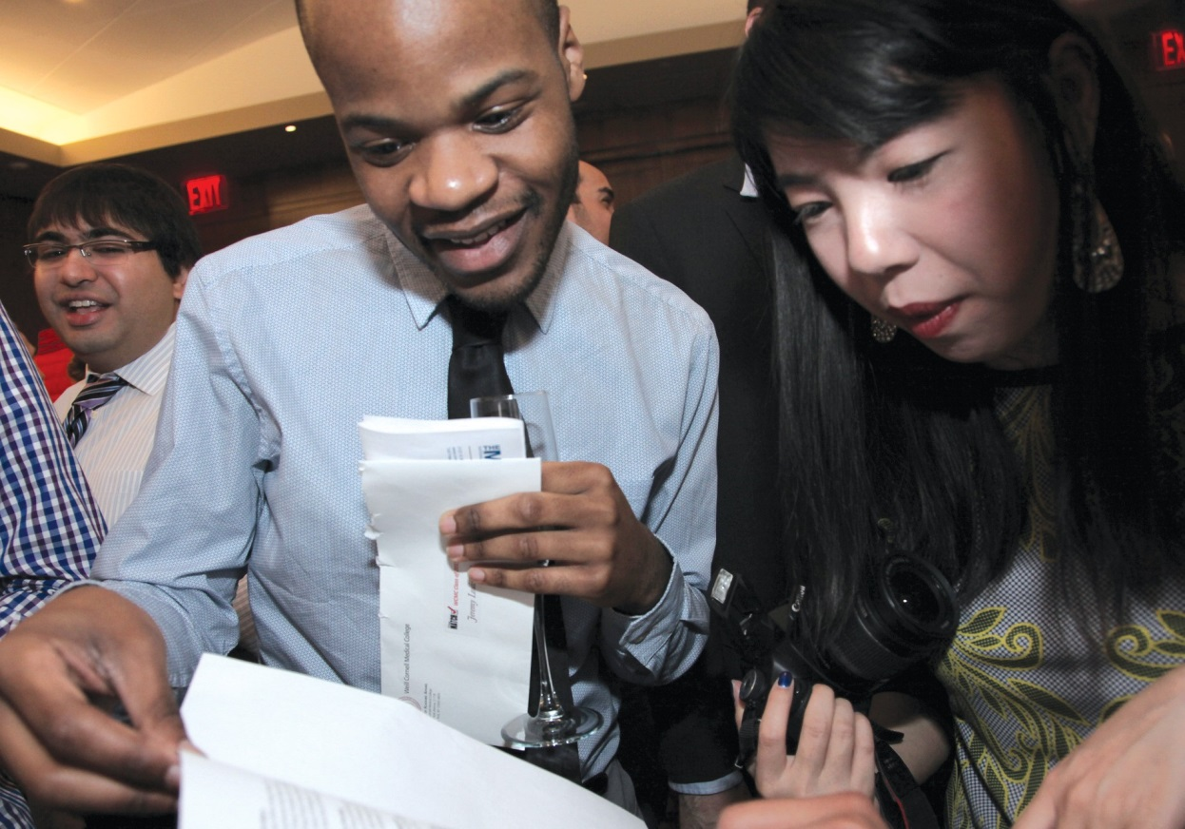
WCMC

In uniform: Physician assistant students now have their own White Coat ceremony.

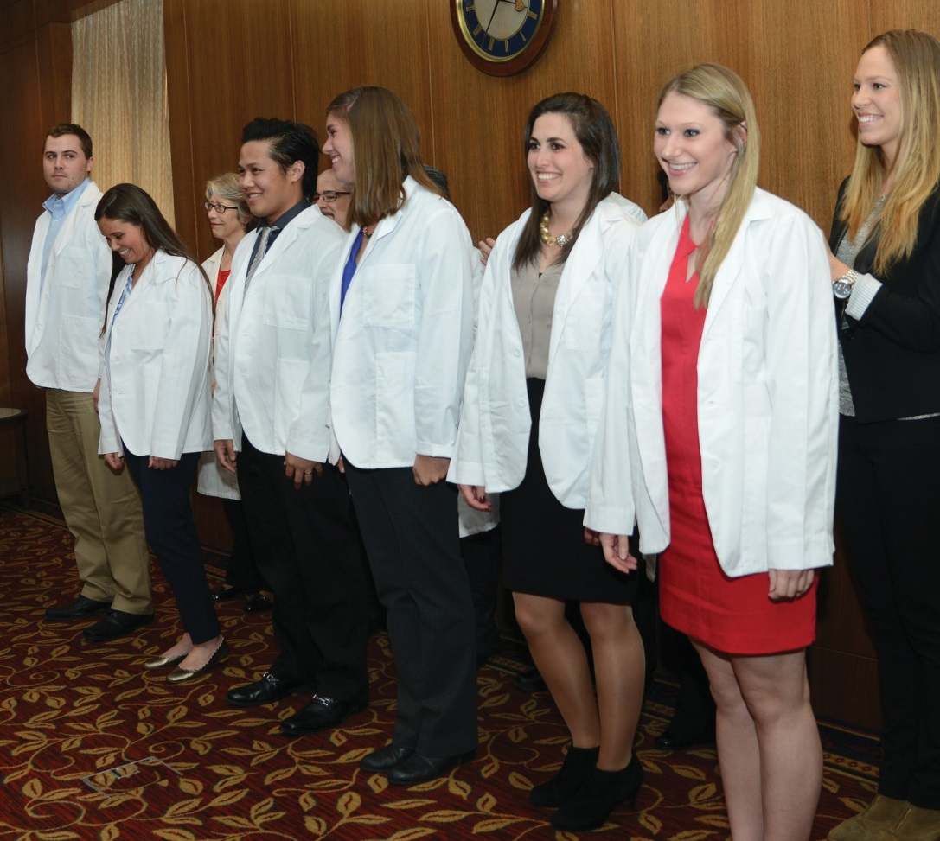
WCMC

Stamford Health Integrative Practices (SHIP) working out of Stamford Hospital. Being part of a larger organization has been a good thing so far and much less stressful. Special interests in my field continue to include robotic/minimally invasive gynecol- ogical surgery as well as integrative medi- cine. I was lucky enough to enjoy a recent Class of 1990 reunion skiing at Windham Mountain with classmates Larry Lind, Vince Ascrizzi, and Hal Baker, who work in Manhasset (LI), Reston (VA), and York (PA), respectively. It was great catching up with everyone and talking about life, our careers, and ongoing challenges in the medical profession.”
Adam Cifu, MD ’93: “My book Ending Medical Reversal: Improving Outcomes, Saving Lives comes out on October 1, 2015 from Johns Hopkins University Press. It should be of interest to both medical and lay audiences.” Montgomery C. Brower, MD ’94: “This December saw the publication of my new book, The Earthen Vessel: Poems of Yoga and Meditation, which I wrote and illustrated. Information and copies can be found online at UrthonaArts.com—the perfect gift

and Health, and spoke at EPA Boston on neuroendocrine effects of indoor mold exposure and the development of chemical sensitivity and dysautonomia as well as adrenal insufficiency from some moldy homes and offices. She was asked to appear in Congress in February 2015 to speak about veterans’ toxic exposures and how to treat them via environmental medicine. Last year she was the keynote speaker in NYC on Superstorm Sandy and how the remediation efforts were inadequate to deal with build- ings that became water damaged with mycotoxin production on the lower levels that has then spread to upper levels.
Stuart J. Rubin, MD ’87: “My wife, Lisa, PhD ’93, and I are in year two of the empty nest. We continue to reside in Williamsville, NY. Son Matthew, 22, works as a computer programmer and game designer for Electronic Arts in the San Francisco area. Son Daniel, 19, is a sophomore at Vanderbilt University, where he double majors in economics and communications.”
Theresa Rohr-Kirchgraber, MD ’88, will become the 100th president of the American Medical Women’s Association and its first Hispanic president. She is the executive director of the Indiana University National Center of Excellence in Women’s Health and the chief physician executive at Eskenazi Health Outpatient Care Centre Primary Care and the Center of Excellence for Women’s
Health. Dr. Rohr-Kirchgraber is an associate professor of clinical medicine and pediatrics and a faculty member in the Division of Adolescent Medicine at IU. She is a health and wellness expert on National Public Radio’s “Sound Medicine” broadcast. In 2014, Indianapolis Monthly named her as one of the “Top Doctors” in Indianapolis.

1990s
Daniel B. Jones ’86, MD ’90, professor
of surgery at Harvard Medical School, vice chair of surgery in the Office of Technology and Innovation and chief of minimally invasive surgical services and director of the bariatric program at Beth Israel Deaconess Medical Center, is releasing a new book in May 2015, Minimally Invasive Surgery: Laparoscopy, Therapeutic Endoscopy and Notes (JP Medical Publishers). Dr. Jones is also chair of the Society of American Gastro- intestinal and Endoscopic Surgeons’ Fundamental Use of Surgical Energy (FUSE), which teaches surgeons, anesthe- siologists, and nurses about the devices used in the operating room and how to prevent OR fires (www.fundamentals- didactics.com).
Russell Turk, MD ’90: “After ten years of private ob/gyn practice in Greenwich, CT, I recently sold my business to join
for the spiritual seeker in your life, or the yogi in you.”
Arie Szatkowski, MD ’97: “In August 2014 I began my position as system medical director of cardiovascular services for Baptist Memorial Healthcare Corporation, a 14- hospital system in the mid-South region, after leading one of their main hospitals, Baptist Desoto, to earn best in region for cardiovascular care by HealthGrades, top in Mississippi in US News and World Report, and high honors in national registries for cardiac care outcomes and delivery.”
Tamara D. Rozental, MD ’99, a hand surgeon in the Department of Orthopedic Surgery at Beth Israel Deaconess Medical Center, was named the 2014 Sterling Bunnell Traveling Fellow by the American Society for Surgery of the Hand. Dr. Rozental has a particular interest in osteoporosis and distal radius wrist fractures. She is also working on a two-year NIH study testing a new device that tests the strength of bone.

2000s
Adam Weinstein, MD ’02: “I’ve been work-
ing at Children’s Hospital of Dartmouth/ Geisel School of Medicine since 2009 as a pediatric nephrologist and co-director of the third-year pediatrics clerkship. 2014 was an exciting year as my family moved into our new ‘bubble-dome’ house, which my kids (12 and 7) now enjoy sledding off the

roof from. Professionally it was a big year, too, as I was appointed co-director of our On Doctoring clerkship, which is analogous to the MPS course back when my class was in school, and I was selected to the Geisel Academy of Master Educators.”
Lowell Frank ’99, MD ’03: “I have recently been appointed the program director of the Cardiology Fellowship Training Program at Children’s National in Washington, D.C. I’ve been here since I started my pediatric cardiology fellowship in 2006 with my wife, Samantha (Cornell ’96), and we have two boys: Max, 5, and Charlie, 2.”
Marc Otten, MD ’06: “After completing neuro- surgery residency at Columbia and a fellowship in minimally invasive neurosurgical oncology at Thomas Jefferson in Philadelphia, my wife, two children, and I moved to Greenwich, Connecticut, in August. This move was to start work with the Department of Neurological Surgery at Columbia. My practice is primarily neurosurgical oncology, focusing on endoscopic and minimally invasive approaches to the skull base. I also serve as the director of neurosurgery at NYP/Columbia at Lawrence Hospital in Bronxville, looking forward to the new cancer center due to open later this year.”
Milan Lombardi, MD ’08, and his wife are currently living in Tampa, Florida, and are expecting their first son in March.
Lauren M. Osborne, MD ’09, has recently relocated to Baltimore, where she is the assistant director of the Women’s Mood Disorders Center at Johns Hopkins. Lauren works on the immune mechanisms of psychiatric illness in the perinatal period, and works clinically with pregnant and postpartum women with mental illness.

In Memoriam

’42 MD—John T. Flynn of New York City, January 17, 2015; chief of medicine, program director, associate chairman of medicine, and trustee at Lower Manhattan Hospital (formerly Beekman Downtown Hospital); research fellow at Case Western Reserve University; medical officer with the 56th General Hospital, US Army Medical Corps, in the European Theater from 1943–45; prolific contributor to medical journals.
’46, ’48 MD—Morton D. Bogdonoff of New York City, March 1, 2015; professor of medicine at Weill Cornell for forty years; co-chief of the Geriatric Division and direc- tor of the Living at Home Program; editor of Archives of Internal Medicine; director of the Division of Behavioral Medicine at Duke University Medical School; chairman of the Department of Medicine at Abraham Lincoln School of Medicine of the University of Illinois, Chicago.
’48 MD—John H. Laragh of Village of Golf, FL, March 20, 2015; former chief of cardiology and founder of the Hypertension Center at NYP/Weill Cornell; founding president of the American Society of Hypertension and founding editor-in-chief of the American Journal of Hypertension; did groundbreaking research that led to the develop- ment of two new classes of hypertensive drugs.
’50 MD—Richard H. Cardozo of Sarasota, FL, formerly of Hanover, NH, and Canaan, NH, April 29, 2014; vice chairman of surgery at the V.A. Hospital in White River Junction, VT; assistant professor of surgery and physiology, Dartmouth Medical School; cardiothoracic surgeon, Hitchcock Clinic and Mary Hitchcock Memorial Hospital; pres- ident and chairman, Hitchcock Clinic; US Navy veteran; president, New Hampshire Orchid Society; supporter of the arts; volunteer at Marie Selby Botanical Gardens.
’55 MD—William S. Augerson of Millbrook, NY, January 18, 2015; VP, Arthur D. Little Inc.; retired Major General, US Army, and Deputy Assistant Secretary of Defense; commanding general of the Army Medical Research and Development Command; developed defenses and treatments for chemical and biological casualties; medical director of the 23rd Infantry Division in Vietnam; medical director of the 82nd Airborne Division during the Cuban Missile Crisis; Army flight surgeon assigned to NASA’s Project Mercury and Apollo programs; consultant; Rotarian; active in civic, community, professional, and religious affairs.




’57 MD—Herbert M. Oestreich of Mamaroneck, NY, November 12, 2014; former chief of neurosurgery, White Plains Hospital; associate professor of neurosurgery, New York Medical College and Westchester Medical Center; trustee, American Association of Neurological Surgeons; president, New York State Neurological Society; golfer; tennis player; skier; music and opera lover.

We want to hear from you!
Keep in touch with your classmates.
Send your news to Chris Furst: cf33@cornell.edu or by mail:
Weill Cornell Medicine 401 East State Street, Suite 301
Ithaca, NY 14850
’56, ’60 MD—James H. Marshall of Alpine, NY, December 29, 2014; general and plastic surgeon; specialist in hand surgeries, cleft palates, birth and maxillofacial defects, burns, finger reattachments, and cosmetic surgeries; developed the Burn Unit at St. Joseph’s Hospital; US Army medical officer with the 6th Special Forces in Ethiopia; out- doorsman; cultivated and sold ornamental conifers at his Alpine Acres Nursery.
’62 MD—Michael G. Zeigler of San Antonio, TX, December 26, 2014; chief of general surgery at Brook Army Medical Center; retired colonel, US Army; Army Ranger; served in Vietnam at the 12th Evacuation Hospital in Cu Chi; practiced at General Surgical Associates in San Antonio; hiker; book club member; active in religious affairs.
’73 MD—Lawrence David Zigelman of Fort Lee, NJ, November 7, 2014; pediatrician; partner, Pedimedica; author of The Pocket Pediatrician: An A-Z Guide to Your Child’s Health; active in religious affairs.
’90 MD—Neil H. Merkatz of Palm City, FL, January 3, 2015; child and adolescent psychiatrist; medical director, Sandy Pines Hospital; triathlete; climber of Colorado’s “Fourteeners”; scholarly reader of fantasy literature; sports fan; animal lover.

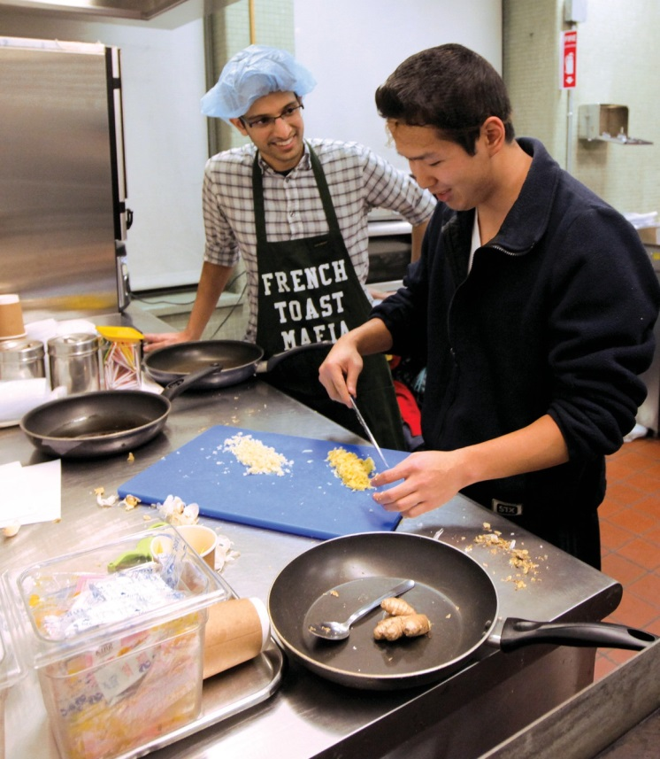

Post Doc

Top Chefs

First-years get lessons in healthful cuisine

or notoriously busy medical students, eating healthy can be a challenge. But a program at Weill Cornell is training them to prepare tasty meals that are
F
quick and easy—and often less expensive than cafeteria fare.

Dubbed Chef Ed, the group cooking classes are held every six weeks or so in a metabolic kitchen on campus—essentially, a small, well-equipped institutional kitchen with highly accurate measuring devices. Normally this is where soon-to-be-discharged patients with
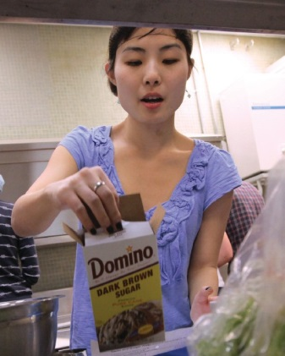
conditions like diabetes or obesity are instructed on proper dietary habits. But on an evening in mid-February, about a dozen first-year students are making Szechuan-style tofu and sautéed chicken with mixed vegetables in a black bean sauce over brown rice—plus banana- chocolate ice cream for dessert. “The most important take-away is that just about any form of cooking at home is healthier, even if you aren’t necessarily grilling chicken and steaming veggies,” says participant Nicole Aguirre ’18. “You can cook food that tastes good, in your
own kitchen, with your own ingredients, and it will be better for you. And even more important for us as students, it’s cheaper than constantly ordering in.”
The program is geared toward first-years, with second-years serv- ing as culinary tutors; there are occasional guest chefs, Q&A sessions, and presentations by visiting nutritionists. “There’s a big demand,” says Solomon Husain ’18, one of the program’s organizers, who’s

JOHN ABBOTT

Good taste: (Clockwise from left) Solomon Husain ’18 (left) and Anthony Nguyen ’18 in the Chef Ed kitchen; moo shu chicken lettuce wraps in the making; and Yoshiko Toyoda ’18 at work

clad in an apron labeled “French Toast Mafia.” “We usually have ten to fifteen students wait-listed.” At the February class, Colleen Webb, a clinical nutritionist at Weill Cornell’s Jill Roberts Center for Inflammatory Bowel Disease, offered tips such as shopping and cooking in bulk on the weekend, then freezing meals to be reheated on the go. “I found it to be very valuable,” Amelia Kelly ’18 says afterward. “In medical school, time is the biggest limiting factor that prevents me from cooking. I learned tools to speed up the prepara- tion process without skimping on nutritional value, and I learned about websites where I can find quick recipes that are also healthy.” Chef Ed is part of an effort, started three years ago, to better integrate nutrition training into the curriculum. In a related program, all first-years meet with Webb in ten-person sessions she calls “Lunch and Learn.” They’re encouraged to bring whatever they normally eat for a mid-day meal, and Webb offers gentle suggestions for more balanced choices. She aims to provide a comfortable setting for students to ask questions and for her to dis- pel common misconceptions, such as the media’s demonization of carbs or the current hype of “super foods.” The Chef Ed classes don’t just benefit the future doctors, Webb notes; physicians who eat well themselves can more credibly counsel their patients on the importance of a healthy diet. “How would you feel if your doctor was eating a Big Mac in front of you?” Webb muses. “When you cook for yourself you are generally eating healthier—more whole
foods with less sodium, fat, and sugar.”
At Chef Ed, participants come to the teaching kitchen with vary- ing levels of culinary skill. Anthony Nguyen ’18 was on the more experienced end, having cooked from an early age—“As a kid, I watched the Food Network more than cartoons”—and even spent time working at a French restaurant in Florida during a summer internship as a Cornell undergrad. “This is fun,” Nguyen says as he dices up a small mound of bright yellow ginger. “It’s nice to get away from the studying, and to get to know your classmates.”
— Ken Stier

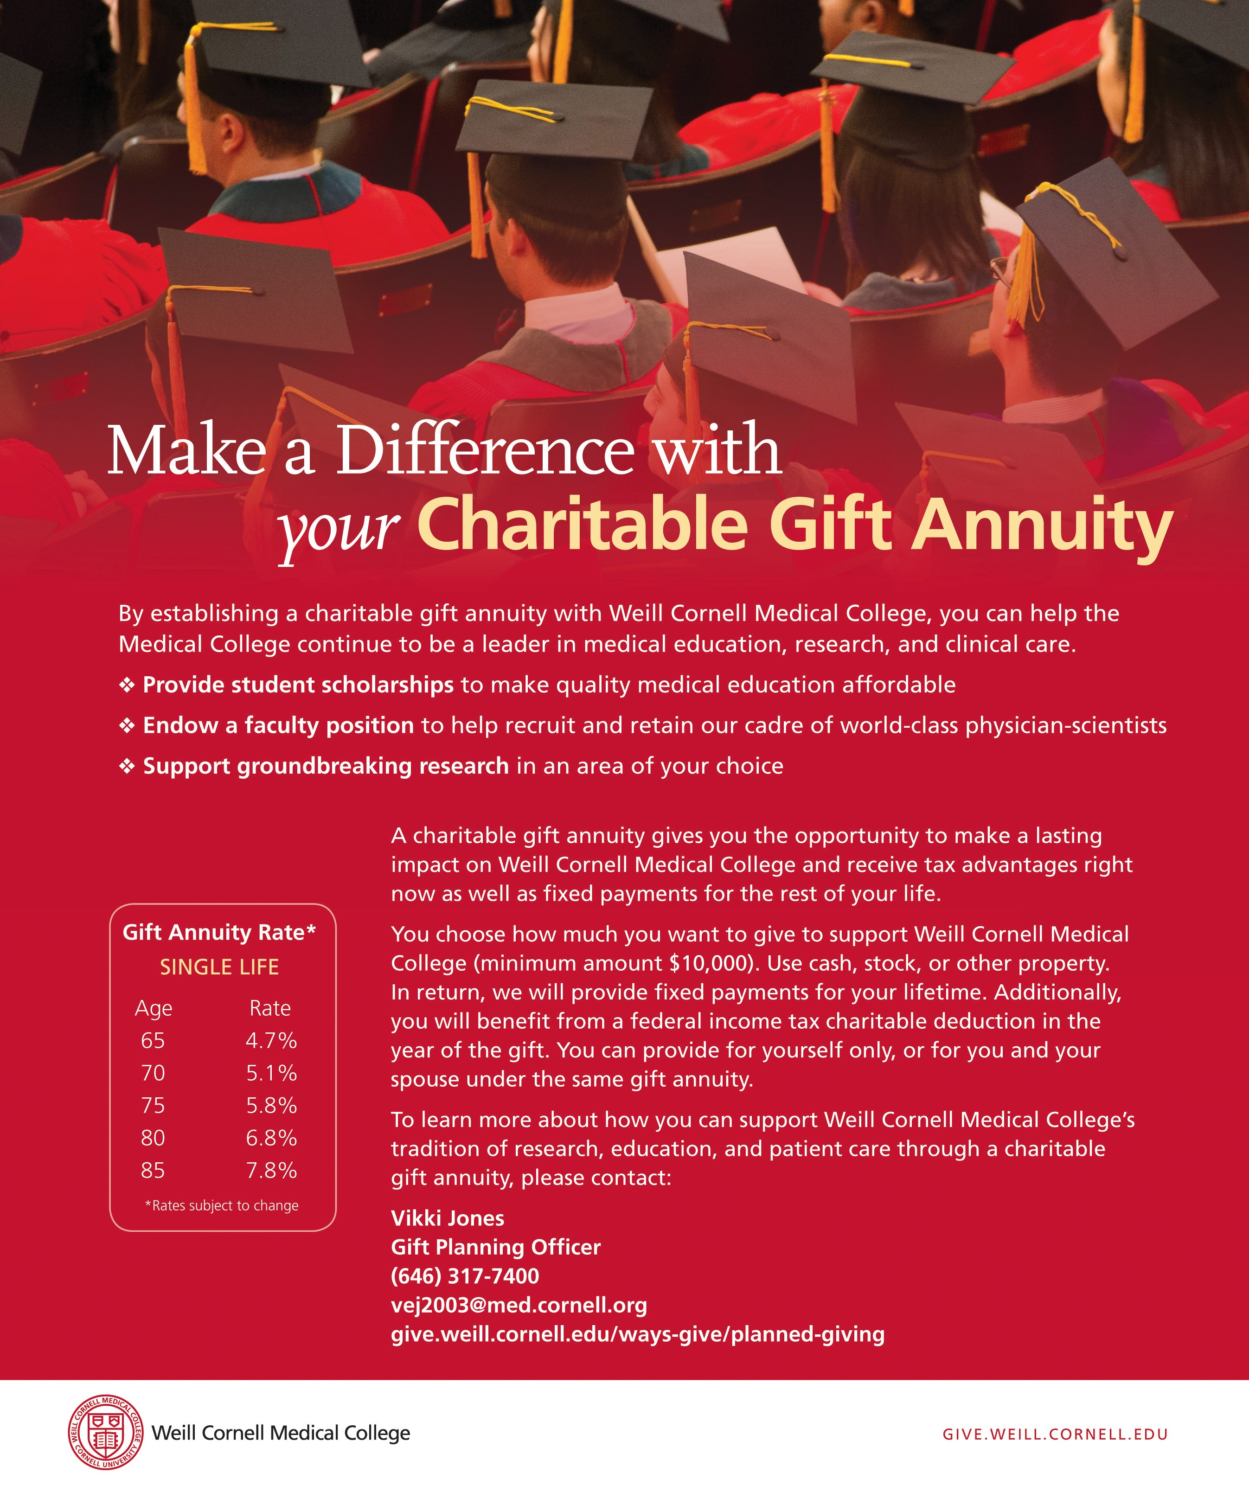

Weill Cornell Medical College and

PRSRT STD
US Postage PAID
Permit 302
Burl., VT. 05401
Weill Cornell Graduate School of Medical Sciences 1300 York Avenue, Box 144
New York, NY 10065

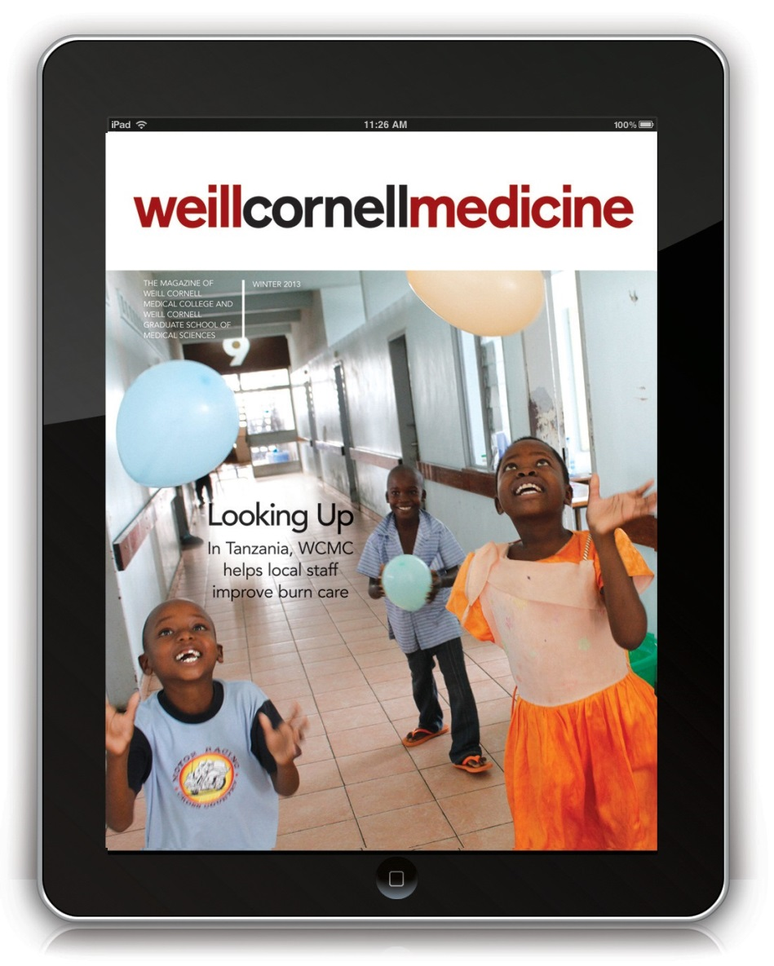
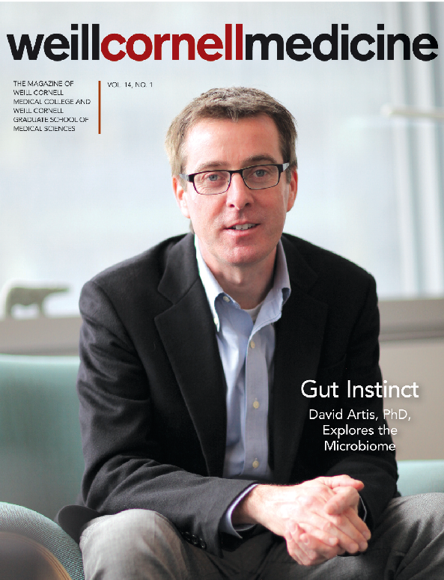
Take a look at our
digital version!
iPad, iPhone, and Android apps too.


www.weillcornellmedicine-digital.com

